Appendix

Chapter 1: Creating Your First App

Activity 1.01: Producing an App to Create RGB Colors

Solution:
- Create a new project called Colors. Start by creating a new Empty Activity project (File | New | New Project | Empty Activity). Name your application Colors and leave everything else with its default values and
click Finish.
- You need to add all the resource values you need that are not added by default here. The strings.xml file is needed to display all the text displayed in
the app:
<resources>
<string name="app_name">Colors</string>

<string name="color_creator_title">Create an RGB Color</string>
<!--Escape special characters by placing a backslash before them-->
<string name="color_creator_description">
Add two hexadecimal characters between 0-9, A-F
or a-f without the \'#\' for each channel </string>
<string name="red_channel">Red Channel</string>
<string name="green_channel">Green Channel</string>
<string name="blue_channel">Blue Channel</string>
<string name="color_creator_button_text">Create RGB Color
</string>
<string name="color_created_display_panel"> Created color display panel</string>
<string name="invalid_characters_found">Invalid Characters Found</string>

</resources>

- This dimens.xml file specifies dimension units in dp (density-independent pixels) used in the layout. This file is not present when initially creating a project, but it can be added by creating the file dimens.xml in the same 'values' folder by going to File | New | Android Resource File or you can do this by right-clicking on the res | values folder and selecting new values.
<?xml version="1.0" encoding="utf-8"?>
<resources>
<dimen name="color_creator_layout_margin">8dp</dimen>
<dimen name="color_creator_display_panel">40dp</dimen>
</resources>
- The themes.xml file is updated to include the following styles.

<style name="color_creator_title" parent="TextAppearance.MaterialComponents.Headline5">
<item name="android:textStyle">bold</item>
</style>
<style name="color_creator_description" parent="TextAppearance.MaterialComponents.Body1" />
<style name="color_input" parent="Widget.MaterialComponents.TextInputLayout.OutlinedBox">
<item name="android:layout_margin">8dp</item>
</style>
<style name="color_button">
<item name="android:layout_margin">8dp</item>
<item name="android:gravity">center</item>
</style>
<style name="color_display" parent="@style/TextAppearance.MaterialComponents.Body1">
<item name="android:layout_margin">8dp</item>
<item name="android:gravity">center</item>
<item name="android:layout_height">40dp</item>
</style>
<style name="screen_layout_margin">
<item name="android:layout_margin">12dp</item>
</style>
- You have now set up the resources that will be used to customize the layout and UI of the app. Now, add a title constrained to the top of the layout. Here, you have to go into activity_main.xml and update the following so
the title is constrained to the top using app:layout_constraintTop_ toTopOf="parent":

<?xml version="1.0" encoding="utf-8"?>
<androidx.constraintlayout.widget.ConstraintLayout
xmlns:android="http://schemas.android.com/apk/res/android"
xmlns:app="http://schemas.android.com/apk/res-auto"
xmlns:tools="http://schemas.android.com/tools"
android:layout_width="match_parent"
android:layout_height="match_parent"
style="@style/screen_layout_margin"
tools:context=".MainActivity">

<TextView
android:layout_width="match_parent"
android:id="@+id/color_creator_title"
android:layout_height="wrap_content"
style="@style/color_creator_title"
android:gravity="center"
android:text="@string/color_creator_title"
app:layout_constraintTop_toTopOf="parent"
app:layout_constraintStart_toStartOf="parent"/>

</androidx.constraintlayout.widget.ConstraintLayout>

- You have now created the title that will be displayed on screen. Add a brief description to the user on how to complete the form. You constrain the description to below the title, and then add style, dimensions, and text:

<?xml version="1.0" encoding="utf-8"?>
<androidx.constraintlayout.widget.ConstraintLayout
xmlns:android="http://schemas.android.com/apk/res/android"
xmlns:app="http://schemas.android.com/apk/res-auto"
xmlns:tools="http://schemas.android.com/tools"
android:layout_width="match_parent"
android:layout_height="match_parent"
style="@style/screen_layout_margin"
tools:context=".MainActivity">

<TextView
android:layout_width="match_parent"
android:id="@+id/color_creator_title"
android:layout_height="wrap_content"
style="@style/color_creator_title"
android:gravity="center"
android:text="@string/color_creator_title"
app:layout_constraintTop_toTopOf="parent"
app:layout_constraintStart_toStartOf="parent"/>

<TextView
android:layout_width="match_parent"
android:id="@+id/color_creator_description"
android:layout_height="wrap_content"
style="@style/color_creator_description"
android:text="@string/color_creator_description"
app:layout_constraintTop_toBottomOf="@id/color_creator_title"
app:layout_constraintStart_toStartOf="parent"/>

</androidx.constraintlayout.widget.ConstraintLayout>

You will notice that styles, dimensions, and text have been added using the preceding resources:

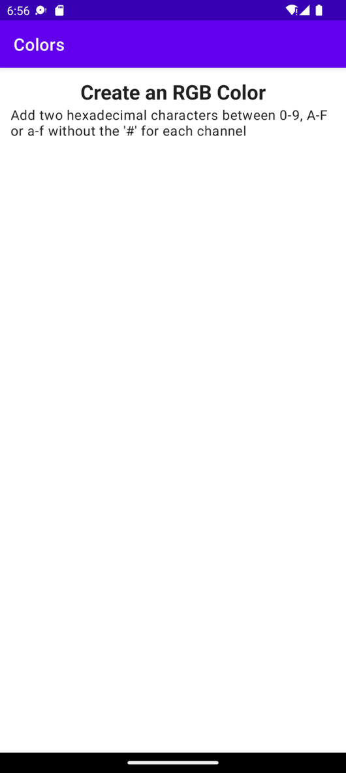

Figure 1.26: Layout with title and description

- The layout is taking shape now that you've added the description. Continue by adding three material TextInputLayout fields wrapping three TextInputEditText fields that appear under Title. These should be constrained so that each view is on top of the other (rather than to the side). Name the TextInputEditText fields Red Channel, Green Channel,
and Blue Channel, respectively and add some restriction to each field to only be able to enter two hexadecimal characters. These views are similar to what you have worked with before in the exercises, the only difference being that they have the digits and maxLength attributes:
<com.google.android.material.textfield.TextInputLayout android:id="@+id/red_channel_wrapper" style="@style/Widget.MaterialComponents.TextInputLayout
.OutlinedBox" android:layout_width="match_parent" android:layout_height="wrap_content"
android:layout_margin="@dimen/color_creator_layout_margin" android:hint="@string/red_channel" app:layout_constraintTop_toBottomOf
="@id/color_creator_description" app:layout_constraintStart_toStartOf="parent">

<com.google.android.material.textfield.TextInputEditText android:id="@+id/red_channel" android:inputType="textCapCharacters" android:digits="ABCDEFabcdef0123456789" android:layout_width="match_parent" android:layout_height="wrap_content" android:maxLength="2" />

</com.google.android.material.textfield.TextInputLayout>

<com.google.android.material.textfield.TextInputLayout android:id="@+id/green_channel_wrapper" style="@style/Widget.MaterialComponents.TextInputLayout
.OutlinedBox" android:layout_width="match_parent" android:layout_height="wrap_content"
android:layout_margin="@dimen/color_creator_layout_margin" android:hint="@string/green_channel"
app:layout_constraintTop_toBottomOf="@id/red_channel_wrapper" app:layout_constraintStart_toStartOf="parent">

<com.google.android.material.textfield.TextInputEditText android:id="@+id/green_channel" android:inputType="textCapCharacters" android:digits="ABCDEFabcdef0123456789" android:layout_width="match_parent" android:layout_height="wrap_content" android:maxLength="2"/>

</com.google.android.material.textfield.TextInputLayout>

<com.google.android.material.textfield.TextInputLayout android:id="@+id/blue_channel_wrapper" style="@style/Widget.MaterialComponents.TextInputLayout
.OutlinedBox" android:layout_width="match_parent" android:layout_height="wrap_content"
android:layout_margin="@dimen/color_creator_layout_margin" android:hint="@string/blue_channel" app:layout_constraintTop_toBottomOf=
"@id/green_channel_wrapper" app:layout_constraintStart_toStartOf="parent">

<com.google.android.material.textfield.TextInputEditText android:id="@+id/blue_channel" android:inputType="textCapCharacters" android:digits="ABCDEFabcdef0123456789" android:layout_width="match_parent" android:layout_height="wrap_content" android:maxLength="2" />

</com.google.android.material.textfield.TextInputLayout>

Once you add this code, the output will be as follows:
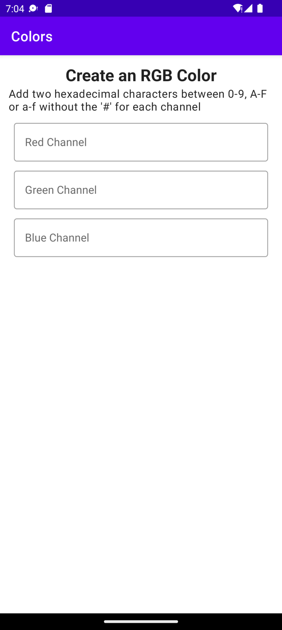

Figure 1.27: Color channel EditText fields added

- You've now added all the input fields shown in Figure 1.27, but now you need to create a button to process these inputs. Add a button that takes the inputs from the three color fields. It's the id that is important here as it's used to trigger retrieval of the values from the color fields:

<com.google.android.material.button.MaterialButton
android:layout_width="match_parent"
android:layout_height="wrap_content"
style="@style/color_button"
android:id="@+id/color_creator_button"
android:gravity="center"
android:text="@string/color_creator_button_text"
app:layout_constraintTop_toBottomOf="@id/blue_channel_wrapper"
app:layout_constraintStart_toStartOf="parent"/>

- Add a View, which will display the produced color in the layout. We need to constrain this view appropriately and make it sufficiently large such that the newly created color will be seen clearly using the dimensions specified previously:

<TextView
android:id="@+id/color_creator_display"
android:layout_width="match_parent"
style="@style/color_display"
android:text="@string/color_created_display_panel"
android:layout_height="40dp"
android:layout_margin="8dp"
app:layout_constraintTop_toBottomOf="@id/color_creator_button"
app:layout_constraintStart_toStartOf="parent" />
- Finally, display the RGB color created from the three channels in the layout. This is where we need to set the click listener on the button and retrieve the three color values. Then, we need to concatenate these values in the correct order in order to create a new color and set that to the background of the color display panel:
package com.example.colors

import android.graphics.Color import android.os.Bundle import android.widget.Button
import android.widget.TextView import android.widget.Toast
import androidx.appcompat.app.AppCompatActivity
import com.google.android.material.textfield.TextInputEditText

class MainActivity : AppCompatActivity() {
override fun onCreate(savedInstanceState: Bundle?) { super.onCreate(savedInstanceState) setContentView(R.layout.activity_main)

findViewById<Button>(R.id.color_creator_button)
?.setOnClickListener {
var redChannelText = findViewById<TextInputEditText>
(R.id.red_channel)?.text.toString()
var greenChannelText = findViewById<TextInputEditText>
(R.id.green_channel)?.text.toString()
var blueChannelText = findViewById<TextInputEditText>
(R.id.blue_channel)?.text.toString()

//Check that all fields are filled in
//and show error message if not. if (redChannelText.isEmpty() or
greenChannelText.isEmpty()
or blueChannelText.isEmpty()) { Toast.makeText(this, "All Values are required",
Toast.LENGTH_LONG).show()
} else {
//check that 2 hexadecimal characters
//have been entered and if not
//add the same hexadecimal character again. if (redChannelText.length == 1) redChannelText =
redChannelText.plus(redChannelText)
if (greenChannelText.length == 1) greenChannelText = greenChannelText.plus(greenChannelText)
if (blueChannelText.length == 1) blueChannelText = blueChannelText.plus(blueChannelText)

val colorToDisplay = redChannelText
.plus(greenChannelText).plus(blueChannelText)

val colorAsInt = Color.parseColor ("#".plus(colorToDisplay))
findViewById<TextView>(R.id.color_creator_display)
?.setBackgroundColor(colorAsInt)

}
}
}
}
Your solution should appear something like the app displayed here. The similarity to the exact layout that follows is not important. This is just to give you an indication of the layout you are aiming for:

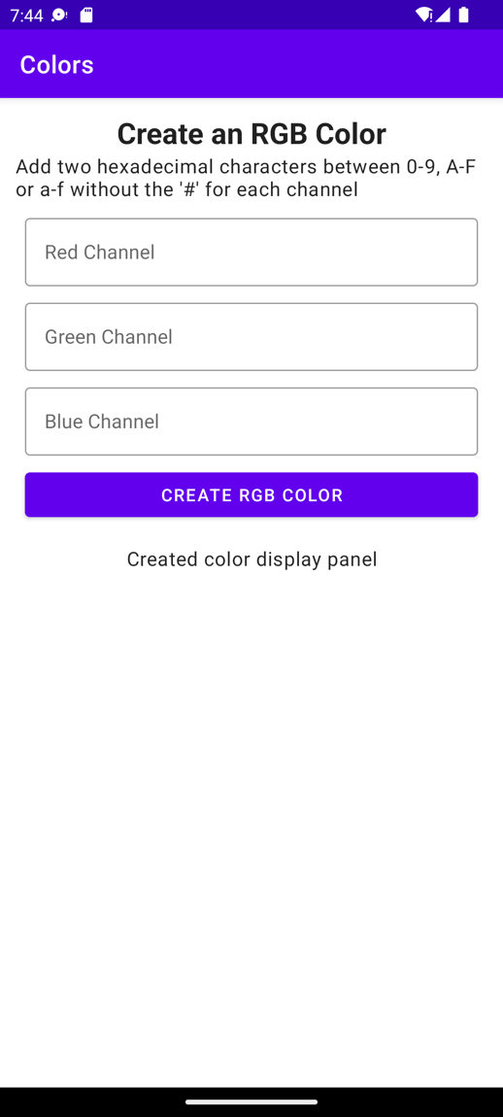

Figure 1.28: Text fields that create RGB colors

The following screenshot shows the display of the app after the color has been
entered and is shown within the app:

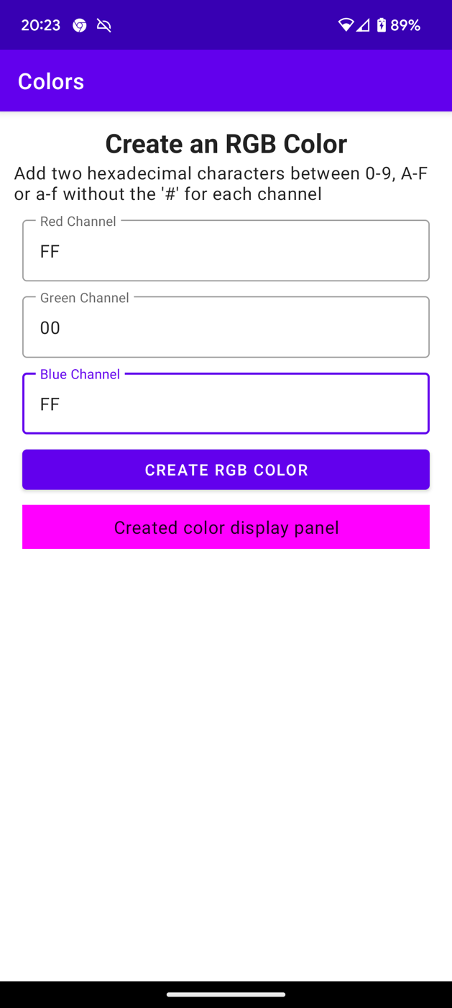

Figure 1.29: Output when the color is displayed
With this activity, we have produced an app to create RGB colors. Depending on the values that you enter in the text fields shown in Figure 1.30, the output will vary.
The source code for this activity is here: Activity1.01

Chapter 2: Building User Screen Flows

Activity 2.01: Creating a Login Form

Solution
- Create a new project called Login Activity. Start by creating a new empty Activity project (File | New | New Project | Empty Activity). Name your application Login Activity and leave everything else with their default values, and then click Finish.
- You need to add all the resource values you need that are not added by default. First, let's make changes to the strings.xml file. This file is needed to display all the text displayed in the app:
<resources>
<string name="app_name">Login Activity</string>
<string name="header_text">Please enter your username and password below to login:</string>
<string name="welcome_text">Hello %s you are now logged in, we hope you enjoy using the app!</string>
<string name="login_form_entry_error">Please fill in both username and password fields!</string>
<string name="login_error">Either your user name or password is not recognised! Please try again.</string>
<string name="username_label">Enter your username:
</string>
<string name="password_label">Enter your password:
</string>
<string name="submit_button_text">LOGIN</string>
</resources>
- Now, open the themes.xml file and add the following styles:
<style name="header" parent="TextAppearance.AppCompat.Title">
<item name="android:gravity">center</item>
<item name="android:layout_marginStart">24dp</item>
<item name="android:layout_marginLeft">24dp</item>
<item name="android:layout_marginEnd">24dp</item>
<item name="android:layout_marginRight">24dp</item>
<item name="android:textSize">20sp</item>
</style>

<style name="edit_text_login" parent="TextAppearance.AppCompat.Body1">
<item name="android:layout_marginTop">16dp</item>

<item name="android:layout_gravity">center</item>
<item name="android:textSize">20sp</item>
<item name="android:inputType">text</item>
</style>

<style name="button" parent="TextAppearance.AppCompat.Button">
<item name="android:layout_margin">16dp</item>
<item name="android:gravity">center</item>
<item name="android:textSize">20sp</item>
</style>

<style name="page">
<item name="android:layout_margin">8dp</item>
<item name="android:padding">8dp</item>
</style>
- This sets up the strings and styles that the app will use. Now, you need to create the layout that the app will use. Open up activity_main.xml and add the header, user_name, password, and submit_button Views. This follows the format you used previously with ConstraintLayout where you added a TextView field called header, which was constrained to the top of its parent using app:layout_constraintTop_toTopOf="parent". The
username is then constrained to the bottom of the header using app:layout_ constraintTop_toBottomOf="@id/header". The rest of the form with the password and submit button follow the same pattern, leaving you with the following layout:
<?xml version="1.0" encoding="utf-8"?>
<androidx.constraintlayout.widget.ConstraintLayout xmlns:android="http://schemas.android.com/apk/res/android" xmlns:app="http://schemas.android.com/apk/res-auto" xmlns:tools="http://schemas.android.com/tools" android:layout_width="match_parent" android:layout_height="match_parent"
style="@style/page" tools:context=".MainActivity">

<TextView
android:id="@+id/header" style="@style/header" android:layout_width="wrap_content"
android:layout_height="wrap_content" android:text="@string/header_text" app:layout_constraintTop_toTopOf="parent" app:layout_constraintEnd_toEndOf="parent" app:layout_constraintStart_toStartOf="parent"/>

<EditText
android:id="@+id/user_name" style="@style/edit_text_login" android:layout_width="wrap_content" android:layout_height="wrap_content" android:hint="@string/username_label" app:layout_constraintTop_toBottomOf="@id/header" app:layout_constraintStart_toStartOf="parent" app:layout_constraintEnd_toEndOf="parent"/>

<EditText
android:id="@+id/password" style="@style/edit_text_login" android:layout_width="wrap_content" android:layout_height="wrap_content" android:hint="@string/password_label" android:inputType="textPassword" app:layout_constraintTop_toBottomOf="@id/user_name" app:layout_constraintStart_toStartOf="parent" app:layout_constraintEnd_toEndOf="parent"/>

<Button
android:id="@+id/submit_button" style="@style/button" android:layout_width="wrap_content" android:layout_height="wrap_content" android:text="@string/submit_button_text" app:layout_constraintTop_toBottomOf="@id/password" app:layout_constraintEnd_toEndOf="parent" app:layout_constraintStart_toStartOf="parent"/>
</androidx.constraintlayout.widget.ConstraintLayout>
Note

You can find the preceding layout in the GitHub repository at
https://github.com/PacktPublishing/How-to-Build-Android-Apps-with-Kotlin-Second-Edition/tree/master/Chapter02/Activity2.01_singleTop.
- Now, the key part of this solution to the Activity is to use a singleTop Android Activity. Go to app | src | main | AndroidManifest.xml and add android:launchMode="singleTop" to MainActivity:
<activity android:name="com.example.loginactivity.MainActivity" android:launchMode="singleTop">
- Next, open up MainActivity and replace the code with the following:
package com.example.loginactivity

import android.content.Context import android.content.Intent
import androidx.appcompat.app.AppCompatActivity import android.os.Bundle
import android.view.Gravity
import android.view.inputmethod.InputMethodManager import android.widget.Button
import android.widget.EditText import android.widget.TextView import android.widget.Toast
import androidx.core.view.isVisible

const val USER_NAME_KEY = "USER_NAME_KEY" const val PASSWORD_KEY = "PASSWORD_KEY"

const val IS_LOGGED_IN = "IS_LOGGED_IN"
const val LOGGED_IN_USERNAME = "LOGGED_IN_USERNAME"

//This is done as an example for simplicity and user/pwd credentials should never be stored in an app
const val USER_NAME_CORRECT_VALUE = "someusername" const val PASSWORD_CORRECT_VALUE = "somepassword"

class MainActivity : AppCompatActivity() {

private var isLoggedIn = false private var loggedInUser = ""

private val submitButton: Button
get() = findViewById(R.id.submit_button)

private val userName: EditText
get() = findViewById(R.id.user_name)

private val password: EditText
get() = findViewById(R.id.password)

private val header: TextView
get() = findViewById(R.id.header)

override fun onCreate(savedInstanceState: Bundle?) { super.onCreate(savedInstanceState) setContentView(R.layout.activity_main)

submitButton.setOnClickListener {

val userNameForm = userName.text.toString().trim() val passwordForm = password.text.toString().trim()

hideKeyboard()

if (userNameForm.isNotEmpty() && passwordForm.isNotEmpty()) {

//Set the name of the activity to launch Intent(this, MainActivity::class.java).also {
loginIntent ->
//Add the data
loginIntent.putExtra(USER_NAME_KEY, userNameForm)
loginIntent.putExtra(PASSWORD_KEY, passwordForm)
//Launch startActivity(loginIntent)
}

} else {
val toast = Toast.makeText(this, getString(R.string.login_form_entry_error),
Toast.LENGTH_LONG)

toast.setGravity(Gravity.CENTER, 0, 0) toast.show()
}

}
}

private fun hideKeyboard() {
if (currentFocus != null) { val imm = getSystemService
(Context.INPUT_METHOD_SERVICE) as InputMethodManager

imm.hideSoftInputFromWindow(currentFocus?.windowToken, 0)
}
}
}
This should be familiar to you from previous exercises. You add interaction with the button by adding a ClickListener interface, checking that the username and password fields are not empty and then creating an intent. In this case, as this is a singleTop Activity, the intent takes the same name as the current MainActivity activity as you are going to launch it again; but on this occasion, it will be a different intent that has the username and password details, which need to be verified. If the user has not entered their username and password correctly, then pop up a toast message.
- Add code to validate the username and password as follows:
private fun setLoggedIn(loggedInUserName: String) { loggedInUser = loggedInUserName
val welcomeMessage = getString(R.string.welcome_text, loggedInUserName)
userName.isVisible = false password.isVisible = false submitButton.isVisible = false header.text = welcomeMessage
}

private fun hasEnteredCorrectCredentials( userNameForm: String,
passwordForm: String
): Boolean {

return userNameForm.contentEquals(USER_NAME_CORRECT_VALUE) && passwordForm.contentEquals(
PASSWORD_CORRECT_VALUE
)
}
The hasEnteredCorrectCredentials method checks that the username
and password match the values stored as constants in the Activity:
const val USER_NAME_CORRECT_VALUE = "someusername" const val PASSWORD_CORRECT_VALUE = "somepassword"
The setLoggedIn method displays a welcome message with the user's name in the header and sets all the other Views to gone so that they no longer appear in the layout.
- Next, we use the onNewIntent function to process the intent that has just
been sent:
override fun onNewIntent(newIntent: Intent?) { super.onNewIntent(newIntent)

//Set the new Intent to the one to process intent = newIntent

//Get the intent which started this activity intent?.let { loginIntent ->

val userNameForm = loginIntent.getStringExtra (USER_NAME_KEY) ?: ""
val passwordForm = loginIntent.getStringExtra (PASSWORD_KEY) ?: ""

val loggedInCorrectly = hasEnteredCorrectCredentials (userNameForm.trim(), passwordForm.trim())

if (loggedInCorrectly) { setLoggedIn(userNameForm) isLoggedIn = true
} else {
val toast = Toast.makeText(this, getString(R.string.login_error), Toast.LENGTH_LONG)
toast.setGravity(Gravity.CENTER, 0, 0) toast.show()

}
}
}
The callback for the singleTop mode Activities is override fun onNewIntent(intent: Intent?), and it's here where you use setIntent(intent) to set the intent to process. The rest of the code retrieves the username and password passed in the intent's extras and then validates these values against the correct username and password, displaying a welcome message with the user's name if they are successful or popping up an error message if the values don't match,
- Then, finally, you store the username and password and the logged-in status so that if the Activity is recreated, the user will still be logged in and the welcome message with their name will still be displayed:
override fun onSaveInstanceState(outState: Bundle) { super.onSaveInstanceState(outState)

outState.putBoolean(IS_LOGGED_IN, isLoggedIn) outState.putString(LOGGED_IN_USERNAME, loggedInUser)
}

override fun onRestoreInstanceState(savedInstanceState: Bundle) {
super.onRestoreInstanceState(savedInstanceState)

isLoggedIn = savedInstanceState.getBoolean(IS_LOGGED_IN, false)
loggedInUser = savedInstanceState.getString (LOGGED_IN_USERNAME, "")

if (isLoggedIn && loggedInUser.isNotEmpty()) { setLoggedIn(loggedInUser)
}
}

- When the details have been entered and we load the screen for the first time, it
will look as in Figure 2.24:

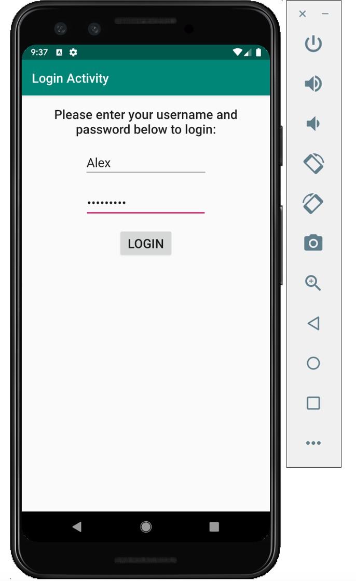
​​
Figure 2.24: The display after the user enters their details

On entering an incorrect username or password, a toast error message will be displayed, as shown in Figure 2.2

Figure 2.25: The display on entering an incorrect username or password

- On a successful login, here's the display, shown in Figure 2.26:

Figure 2.26: The display after the user successfully logs in
This activity has demonstrated how to create a login form, add interaction with the user, and validate the entered data to either log in successfully or handle errors and give feedback to the user.

The solution code for all of the approaches to solve this activity, including this one, can be found on GitHub at the following locations:
- Using a singleTop Activity: https://github.com/PacktPublishing/How-to-Build-Android-Apps-with-Kotlin-Second-Edition/tree/master/Chapter02/Activity2.01_singleTop
- Using a standard Activity: https://github.com/PacktPublishing/How-to-Build-Android-Apps-with-Kotlin-Second-Edition/tree/master/Chapter02/Activity2.02_standard
- Using registerForActivityResult: https://github.com/PacktPublishing/How-to-Build-Android-Apps-with-Kotlin-Second-Edition/tree/master/Chapter02/Activity2.03_register_for_activity_result

Chapter 3: Developing the UI with Fragments

Activity 3.01: Creating a Quiz on the Planets

Solution:
- First of all, create a new project with an empty activity and call it Planet Quiz.
- Once you have done that, add the following dependency you need to manage adding/replacing fragments, FragmentContainerView into app/build.gradle within the dependences{ } block:
implementation 'androidx.fragment:fragment-ktx:1.5.5'
- Add the following strings needed in the project:
strings.xml

<string name="app_name">Planet Quiz</string>
<string name="largest_planet">What is the largest planet?</string>
<string name="most_moons">Which planet has the most moons?</string>
<string name="side_spinning">Which planet spins on its side?</string>

<string name="mercury">MERCURY</string>
<string name="venus">VENUS</string>
<string name="earth">EARTH</string>
<string name="mars">MARS</string>
<string name="jupiter">JUPITER</string>
<string name="saturn">SATURN</string>
<string name="uranus">URANUS</string>
<string name="neptune">NEPTUNE</string>

<string name="jupiter_answer">%s Jupiter is the largest planet
and is 2.5 times the mass of all the other planets put together.
</string>
<string name="saturn_answer">%s Saturn has the most moons and has 82 moons.</string>
<string name="uranus_answer">%s Uranus spins on its side
with its axis at nearly a right angle to the sun.</string>
<string name="correct">CORRECT!</string>
<string name="wrong">WRONG!</string>

You will notice that the answer strings have %s in them. This is so the answer strings can be formatted with a string format argument to display whether the answer is CORRECT! or WRONG!.
- Then update themes.xml:
themes.xml
<style name="HeaderText" parent="Base.TextAppearance.AppCompat.Large">
<item name="android:padding">18dp</item>
<item name="android:textSize">24sp</item>
<item name="android:textStyle">bold</item>
<item name="android:gravity">center</item>
</style>

<style name="ButtonText">
<item name="android:layout_margin">8dp</item>
<item name="android:padding">14dp</item>
<item name="android:textAllCaps">false</item>
<item name="android:textSize">18sp</item>
</style>

<style name="AnswerText">
<item name="android:padding">14dp</item>
<item name="android:textSize">18sp</item>
<item name="android:textStyle">bold</item>
</style>
These are basic styles so feel free to change them. Buttons, by default, display in uppercase text so the android:textAllCaps item set to false allows us to not display the buttons in uppercase.
The approach that is used for this activity is to use dynamic fragments and a listener in a QuestionsFragment class to pass data to an AnswersFragment with the fragments being added to a container
FragmentContainerView in the activity layout file.
- The first stage of creating this is to create a new blank fragment with the toolbar File | New | Fragment | Fragment (Blank) option and call it QuestionsFragment.

- Once the fragment has been created, open the fragment_questions.xml
layout file and add this code:
<?xml version="1.0" encoding="utf-8"?>
<LinearLayout xmlns:android="http://schemas.android.com/apk/res/android"

xmlns:tools="http://schemas.android.com/tools" android:layout_width="match_parent" android:layout_height="match_parent" android:orientation="vertical" tools:context=".QuestionsFragment">

<TextView
style="@style/HeaderText" android:layout_width="match_parent" android:layout_height="wrap_content" android:gravity="center" android:text="@string/app_name"/>

<Button
android:id="@+id/largest_planet" style="@style/ButtonText" android:layout_width="match_parent" android:layout_height="wrap_content" android:gravity="center" android:text="@string/largest_planet"/>

<Button
android:id="@+id/most_moons" style="@style/ButtonText" android:layout_width="match_parent" android:layout_height="wrap_content" android:gravity="center" android:text="@string/most_moons"/>

<Button
android:id="@+id/side_spinning" style="@style/ButtonText"

android:layout_width="match_parent" android:layout_height="wrap_content" android:gravity="center" android:text="@string/side_spinning"/>
</LinearLayout>
You are adding a simple LinearLayout to display the questions one on top of the other. You assign IDs to the buttons so they can be retrieved in the fragment.
- Next, go into the QuestionsFragment and update the code to the following:
package com.example.planetquiz

import android.content.Context import android.os.Bundle
import androidx.fragment.app.Fragment import android.view.LayoutInflater import android.view.View
import android.view.ViewGroup

interface AnswersListener {
fun onSelected(questionId: Int)
}
class QuestionsFragment : Fragment(), View.OnClickListener { private lateinit var answersListener: AnswersListener override fun onAttach(context: Context) {
super.onAttach(context)
if (context is AnswersListener) { answersListener = context
} else {
throw RuntimeException("Must implement AnswersListener")
}
}

override fun onCreateView(
inflater: LayoutInflater, container: ViewGroup?,
savedInstanceState: Bundle?): View? {

return inflater.inflate(R.layout.fragment_questions, container,
false)

}

override fun onViewCreated(view: View, savedInstanceState: Bundle?) {
super.onViewCreated(view, savedInstanceState)

val planets = listOf<View>( view.findViewById(R.id.most_moons), view.findViewById(R.id.largest_planet), view.findViewById(R.id.side_spinning)
)

planets.forEach { it.setOnClickListener(this)
}
}
override fun onClick(v: View?) { v?.let { question ->
answersListener.onSelected(question.id)
}
}
}
As you saw in Exercise 3.04, Adding Fragments Dynamically to an Activity, you define a listener (AnswersListener) that will be associated with the Android activity, and the fragment is included with the onAttach method. This is the way you will communicate back to the activity which question the user has clicked on. The rest of the class should be quite familiar. You set the layout and then retrieve
the view by IDs before setting a ClickListener to pass the selected question
back into the Android activity.
- Next, create another blank fragment called AnswersFragment. The first thing
to do is update the fragment_answers.xml layout file to include a view for the question header text, all of the planet buttons, and a view to show the answer. Update the file to the following:
<?xml version="1.0" encoding="utf-8"?>
<ScrollView xmlns:android="http://schemas.android.com/apk/res/android"
xmlns:tools="http://schemas.android.com/tools"
android:layout_width="match_parent" android:layout_height="wrap_content" tools:context=".AnswersFragment">

<LinearLayout
android:layout_width="match_parent" android:layout_height="wrap_content" android:orientation="vertical">

<TextView
android:id="@+id/header_text" android:layout_width="match_parent" android:layout_height="wrap_content" android:gravity="center" style="@style/HeaderText" tools:text="Question Text" />

<Button
android:id="@+id/mercury" android:layout_width="match_parent" android:layout_height="wrap_content" android:gravity="center" style="@style/ButtonText" android:text="@string/mercury" />

<!-- Add the 7 other planets below this line here -->

<TextView
android:id="@+id/answer" android:layout_width="match_parent" android:layout_height="wrap_content" style="@style/AnswerText" tools:text="Planet"/>

</LinearLayout>
</ScrollView>
What is shown here is only a snippet of the full file.
- Add the other seven planets after mercury, making sure the IDs are all
lowercase as they are referenced as lower case in the following code examples.

- Add the following constants to the companion object in the AnswersFragment:

private const val QUESTION_ID = "QUESTION_ID" private const val NO_QUESTION_SET = 0
These will be used to pass in the ID of the question from the MainActivity by setting the fragment arguments with the QUESTION_ID key and also to add a default value with NO_QUESTION_SET.
- In the class header, add a view click listener so it appears like this:
class AnswersFragment : Fragment(), View.OnClickListener
It will be highlighted in red, and if you hover over the error, it will prompt you to
implement the click listener function, onClick, which you should do.
- For now, it will just display as follows:
override fun onClick(v: View?) {
TODO("not implemented yet")
}
- Add the view widget import to the imports list:
import android.widget.TextView
- Add the questionId property and view references below the class header, so it appears like this:
class AnswersFragment : Fragment(), View.OnClickListener { var questionId: Int = NO_QUESTION_SET
private val headerText: TextView?
get() = view?.findViewById(R.id.header_text)

private val answer: TextView?
get() = view?.findViewById(R.id.answer)
This will be the property used to both set the question header with what text to display on this screen as well as to evaluate which question is being answered when the user clicks an answer to a question to set the result.

- Next, replace the newInstance function in the companion object with
the following:
@JvmStatic
fun newInstance(questionId: Int) = AnswersFragment().apply {
arguments = Bundle().apply { putInt(QUESTION_ID, questionId)
}
}
We can put java's static methods inside Kotlin Companion objects. Here, you are creating a factory method, newInstance, which the MainActivity will use to create the AnswersFragment and pass in the questionId with the QUESTION_ID key. This can then be retrieved in the AnswersFragment.
- Next, override the onViewCreated function:
override fun onViewCreated(view: View, savedInstanceState: Bundle?) { super.onViewCreated(view, savedInstanceState)

val planets = listOf<View>( view.findViewById(R.id.mercury), view.findViewById(R.id.venus), view.findViewById(R.id.earth), view.findViewById(R.id.mars), view.findViewById(R.id.jupiter), view.findViewById(R.id.saturn), view.findViewById(R.id.uranus), view.findViewById(R.id.neptune)
)

planets.forEach { it.setOnClickListener(this)
}

questionId = arguments?.getInt(QUESTION_ID) ?: NO_QUESTION_SET

//Set Header Text when (questionId) {
R.id.largest_planet -> {
headerText?.text = getString(R.string.largest_planet)

}
R.id.most_moons -> {
headerText?.text = getString(R.string.most_moons)
}
R.id.side_spinning -> {
headerText?.text = getString(R.string.side_spinning)
}
}
}
- Here, you are retrieving the IDs of the buttons representing planets in the layout with the val planets = listOf<View>(view.findViewById(R. id.mercury), view.findViewById(R.id.venus), ...) line. Most importantly, it's here where you set the questionId:
questionId = arguments?.getInt(QUESTION_ID) ?: NO_QUESTION_SET
This is then used to show the question header text to display in the layout, but also will be used in the onClick method to show the answer the user has clicked based on the question.
- Now update the onClick function with the following:
when (questionId) { R.id.largest_planet -> {
if (v?.id == R.id.jupiter) {
answer?.text = getString(R.string.jupiter_answer, getString(R.string.correct))
} else {
answer?.text = getString(R.string.jupiter_answer, getString(R.string.wrong))
}
}
R.id.most_moons -> {
if (v?.id == R.id.saturn) {
answer?.text = getString(R.string.saturn_answer, getString(R.string.correct))
} else {
answer?.text = getString(R.string.saturn_answer, getString(R.string.wrong))

}
}
R.id.side_spinning -> {
if (v?.id == R.id.uranus) {
answer?.text = getString(R.string.uranus_answer, getString(R.string.correct))
} else {
answer?.text = getString(R.string.uranus_answer, getString(R.string.wrong))
}
}
}
You have already set the questionId by parsing the argument, which was set when the AnswersFragment was created in onViewCreated. Here, you evaluate the questionId in the when expression, which has already been set, and then you know which branch of the when expression to execute.
R.id.most_moons ->, for example, when clicked, then uses a further if condition to check whether the button the user clicked is the correct one by evaluating the ID of the button clicked, if (v?.id == R.id.saturn), then display to the user that their answer is correct passing in the message text to display, formatting it with the CORRECT! string argument. Otherwise in the else statement format the message text to display with the WRONG! string argument.
- Currently, the QuestionsFragment and AnswersFragment are not connected. To do this firstly, you need to open the activity_main.xml file and replace the ConstraintLayout with a FragmentContainerView:
<?xml version="1.0" encoding="utf-8"?>
<androidx.fragment.app.FragmentContainerView xmlns:android="http://schemas.android.com/apk/res/android"
android:id="@+id/fragment_container" android:layout_width="match_parent" android:layout_height="match_parent" />

- This will be used as the container for the fragments. Next, go into
MainActivity and update it with the following:
import androidx.fragment.app.FragmentContainerView
class MainActivity : AppCompatActivity(), AnswersListener {

override fun onCreate(savedInstanceState: Bundle?) {
super.onCreate(savedInstanceState)
setContentView(R.layout.activity_main)

if (savedInstanceState == null) {

findViewById<FragmentContainerView>(R.id.fragment_container)?.let { frameLayout -> val questionsFragment = QuestionsFragment()
supportFragmentManager.beginTransaction()
.add(frameLayout.id, questionsFragment).commit()
}
}
}

override fun onSelected(questionId: Int) {
findViewById<FragmentContainerView>(R.id.fragment_container)?.let {frameLayout ->

val answersFragment = AnswersFragment.newInstance(questionId)

supportFragmentManager.beginTransaction()
.replace(frameLayout.id, answersFragment)
.addToBackStack(null)
.commit()
}
}
}

An example of a correct answer to one of the planet questions is as follows:

Figure 3.23: Planet Quiz answer screen with the correct answer
The MainActivity begins by retrieving the FrameLayout by its ID and then if the fragment_container is not null, which is checked by the ?.let scope function, add the QuestionsFragment to the FrameLayout and commit the transaction.

The MainActivity implements the AnswersListener and in the onSelected
function, retrieves the result of the user clicking on one of the question buttons
by creating the AnswersFragment and passing in the questionId of the question button to the newInstance static method, which sets the questionId argument in the AnswersFragment. Then, the AnswersFragment
replaces the QuestionsFragment with .replace(frameLayout.id, answersFragment), the back stack is created with .addToBackStack(null), and finally, the transaction is committed (.commit()), which executes
the transaction that began with supportFragmentManager. beginTransaction().
The source for this activity is at
https://github.com/PacktPublishing/How-to-Build-Android-Apps-with-Kotlin-Second-Edition/tree/master/Chapter03/Activity3.01

Chapter 4: Building App Navigation

Activity 4.01: Building Primary and Secondary App Navigation

Solution:
- Create a new app in Android Studio with an empty activity called Navigation Activity.
- Add the following dependencies to app/build.gradle:
implementation 'androidx.navigation:navigation-fragment- ktx:2.5.3'
implementation 'androidx.navigation:navigation-ui-ktx:2.5.3'

- Append strings.xml in the res/values folder with the following values:
<string name="home">Home</string>
<string name="account">Account</string>
<string name="mysports">My Sports</string>
<string name="profile">Profile</string>

<string name="home_fragment">Home Fragment</string>
<string name="account_fragment">Account Fragment</string>
<string name="mysports_fragment">My Sports Fragment</string>
<string name="profile_fragment">Profile Fragment</string>
<string name="football">Football</string>
<string name="basketball">Basketball</string>
<string name="hockey">Hockey</string>
<string name="football_fragment"> Football Fragment</string>

<string name="basketball_fragment"> Basketball Fragment</string>
<string name="hockey_fragment">Hockey Fragment</string>
- Update themes.xml with the following:
<style name="button_card" parent="Widget.MaterialComponents.Button.OutlinedButton">
<item name="strokeColor">@color/purple_500</item>
<item name="strokeWidth">3dp</item>
</style>

- Create the following blank fragments:
  - HomeFragment
  - MySportsFragment
  - ProfileFragment
  - AccountFragment
  - HockeyFragment
  - FootballFragment
  - BasketballFragment

- Add the following content for all the layout files except fragment_mysports. xml, changing only the TextView string corresponding to the layout name. There is an example of one of these fragment layout files below:
fragment_profile.xml

<?xml version="1.0" encoding="utf-8"?>
<androidx.constraintlayout.widget.ConstraintLayout xmlns:android="http://schemas.android.com/apk/res/android"
xmlns:app="http://schemas.android.com/apk/res-auto"
android:layout_width="match_parent"
android:layout_height="match_parent">

<TextView
android:layout_width="match_parent"
android:layout_height="wrap_content"
android:layout_gravity="center_horizontal"
android:layout_marginStart="8dp"
android:layout_marginTop="8dp"
android:layout_marginEnd="8dp"
android:layout_marginBottom="8dp"
android:text="@string/profile_fragment"
android:textAlignment="center"
android:textSize="20sp"
app:layout_constraintBottom_toBottomOf="parent"
app:layout_constraintEnd_toEndOf="parent"
app:layout_constraintStart_toStartOf="parent"
app:layout_constraintTop_toTopOf="parent" />

</androidx.constraintlayout.widget.ConstraintLayout>
- Update the fragment_mysports.xml layout file with the three material style buttons you used in the other exercises in this chapter to link to the three sports secondary destinations; that is, basketball, football, and hockey:
<?xml version="1.0" encoding="utf-8"?>
<androidx.constraintlayout.widget.ConstraintLayout xmlns:android="http://schemas.android.com/apk/res/android"
xmlns:app="http://schemas.android.com/apk/res-auto" android:layout_width="match_parent" android:layout_height="match_parent">

<com.google.android.material.button.MaterialButton
android:id="@+id/football" style="@style/button_card" android:layout_width="140dp" android:layout_height="140dp" android:layout_marginTop="16dp" android:layout_marginStart="16dp" android:text="@string/football" app:layout_constraintStart_toStartOf="parent" app:layout_constraintTop_toTopOf="parent" />

<com.google.android.material.button.MaterialButton android:id="@+id/basketball" style="@style/button_card" android:layout_width="140dp" android:layout_height="140dp" android:layout_marginTop="16dp" android:layout_marginStart="16dp" android:text="@string/basketball" app:layout_constraintStart_toEndOf="@id/football" app:layout_constraintTop_toTopOf="parent" />

<com.google.android.material.button.MaterialButton android:id="@+id/hockey" style="@style/button_card" android:layout_width="140dp" android:layout_height="140dp" android:layout_marginTop="4dp" android:layout_marginStart="16dp" android:text="@string/hockey" app:layout_constraintStart_toStartOf="parent"
app:layout_constraintTop_toBottomOf="@id/football" />

</androidx.constraintlayout.widget.ConstraintLayout>
- Create a navigation folder and then a navigation graph file named mobile_ navigation with the following content:
<?xml version="1.0" encoding="utf-8"?>
<navigation xmlns:android="http://schemas.android.com/apk/res/android"
xmlns:app="http://schemas.android.com/apk/res-auto" xmlns:tools="http://schemas.android.com/tools"
android:id="@+id/mobile_navigation" app:startDestination="@+id/nav_home">

<fragment
android:id="@+id/nav_home"
android:name="com.example.navigationactivity.HomeFragment"
android:label="@string/home"
tools:layout="@layout/fragment_home" />

<fragment
android:id="@+id/nav_account"
android:name="com.example.navigationactivity.AccountFragment"
android:label="@string/account"
tools:layout="@layout/fragment_account" />

<fragment
android:id="@+id/nav_profile"
android:name="com.example.navigationactivity.ProfileFragment"
android:label="@string/profile"
tools:layout="@layout/fragment_profile" />

<fragment
android:id="@+id/nav_football"
android:name="com.example.navigationactivity.FootballFragment"
android:label="@string/football"
tools:layout="@layout/fragment_football" />

<fragment
android:id="@+id/nav_basketball"
android:name="com.example.navigationactivity.BasketballFragment"
android:label="@string/basketball"
tools:layout="@layout/fragment_basketball" />

<fragment
android:id="@+id/nav_hockey"
android:name="com.example.navigationactivity.HockeyFragment"
android:label="@string/hockey"
tools:layout="@layout/fragment_hockey" />

<fragment
android:id="@+id/nav_mysports"
android:name="com.example.navigationactivity.MySportsFragment"
android:label="@string/mysports"
tools:layout="@layout/fragment_my_sports" />

</navigation>

tools:layout="@layout/fragment_hockey" />

<fragment
android:id="@+id/nav_mysports" android:name="com.example.navigationactivity
.MySportsFragment" android:label="@string/mysports"
tools:layout="@layout/fragment_mysports" />

</navigation>
- Now that you have added all seven fragments that will be used in the app, create the three actions that will be used to navigate from the My Sports primary destination to the secondary destinations. These should be added to the fragment with id nav_mysports in the mobile_navigation.xml file.
<fragment
android:id="@+id/nav_mysports" android:name="com.example.navigationactivity
.MySportsFragment" android:label="@string/mysports"
tools:layout="@layout/fragment_mysports" >

<action
android:id="@+id/nav_mysports_to_football" app:destination="@id/nav_football" app:popUpTo="@id/nav_mysports" />

<action
android:id="@+id/nav_mysports_to_basketball" app:destination="@id/nav_basketball" app:popUpTo="@id/nav_mysports" />

<action
android:id="@+id/nav_mysports_to_hockey" app:destination="@id/nav_hockey" app:popUpTo="@id/nav_mysports" />

</fragment>

- Go back into MySportsFragment and replace it with the following to set up the Navigation click listeners to these secondary destinations:
package com.example.navigationactivity

import android.os.Bundle
import android.view.LayoutInflater
import android.view.View
import android.view.ViewGroup
import android.widget.Button
import androidx.fragment.app.Fragment
import androidx.navigation.Navigation

class MySportsFragment : Fragment() {

override fun onCreateView(
inflater: LayoutInflater, container: ViewGroup?, savedInstanceState: Bundle?
): View? {

val view = inflater.inflate(R.layout.fragment_my_sports, container, false)
view.findViewById<Button>(R.id.basketball)
?.setOnClickListener(
Navigation.createNavigateOnClickListener(R.id.nav_mysports_to_basketball, null)
)

view.findViewById<Button>(R.id.football)
?.setOnClickListener(
Navigation.createNavigateOnClickListener(R.id.nav_mysports_to_football, null)
)

view.findViewById<Button>(R.id.hockey)
?.setOnClickListener(
Navigation.createNavigateOnClickListener(R.id.nav_mysports_to_hockey, null)
)

return view
}
}

- Add the navigation icons you want to use by creating these icons using the Vector Clip Art available within Android Studio. Go to File | New | Vector Asset, select Clip Art and browse to the icons you wish to use in the Home, Account, Profile and My Sport sections. Remember to have the res folder selected before you use the File Toolbar option so that the option to create a vector asset appears. Alternatively use the icons available in the completed exercise here: https://github.com/PacktPublishing/How-to-Build-Android-Apps-with-Kotlin-Second-Edition/tree/master/Chapter04/Activity4.01/app/src/main/res/drawable
- Add the menu and icons you want to populate the bottom navigation with. The icons you have just created will be stored in the res/drawable folder. Do this by creating a menu called bottom_nav_menu and adding the following content:
<?xml version="1.0" encoding="utf-8"?>
<menu xmlns:android
="http://schemas.android.com/apk/res/android">

<item
android:id="@+id/nav_home" android:title="@string/home" android:icon="@drawable/home"/>

<item
android:id="@+id/nav_account" android:title="@string/account" android:icon="@drawable/account"/>

<item
android:id="@+id/nav_profile" android:title="@string/profile" android:icon="@drawable/profile"/>

<item
android:id="@+id/nav_mysports" android:title="@string/mysports"
android:icon="@drawable/mysports"/>
</menu>

Now, it's time to connect everything together.

- Update activity_main.xml with BottomNavigationView and
NavHostFragment:
<?xml version="1.0" encoding="utf-8"?>
<androidx.constraintlayout.widget.ConstraintLayout xmlns:android="http://schemas.android.com/apk/res/android"
xmlns:app="http://schemas.android.com/apk/res-auto" android:id="@+id/container" android:layout_width="match_parent" android:layout_height="match_parent">

<com.google.android.material.bottomnavigation.BottomNavigationView android:id="@+id/nav_view"
android:layout_width="0dp" android:layout_height="wrap_content" android:layout_marginStart="0dp" android:layout_marginEnd="0dp" android:background="?android:attr/windowBackground" app:layout_constraintBottom_toBottomOf="parent" app:layout_constraintStart_toStartOf="parent" app:layout_constraintEnd_toEndOf="parent" app:menu="@menu/bottom_nav_menu" app:labelVisibilityMode="labeled"/>

<androidx.fragment.app.FragmentContainerView android:id="@+id/nav_host_fragment" app:layout_constraintStart_toStartOf="parent" app:layout_constraintEnd_toEndOf="parent" app:layout_constraintLeft_toLeftOf="parent" app:layout_constraintRight_toRightOf="parent" app:layout_constraintBottom_toTopOf="@id/nav_view" android:name=
"androidx.navigation.fragment.NavHostFragment" android:layout_width="match_parent"
android:layout_height="match_parent" app:defaultNavHost="true"

app:navGraph="@navigation/mobile_navigation" />

</androidx.constraintlayout.widget.ConstraintLayout>
- Then go back into MainActivity and update it with the syntax from
Exercise 4.02: Adding Bottom Navigation to Your App:

package com.example.navigationactivity

import android.os.Bundle
import androidx.appcompat.app.AppCompatActivity
import androidx.navigation.findNavController
import androidx.navigation.fragment.NavHostFragment import androidx.navigation.ui.AppBarConfiguration import androidx.navigation.ui.navigateUp
import androidx.navigation.ui.setupActionBarWithNavController import androidx.navigation.ui.setupWithNavController
import com.google.android.material.bottomnavigation.BottomNavigationView

class MainActivity : AppCompatActivity() {

private lateinit var appBarConfiguration:
AppBarConfiguration

override fun onCreate(savedInstanceState: Bundle?) { super.onCreate(savedInstanceState)
setContentView(R.layout.activity_main)

val navHostFragment = supportFragmentManager
.findFragmentById(R.id.nav_host_fragment) as
NavHostFragment
val navController = navHostFragment.navController

appBarConfiguration = AppBarConfiguration(setOf( R.id.nav_home, R.id.nav_account, R.id.nav_profile, R.id.nav_mysports))
setupActionBarWithNavController(navController,
appBarConfiguration)
findViewById<BottomNavigationView>(R.id.nav_view)
?.setupWithNavController(navController)
}

override fun onSupportNavigateUp(): Boolean {
val navController
= findNavController(R.id.nav_host_fragment)
return navController.navigateUp(appBarConfiguration)
|| super.onSupportNavigateUp()
}
}

- Now, run the app and navigate to the My Sports section:

Figure 4.18: Bottom navigation with the My Sports menu displayed

- Now, select one of the sports within this screen to use the action within the navigation graph to go to that sport's page:

Figure 4.19: Bottom navigation showing a secondary sports destination

As you can see, the My Sports item is still selected in the primary bottom navigation, which lets the user know which section they are in. The content of the sport is displayed in the body of the page, the title of the destination is set, and the back navigation is handled by signaling to the user, with the arrow on the toolbar, that they can click it to go back to the primary destination.
This solution fulfills all the original criteria for this activity and has been developed using the power of Jetpack navigation and the view widgets available to us, such as BottomNavigationView and FragmentContainerView. They do the heavy lifting while the navigation graph and bottom menu add the required configuration to bring your app together.

Chapter 5: Essential Libraries: Retrofit, Moshi, and Glide

Activity 5.01: Displaying the Current Weather

Solution:
Perform the following steps to complete the activity.
- Create a new empty activity app.
- Add internet permissions to the app's AndroidManifest.xml file to allow us to make API and image requests:
<manifest xmlns:android="http://schemas.android.com/apk/res/android" package="com.example.newyorkweather">

<uses-permission android:name="android.permission.INTERNET" />

<application ...>
...
</application>

</manifest>
- Add Retrofit, the Moshi converter, and Glide support to the app's
build.gradle file:
Dependencies {
...
implementation 'com.squareup.retrofit2:retrofit:
(latest version here)'
implementation 'com.squareup.retrofit2:converter-moshi:2.9.0' implementation 'com.github.bumptech.glide:glide:4.11.0'
...
}
You can use later versions, if available.
- Add title, status, and description TextView instances to your main layout. Also, add an ImageView for the weather icon. Your layout should look somewhat like this:
<?xml version="1.0" encoding="utf-8"?>
<androidx.constraintlayout.widget.ConstraintLayout xmlns:android="http://schemas.android.com/apk/res/android"
xmlns:app="http://schemas.android.com/apk/res-auto" xmlns:tools="http://schemas.android.com/tools" android:layout_width="match_parent" android:layout_height="match_parent" android:padding="16dp">

<TextView
android:id="@+id/main_title" android:layout_width="0dp" android:layout_height="wrap_content" android:textSize="18sp"
app:layout_constraintEnd_toStartOf="@+id/main_weather_icon" app:layout_constraintStart_toStartOf="parent" app:layout_constraintTop_toTopOf="parent"
tools:text="New York" />

<TextView
android:id="@+id/main_status" android:layout_width="0dp" android:layout_height="wrap_content" android:textSize="16sp"
app:layout_constraintEnd_toStartOf="@+id/main_weather_icon" app:layout_constraintStart_toStartOf="parent" app:layout_constraintTop_toBottomOf="@+id/main_title" tools:text="Light Rain" />

<TextView
android:id="@+id/main_description" android:layout_width="0dp" android:layout_height="wrap_content" app:layout_constraintEnd_toStartOf="@+id/main_weather_icon" app:layout_constraintStart_toStartOf="parent" app:layout_constraintTop_toBottomOf="@+id/main_status" tools:text="Humidity: 69%\nPredictability: 75%" />

<ImageView
android:id="@+id/main_weather_icon" android:layout_width="48dp" android:layout_height="48dp" app:layout_constraintEnd_toEndOf="parent"

app:layout_constraintTop_toTopOf="parent" tools:background="@color/colorAccent" />

</androidx.constraintlayout.widget.ConstraintLayout>
The output is as follows:
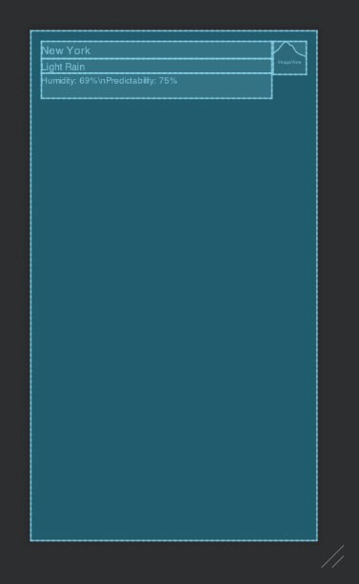
Figure 5.8: Main layout blueprint preview

- Add models for the OpenWeatherMap weather API response. Given that we only have to define fields for data that is relevant to us, your models could look like this:
package com.example.newyorkweather.model

data class OpenWeatherMapResponseData(
@field:Json(name = "name")
val locationName: String,
val weather: List<OpenWeatherMapWeatherData>
)

data class OpenWeatherMapWeatherData(
@field:Json(name = "main")
val status: String,
val description: String, val icon: String
)
Remember that you can use the @field:Json annotation to map API names to names that are meaningful to your app. In this example, name is mapped to locationName and main is mapped to status.
- Add a service for the OpenWeatherMap weather API endpoint at https:// api.openweathermap.org/data/2.5/weather, taking into account the location (q) and token (appid) query parameters, like so:
package com.example.newyorkweather.api

import retrofit2.Call import retrofit2.http.GET import retrofit2.http.Query

interface OpenWeatherMapService { @GET("weather")
fun getWeather(
@Query("q") location: String, @Query("appid") token: String
) : Call<OpenWeatherMapResponseData>
}

- Create a Retrofit instance with a Moshi converter and the
OpenWeatherMap service:
class MainActivity : AppCompatActivity() {
private val retrofit by lazy { Retrofit.Builder()
.baseUrl("https://api.openweathermap.org/data/2.5/")
.addConverterFactory(MoshiConverterFactory.create())
.build()
}
private val weatherApiService by lazy { retrofit.create(OpenWeatherMapService::class.java)
}

...
}
- Make a call to the API service in the onResume function of MainActivity with
appid set to your token and the city set to New York:
override fun onCreate(savedInstanceState: Bundle?) { super.onCreate(savedInstanceState) setContentView(R.layout.activity_main)

weatherApiService
.getWeather("New York", "[YOUR TOKEN]")
.enqueue(object : Callback<OpenWeatherMapResponseData> {
override fun onFailure(call:
Call<OpenWeatherMapResponseData>, t: Throwable) {
}

override fun onResponse(
call: Call<OpenWeatherMapResponseData>, response: Response<OpenWeatherMapResponseData>
) {
}
})
}
While we hardcode the app token in this example, remember to never include
your private tokens and other private information in code.

- Handle the happy path: process the response, get the first result, and construct a weather URL for it based on the API response:
package com.example.newyorkweather
...
class MainActivity : AppCompatActivity() {
private val titleView: TextView
by lazy { findViewById(R.id.main_title) }
private val statusView: TextView
by lazy { findViewById(R.id.main_status) }
private val descriptionView: TextView
by lazy { findViewById(R.id.main_description) }
private val weatherIconView: ImageView
by lazy { findViewById(R.id.main_weather_icon) }
...
override fun onCreate(savedInstanceState: Bundle?) {
...
weatherApiService
.getWeather("New York", "[YOUR TOKEN]")
.enqueue(object : Callback<OpenWeatherMapResponseData> {
...
override fun onResponse(
call: Call<OpenWeatherMapResponseData>, response: Response<OpenWeatherMapResponseData>
) = handleResponse(response)
})
}

private fun handleResponse(response: Response<OpenWeatherMapResponseData>) =
if (response.isSuccessful) { response.body()?.let { validResponse ->
handleValidResponse(validResponse)
} ?: Unit
} else {
}

private fun handleValidResponse(response:
OpenWeatherMapResponseData) {
titleView.text = response.locationName
response.weather.firstOrNull()?.let { weather -> statusView.text = weather.status descriptionView.text = weather.description Glide.with(this)
.load("https://openweathermap.org/img/wn/
${weather.icon}@2x.png")
.centerInside()
.into(weatherIconView)
}
}
}
There are a few points to note about the preceding code. Firstly, we looked up the views of the layout and kept references to them. We used lazy to do so on demand rather than immediately. We extracted the handling of the response to a private function to improve the code readability. Doing so also reduces nesting in our code, which in turn reduces the cognitive effort required to understand it. We then implemented a function to handle just the happy path scenario—when the response is successful and contains valid data. After grabbing the location name, we get the first weather response, if any, and grab the status, description, and icon from it. We took a shortcut by using Glide directly for the sake of keeping this example short. However, you should follow the instructions in this chapter and extract this into a GlideImageLoader class implementing an ImageLoader interface. Finally, we obtain the icon's URL template from https:// openweathermap.org/weather-conditions. We replaced the provided HTTP URL with an HTTPS one for security reasons. Now, when you run the app, you should get an output similar to the following:

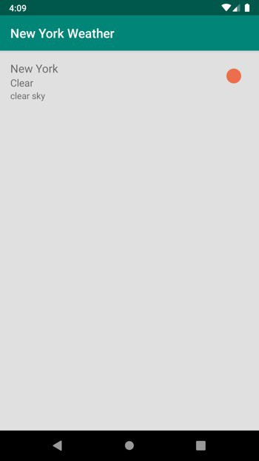

Figure 5.9: Showing the weather and a relevant icon
- Handle the different possible failure outcomes of making the request:
class MainActivity : AppCompatActivity() {
...
override fun onCreate(savedInstanceState: Bundle?) {
...
weatherApiService

.getWeather("New York", "[YOUR TOKEN]")
.enqueue(object : Callback<OpenWeatherMapResponseData> { override fun onFailure(call:
Call<OpenWeatherMapResponseData>, t: Throwable) {
showError("Response failed: ${t.message}")
}
})
}

private fun handleResponse(response: Response<OpenWeatherMapResponseData>) =
if (response.isSuccessful) {
...
} else {
showError("Response was unsuccessful:
${response.errorBody()}")
}

private fun showError(message: String) = Toast.makeText(this, message, Toast.LENGTH_SHORT)
.show()
}
Remember to replace [YOUR TOKEN] with the token obtained earlier from
https://home.openweathermap.org/users/sign_up.
We can handle the two possible error scenarios—when the call fails altogether due to an exception and when it fails due to an API failure—optionally with a failure message. Both scenarios result in a toast being presented to the user with some information about what went wrong.

Chapter 6: RecyclerView

Activity 6.01: Managing a List of Items

Solution:
- Create a new app by navigating to File | New | New Project, selecting Empty Activity, clicking Next, and filling in the app name, and then save the location and click Finish.
- Update the activity_main.xml layout file by removing TextView and adding RecyclerView, two EditText fields, and two buttons. Your layout should look like this:
<?xml version="1.0" encoding="utf-8"?>
...

<androidx.recyclerview.widget.RecyclerView android:id="@+id/main_recipes_list" android:layout_width="match_parent" android:layout_height="0dp" app:layout_constraintBottom_toTopOf="@id/main_recipe_title" app:layout_constraintTop_toTopOf="parent" />

<EditText
android:hint="Recipe Title" android:id="@+id/main_recipe_title" android:layout_width="match_parent" android:layout_height="wrap_content" app:layout_constraintBottom_toTopOf
="@+id/main_recipe_description" />

...

<Button
android:id="@+id/main_add_savory_button" android:layout_width="0dp" android:layout_height="wrap_content" android:text="Add Savory"

The complete code for this step can be found at http://packt.live/3pgdeZK.
app:layout_constraintBottom_toBottomOf="parent" app:layout_constraintEnd_toStartOf
="@id/main_add_sweet_button" app:layout_constraintStart_toStartOf="parent" />

...

</androidx.constraintlayout.widget.ConstraintLayout>
- Define your model. One approach would be to define a common interface, then implement it for both the title and the recipe models. Create an empty Kotlin file named ListItem.kt and place it under the com.example.recipebook. model package. Add the following code to it:
interface ListItem

data class TitleUiModel( val title: String
) : ListItem

data class RecipeUiModel( val title: String,
val description: String,
val flavor: Flavor
) : ListItem

enum class Flavor { SAVORY,
SWEET
}
- Add layouts for the flavor title and the recipe title. The flavor title, named item_ title.xml, could look like this:
<?xml version="1.0" encoding="utf-8"?>
<FrameLayout xmlns:android="http://schemas.android.com/apk/res/android"
xmlns:tools="http://schemas.android.com/tools" android:layout_width="match_parent" android:layout_height="wrap_content" android:padding="8dp">

<TextView
android:id="@+id/title_label" android:layout_width="match_parent" android:layout_height="wrap_content" android:textSize="16sp" android:textStyle="bold" tools:text="Sweet" />

</FrameLayout>
The recipe title, named item_recipe.xml, could look like this:
<?xml version="1.0" encoding="utf-8"?>
<FrameLayout xmlns:android="http://schemas.android.com/apk/res/android"
xmlns:tools="http://schemas.android.com/tools" android:layout_width="match_parent" android:layout_height="wrap_content" android:padding="8dp">

<TextView
android:id="@+id/recipe_title" android:layout_width="match_parent" android:layout_height="wrap_content" android:layout_marginStart="16dp" android:layout_marginLeft="16dp" android:textSize="12sp" tools:text="Tex-Mex Eggs" />

</FrameLayout>
- Create a file named ViewHolder.kt. Add an abstract view holder as a superclass for the title and recipe view holders, and extend it to implement the title and recipe view holders:
class TitleViewHolder(containerView: View) : BaseViewHolder(containerView) {
private val titleView: TextView
by lazy { containerView.findViewById(R.id.title_label) }

override fun bindData(listItem: ListItem) { titleView.text = (listItem as TitleUiModel).title
}

}

class RecipeViewHolder( containerView: View
) : BaseViewHolder(containerView) { private val titleView: TextView
by lazy { containerView.findViewById(R.id.recipe_title) }

override fun bindData(listItem: ListItem) { titleView.text = (listItem as RecipeUiModel).title
}
}
- Add your adapter by implementing RecyclerView.Adapter:
private const val VIEW_TYPE_TITLE = 0 private const val VIEW_TYPE_RECIPE = 1

class RecipesAdapter(
private val layoutInflater: LayoutInflater) :
RecyclerView.Adapter<BaseViewHolder>() { private val savoryTitle = TitleUiModel("Savory")
private val sweetTitle = TitleUiModel("Sweet")
private val listItems = mutableListOf<ListItem>(savoryTitle, sweetTitle)

override fun getItemViewType(position: Int) = when (listItems[position]) {
is TitleUiModel -> VIEW_TYPE_TITLE is RecipeUiModel -> VIEW_TYPE_RECIPE
else -> throw IllegalStateException("Unexpected data type at
$position")
}

override fun onCreateViewHolder(parent: ViewGroup, viewType: Int): BaseViewHolder =
when (viewType) {
VIEW_TYPE_TITLE -> TitleViewHolder(
layoutInflater.inflate(R.layout.item_title,

parent, false)
)
VIEW_TYPE_RECIPE -> RecipeViewHolder(
layoutInflater.inflate(R.layout.item_recipe, parent,
false)
)
else -> throw IllegalStateException("Unexpected view type
$viewType")
}
override fun getItemCount() = listItems.size override fun onBindViewHolder(holder: BaseViewHolder,
position: Int) = holder.bindData(listItems[position])
}
- Update RecipeViewHolder to handle clicks:
class RecipeViewHolder( containerView: View,
private val onClickListener: OnClickListener
) : BaseViewHolder(containerView) { private val titleView: TextView
by lazy { containerView.findViewById(R.id.recipe_title) }

override fun bindData(listItem: ListItem) { titleView.text = (listItem as RecipeUiModel).title titleView.setOnClickListener {
onClickListener.onClick(listItem)
}
}

interface OnClickListener {
fun onClick(recipe: RecipeUiModel)
}
}

- Add an OnClickListener interface to the adapter and include it in
the constructor:
class RecipesAdapter(
private val layoutInflater: LayoutInflater, private val onClickListener: OnClickListener
) : RecyclerView.Adapter<BaseViewHolder>() {
...
interface OnClickListener {
fun onItemClick(recipe: RecipeUiModel)
}
}
Revise the RecipeViewHolder construction:
RecipeViewHolder(
layoutInflater.inflate(R.layout.item_recipe, parent, false),
object : RecipeViewHolder.OnClickListener { override fun onClick(recipe: RecipeUiModel) {
onClickListener.onItemClick(recipe)
}
}
)
- Update the adapter to support adding new recipes. Make sure savory recipes appear under the Savory title, and sweet under the Sweet title:
private val savoryTitle = TitleUiModel("Savory") private val sweetTitle = TitleUiModel("Sweet")
private val listItems = mutableListOf<ListItem>(savoryTitle, sweetTitle)

fun addRecipe(recipe: RecipeUiModel) {
val insertionIndex = listItems.indexOf(when (recipe.flavor) {
Flavor.SAVORY -> savoryTitle Flavor.SWEET -> sweetTitle
}) + 1
listItems.add(insertionIndex, recipe) notifyItemInserted(insertionIndex)
}

- Also, update the adapter by adding swipe behavior:
class RecipesAdapter(...) : RecyclerView.Adapter<BaseViewHolder>() {
val swipeToDeleteCallback = SwipeToDeleteCallback()
...
inner class SwipeToDeleteCallback :
ItemTouchHelper.SimpleCallback(0, ItemTouchHelper.LEFT or ItemTouchHelper.RIGHT) {
override fun onMove( recyclerView: RecyclerView,
viewHolder: RecyclerView.ViewHolder, target: RecyclerView.ViewHolder
): Boolean = false

override fun getMovementFlags( recyclerView: RecyclerView, viewHolder: RecyclerView.ViewHolder
) = if (viewHolder is RecipeViewHolder) {
makeMovementFlags( ItemTouchHelper.ACTION_STATE_IDLE, ItemTouchHelper.LEFT or ItemTouchHelper.RIGHT
) or makeMovementFlags( ItemTouchHelper.ACTION_STATE_SWIPE, ItemTouchHelper.LEFT or ItemTouchHelper.RIGHT
)
} else { 0
}

override fun onSwiped(viewHolder: RecyclerView.ViewHolder,
direction: Int) {
val position = viewHolder.adapterPosition listItems.removeAt(position) notifyItemRemoved(position)
}
}
}

- Lastly, update your activity to handle the recipe-adding buttons, adapter clicks, and swipes:
class MainActivity : AppCompatActivity() { private val recipesList: RecyclerView
by lazy { findViewById(R.id.main_recipes_list) }
private val addSavoryButton: View
by lazy { findViewById(R.id.main_add_savory_button) }
private val addSweetButton: View
by lazy { findViewById(R.id.main_add_sweet_button) }
private val titleView: TextView
by lazy { findViewById(R.id.main_recipe_title) }
private val descriptionView: TextView
by lazy { findViewById(R.id.main_recipe_description) }

private val recipesAdapter by lazy { RecipesAdapter(
layoutInflater,
object : RecipesAdapter.OnClickListener {
override fun onItemClick(recipe: RecipeUiModel) { val builder = AlertDialog
.Builder(this@MainActivity) builder.setMessage(recipe.description)
.setPositiveButton("OK", null)
.create()
.show()
}
}
)
}

override fun onCreate(savedInstanceState: Bundle?) { super.onCreate(savedInstanceState) setContentView(R.layout.activity_main)

recipesList.apply {
adapter = recipesAdapter layoutManager = LinearLayoutManager
(this@MainActivity, VERTICAL, false)

val itemTouchHelper = ItemTouchHelper(recipesAdapter.swipeToDeleteCallback)
itemTouchHelper.attachToRecyclerView(this)
}

addSavoryButton.setOnClickListener { addRecipeAndClearForm(Flavor.SAVORY)
}

addSweetButton.setOnClickListener { addRecipeAndClearForm(Flavor.SWEET)
}
}

private fun addRecipeAndClearForm(flavor: Flavor) {
val title = titleView.text.toString().trim()
val description = descriptionView.text.toString().trim() if (title.isEmpty() || description.isEmpty()) return

recipesAdapter.addRecipe(
RecipeUiModel(title, description, flavor)
)
titleView.text = "" descriptionView.text = ""
}
}
Note how we also added validation to make sure users can't add empty recipes. This can be handled in different ways:
- You could disable the button until a valid date is provided. This probably
provides a preferable user experience, but requires more code.
- You could prevent adding invalid items. This is the shortest solution, which is why we opted for it here. However, it doesn't provide a great user experience because the user has to guess why the button doesn't work.

- You could present the user with an error message via a dialog for a view. This is somewhat better than the option we opted for and is still easier to implement than disabling the button:
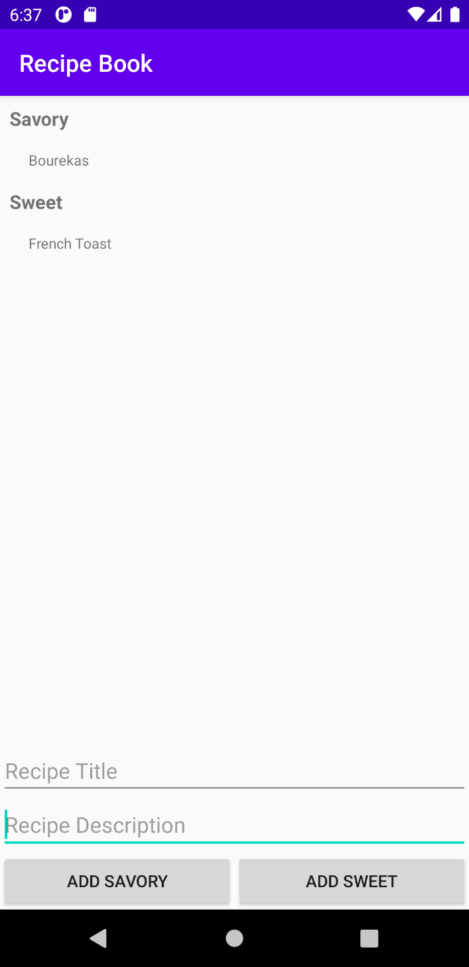
Figure 6.19: The Recipe Book app with some recipes

Chapter 7: Android Permissions and Google Maps

Activity 7.01: Creating an App to Find the Location of a Parked Car

Solution:
- Create a Google Maps Activity app named Find My Car.
- Obtain an API key for the app by following the instructions in the link provided in your google_maps_api.xml file located under app/res/values. Update your google_maps_api.xml file by replacing YOUR_KEY_HERE with the key you obtained in the following string:
<string name="google_maps_key" templateMergeStrategy="preserve" translatable="false">YOUR_KEY_HERE</string>
- Update its main layout to show a button at the bottom with an I'm parked here label:
<androidx.constraintlayout.widget.ConstraintLayout xmlns:android="http://schemas.android.com/apk/res/android"
xmlns:map="http://schemas.android.com/apk/res-auto" xmlns:tools="http://schemas.android.com/tools" android:layout_width="match_parent" android:layout_height="match_parent">

<fragment
android:id="@+id/map" android:name="com.google.android.gms.maps.SupportMapFragment" android:layout_width="match_parent" android:layout_height="0dp" map:layout_constraintBottom_toTopOf=
"@+id/maps_mark_location_button" map:layout_constraintTop_toTopOf="parent" tools:context=".MapsActivity" />

<Button
android:id="@+id/maps_mark_location_button" android:layout_width="match_parent" android:layout_height="wrap_content" android:text="I'm parked here" map:layout_constraintBottom_toBottomOf="parent" />

</androidx.constraintlayout.widget.ConstraintLayout>

The output will be as follows:
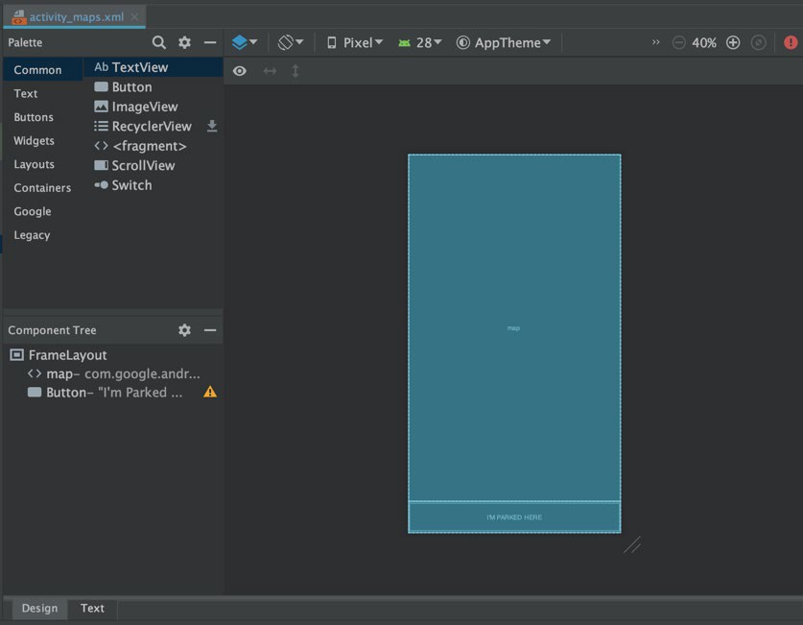
Figure 7.16: The main layout
- Include the Google Play location service in your app's build.gradle file:
dependencies {
implementation "com.google.android.gms:play-services-
location:17.1.0"
...
}
- Request the user's permission to access their location. Present the rationale if the SDK tells your app it is required:
private const val PERMISSION_CODE_REQUEST_LOCATION = 1

class MapsActivity : AppCompatActivity(), OnMapReadyCallback {
...
override fun onResume() {
super.onResume()

val hasLocationPermissions = getHasLocationPermission()
}

private fun getHasLocationPermission() = if ( ContextCompat.checkSelfPermission(
this, Manifest.permission.ACCESS_FINE_LOCATION
) == PackageManager.PERMISSION_GRANTED
) {
true

} else {

if (ActivityCompat.shouldShowRequestPermissionRationale( this, Manifest.permission.ACCESS_FINE_LOCATION

)
) {
showPermissionRationale { requestLocationPermission() }
} else {
requestLocationPermission()
}
false
}

private fun showPermissionRationale(positiveAction: () -> Unit) {
AlertDialog.Builder(this)
.setTitle("Location permission")
.setMessage("We need your permission to find your
current location")
.setPositiveButton( "OK"
) { _, _ -> positiveAction() }
.create()
.show()
}

private fun requestLocationPermission() {
ActivityCompat.requestPermissions( this,
arrayOf(Manifest.permission.ACCESS_FINE_LOCATION), PERMISSION_CODE_REQUEST_LOCATION

)
}
...
}
- Obtain the user's location and place a pin on the map at that location:
class MapsActivity : AppCompatActivity(), OnMapReadyCallback {
private val fusedLocationProviderClient by lazy {
LocationServices.getFusedLocationProviderClient(this)
}

...

override fun onResume() {
...
if (hasLocationPermissions) {
getLastLocation()
}
}

...

@SuppressLint("MissingPermission")
private fun getLastLocation() {
fusedLocationProviderClient.lastLocation
.addOnSuccessListener { location: Location? -> location?.let {
val userLocation = LatLng(location.latitude, location.longitude)
updateMapLocation(userLocation) addMarkerAtLocation(userLocation, "You")
}
}
}

private fun updateMapLocation(location: LatLng) {
mMap.moveCamera(CameraUpdateFactory
.newLatLngZoom(location, 7f))
}

private fun addMarkerAtLocation(location: LatLng, title: String)

{
mMap.addMarker(MarkerOptions().title(title)
.position(location))
}

override fun onRequestPermissionsResult( requestCode: Int,
permissions: Array<out String>, grantResults: IntArray
) {
super.onRequestPermissionsResult(requestCode, permissions, grantResults)

when (requestCode) {
PERMISSION_CODE_REQUEST_LOCATION -> getLastLocation()
}
}
}
- Add a car icon to your project from the Android Studio Clip Art library:
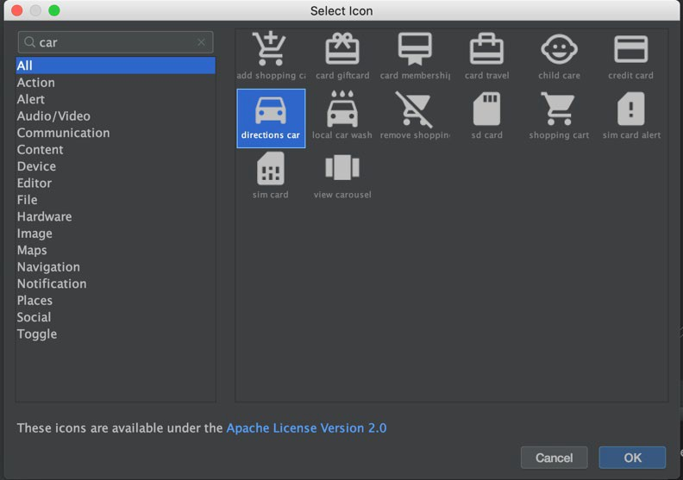
Figure 7.17: Choosing the car icon

- Add a function to load vector drawable assets to your MapsActivity class:
private fun getBitmapDescriptorFromVector(@DrawableRes vectorDrawableResourceId: Int): BitmapDescriptor? {
val bitmap =
ContextCompat.getDrawable(this, vectorDrawableResourceId)?.let { vectorDrawable ->
vectorDrawable
.setBounds(0, 0, vectorDrawable.intrinsicWidth, vectorDrawable.intrinsicHeight)

val drawableWithTint = DrawableCompat
.wrap(vectorDrawable) DrawableCompat.setTint(drawableWithTint, Color.RED)

val bitmap = Bitmap.createBitmap( vectorDrawable.intrinsicWidth, vectorDrawable.intrinsicHeight, Bitmap.Config.ARGB_8888
)
val canvas = Canvas(bitmap) drawableWithTint.draw(canvas) bitmap
}
return BitmapDescriptorFactory.fromBitmap(bitmap).also { bitmap?.recycle()
}
}
- At the top of the MapsActivity class, define two markers, one for the user and one for their car:
private lateinit var mMap: GoogleMap

private var userMarker: Marker? = null private var carMarker: Marker? = null
- Update your getLastLocation function to take a lambda to execute once a
location is obtained:
@SuppressLint("MissingPermission") private fun getLastLocation(onLocation:
(location: Location) -> Unit) {

fusedLocationProviderClient.lastLocation
.addOnSuccessListener { location: Location? -> location?.let { onLocation(it) }
}
}
- Update your existing calls in onRequestPermissionsResult and
onResume to pass in a lambda function:
override fun onRequestPermissionsResult( requestCode: Int,
permissions: Array<out String>, grantResults: IntArray
) {
super.onRequestPermissionsResult(requestCode, permissions, grantResults)

when (requestCode) { PERMISSION_CODE_REQUEST_LOCATION ->
getLastLocation { location ->
val userLocation = LatLng(location.latitude, location.longitude)
updateMapLocation(userLocation)
userMarker = addMarkerAtLocation(userLocation, "You")
}
}
}

override fun onResume() {
if (hasLocationPermissions) { getLastLocation { location ->
val userLocation = LatLng(location.latitude, location.longitude)
updateMapLocation(userLocation)
userMarker = addMarkerAtLocation(userLocation, "You")
}
}
}
- Still in MapsActivity, introduce a function to add a marker to the map at a given location:
private fun addMarkerAtLocation( location: LatLng,

title: String,
markerIcon: BitmapDescriptor? = null
) = mMap.addMarker( MarkerOptions()
.title(title)
.position(location)
.apply {
markerIcon?.let { icon(markerIcon) }
}
)
- Now, add a function to mark the location of the car:
private fun markParkedCar() { getLastLocation { location ->
val userLocation = LatLng(location.latitude, location.longitude)
userMarker?.remove() carMarker?.remove() updateMapLocation(userLocation) carMarker = addMarkerAtLocation(
userLocation, "Your Car",
getBitmapDescriptorFromVector
(R.drawable.ic_baseline_directions_car_24)
)
userMarker = addMarkerAtLocation(userLocation, "You") saveLocation(userLocation)
}
}
- To receive user clicks on the I'm parked here button, you first need to keep a reference to the button. Do so by adding the field below to your MapsActivity class:
class MapsActivity : AppCompatActivity(), OnMapReadyCallback {
private val markLocationButton: View by lazy { findViewById(R.id.maps_mark_location_button)
}

- Lastly, when the user clicks the I'm parked here button, add or move the car icon to the user's current location:
class MapsActivity : AppCompatActivity(), OnMapReadyCallback {

override fun onCreate(savedInstanceState: Bundle?) {
...
markLocationButton.setOnClickListener { if (getHasLocationPermission()) {
markParkedCar()
}
}
}
}
- Store the selected location in SharedPreferences. This function, placed in your activity, will help:
private fun saveLocation(latLng: LatLng) = getPreferences(MODE_PRIVATE)?.edit()?.apply {
putString("latitude", latLng.latitude.toString()) putString("longitude", latLng.longitude.toString()) apply()
}
- Upon resuming the activity, restore any saved location and place the car icon at that location. You can use this function:
private fun restoreLocation() = getPreferences(Context.MODE_PRIVATE)?.let { sharedPreferences ->
val latitude = sharedPreferences.getString("latitude", null)
?.toDoubleOrNull()?: return null val longitude =
sharedPreferences.getString("longitude", null)
?.toDoubleOrNull()?: return null LatLng(latitude, longitude)
}

- Call restoreLocation from onMapReady(GoogleMap) to make sure you
have a map to add a marker to:
override fun onMapReady(googleMap: GoogleMap) {
...

restoreLocation()?.let { userLocation ->
carMarker = addMarkerAtLocation( userLocation,
"Your Car", getBitmapDescriptorFromVector
(R.drawable.ic_baseline_directions_car_24)
)
userMarker = addMarkerAtLocation(userLocation, "You")
}
}

Chapter 8: Services, WorkManager, and Notifications

Activity 8.01: Reminder to Drink Water

Solution:
  - Create an empty Activity project. Name your app My Water Tracker, and
set its package name to com.example.mywatterttracker.
  - Add the FOREGROUND_SERVICE permission to your AndroidManifest.xml
file:
<manifest ...>

<uses-permission android:name="android.permission
.FOREGROUND_SERVICE"/>

<application ...>
  - Create a new Service called WaterTrackingService:
class WaterTrackingService : Service() {
override fun onBind(intent: Intent?): IBinder? = null
}
  - Add a private mutable (var) fluidBalanceMilliliters field to your class. Set its initial value to 0f (the f tells Kotlin this is a float value). This field will store the current user's fluid balance. Also, add late initialization fields for NotificationCompat.Builder and serviceHandler, to be used later to construct the notification and to execute in the background, respectively:
class WaterTrackingService : Service() { private var fluidBalanceMilliliters = 0f private lateinit var notificationBuilder:
NotificationCompat.Builder
private lateinit var serviceHandler: Handler

override fun onBind(intent: Intent?): IBinder? = null
}

  - Add a companion object to your WaterTrackingService class with two constants—one for the notification ID and the other for the key used to read the extra intake intent data:
companion object {
const val EXTRA_INTAKE_AMOUNT_MILLILITERS = "intake" private const val NOTIFICATION_ID = 0x3A7A
}
  - Add the functions required to set up the notification:
private fun getPendingIntent() = PendingIntent.getActivity(this, 0, Intent(this,
MainActivity::class.java), 0)

@RequiresApi(Build.VERSION_CODES.O)
private fun createNotificationChannel(): String {
val channelId = "FluidBalanceTracking" val channelName = "Fluid Balance Tracking" val channel =
NotificationChannel(channelId, channelName, NotificationManager.IMPORTANCE_DEFAULT)
val service = getSystemService(Context.NOTIFICATION_SERVICE) as
NotificationManager service.createNotificationChannel(channel)
return channelId
}

private fun getNotificationBuilder(pendingIntent: PendingIntent,
channelId: String) =
NotificationCompat.Builder(this, channelId)
.setContentTitle("Tracking your fluid balance")
.setContentText("Tracking")
.setSmallIcon(R.drawable.ic_launcher_foreground)
.setContentIntent(pendingIntent)
.setTicker("Fluid balance tracking started")

  - Now add a function to start the foreground service:
private fun startForegroundService(): NotificationCompat.Builder {
val pendingIntent = getPendingIntent()

val channelId = if (Build.VERSION.SDK_INT >= Build.VERSION_CODES.O) {
createNotificationChannel()
} else {
""
}

val notificationBuilder = getNotificationBuilder(pendingIntent,
channelId)
startForeground(NOTIFICATION_ID, notificationBuilder.build()) return notificationBuilder
}
  - Add a function to update the water balance. Because we operate on two different threads, don't forget to synchronize the call:
private fun addToFluidBalance(amountMilliliters: Float) { synchronized(this) {
fluidBalanceMilliliters += amountMilliliters
}
}
  - Create a function to update the fluid balance every 5 seconds:
private fun updateFluidBalance() { serviceHandler.postDelayed({
updateFluidBalance() addToFluidBalance(-0.144f) notificationBuilder.setContentText(
"Your fluid balance: %.2f".format(fluidBalanceMilliliters)
)
startForeground(NOTIFICATION_ID, notificationBuilder.build())
}, 5000L)
}

A few things to note here. We made a very inaccurate assumption that, since a human loses 2500ml in a day, they lose roughly 104.16ml per hour, 1.736ml per minute, and so 0.029ml per second, or 0.144ml every 5 seconds (the value we used). We also ignored the fact that over time, we would probably get even less accurate values, as each call would not be precisely 5 seconds apart from the previous one (handlers are inaccurate that way). We could have used
a field to store the last time the method was called and used that to get a more accurate result, but that would have complicated our example. We should have also used a string resource, and not a hardcoded string. Lastly, we should have used constants or variables instead of the magic numbers (-0.144f, 5000L). Again, for the sake of simplicity, we didn't. But you really should.
  - Next, make sure that when the service is created, the service is started in
the foreground, a reference is stored to NotificationCompat.Builder, serviceHandler is instantiated, and you start updating the fluid balance:
override fun onCreate() { super.onCreate()

notificationBuilder = startForegroundService()
val handlerThread = HandlerThread("RouteTracking").apply
{ start() }
serviceHandler = Handler(handlerThread.looper) updateFluidBalance()
}
  - Now, handle the addition of fluids (such as drinking a glass of water) by overriding onStartCommand(Intent?, Int, Int) and reading the provided Intent, if available:
override fun onStartCommand(intent: Intent?, flags: Int, startId:
Int): Int {
val returnValue = super.onStartCommand(intent, flags, startId)

val intakeAmountMilliliters = intent?.getFloatExtra(EXTRA_INTAKE_AMOUNT_MILLILITERS, 0f)
intakeAmountMilliliters?.let { addToFluidBalance(it)
}

return returnValue
}

  - Lastly, clean up when the service is destroyed, stopping the handler loop:
override fun onDestroy() { serviceHandler.removeCallbacksAndMessages(null)
}
  - To launch the service, you must first register it in your app's
AndroidManifest.xml file:
<application ...>

<service
android:name=".WaterTrackingService" android:enabled="true" android:exported="true"/>

<activity android:name=".MainActivity">
  - Then, in your MainActivity class, you can add a function to launch the service, with an optional intake value:
private fun launchTrackingService(intakeAmount: Float = 0f) { val serviceIntent =
Intent(this, WaterTrackingService::class.java).apply { putExtra(EXTRA_INTAKE_AMOUNT_MILLILITERS, intakeAmount)
}
ContextCompat.startForegroundService(this, serviceIntent)
}
  - After that, call it from the onCreate(Bundle?) function, omitting the
intakeAmount value:
override fun onCreate(savedInstanceState: Bundle?) { super.onCreate(savedInstanceState) setContentView(R.layout.activity_main)

launchTrackingService()
}

  - To allow users to let the app know that they drank a glass of water, replace the Hello World! TextView in activity_main.xml with a button, updating its text and assigning it an ID like so:
<?xml version="1.0" encoding="utf-8"?>
<androidx.constraintlayout.widget.ConstraintLayout ...>

<Button
android:id="@+id/main_water_button" android:layout_width="wrap_content" android:layout_height="wrap_content" android:text="Drank a Glass of Water" app:layout_constraintBottom_toBottomOf="parent" app:layout_constraintLeft_toLeftOf="parent" app:layout_constraintRight_toRightOf="parent" app:layout_constraintTop_toTopOf="parent" />

</androidx.constraintlayout.widget.ConstraintLayout>
Remember, you should not really hardcode text values. Instead, use strings. xml.
  - Hold a reference to your newly added view in your MainActivity class:
class MainActivity : AppCompatActivity() {
private val waterButton: View by lazy { findViewById(R.id.main_water_button)
}
...
}

  - Now, in your MainActivity class, attach a click listener to your button:
override fun onCreate(savedInstanceState: Bundle?) { super.onCreate(savedInstanceState) setContentView(R.layout.activity_main)

launchTrackingService()

waterButton.setOnClickListener { launchTrackingService(250f)
}
}
Remember to use constants rather than magic numbers (250f could be stored as GLASS_WATER_AMOUNT_MILLILITER, for example). This makes the code easier to understand and easier to maintain.
  - Run your app. As soon as the app starts, you should see a notification added to your status bar. It's a sticky notification, so it will keep running even if you stopped your MainActivity. It will be removed if, for example, you force stopped the app, uninstalled it, or restarted your device. The notification will
count down from 5 and refresh every 5 seconds. If you click the button, the next refresh will reflect the added fluids.

Chapter 9: Unit Tests and Integration Tests with JUnit, Mockito, and Espresso

Activity 9.01: Developing with TDD

Solution:
- Let's start by adding the necessary files in Gradle:
implementation "androidx.recyclerview:recyclerview:1.1.0" implementation 'androidx.test.espresso:espresso-core:3.3.0' testImplementation 'junit:junit:4.13.1'
testImplementation 'org.mockito:mockito-core:3.6.0' testImplementation 'com.nhaarman.mockitokotlin2
:mockito-kotlin:2.2.0'
testImplementation 'org.robolectric:robolectric:4.4' testImplementation 'androidx.test.ext:junit:1.1.2' testImplementation 'androidx.test.espresso:espresso-intents
:3.3.0'
testImplementation 'com.android.support.test
.espresso:espresso-contrib:3.3.0' androidTestImplementation 'androidx.test.ext:junit:1.1.2' androidTestImplementation 'androidx.test
.espresso:espresso-core:3.3.0' androidTestImplementation 'androidx.test:rules:1.3.0' androidTestImplementation 'com.android.support.test
.espresso:espresso-contrib:3.3.0'
- We can put these strings in the res/strings.xml file, which will be used across the application:
<string name="submit">Submit</string>
<string name="item_x">Item %d</string>
<string name="you_clicked_y">You clicked %s</string>
- Let's create a layout called activity_1.xml:
<LinearLayout xmlns:android="http://schemas.android.com/apk/res/android"
android:layout_width="match_parent" android:layout_height="match_parent" android:orientation="vertical">

<EditText
android:id="@+id/activity_1_edit_text" android:layout_width="match_parent" android:layout_height="wrap_content" android:inputType="number" />

<Button
android:id="@+id/activity_1_button" android:layout_width="wrap_content" android:layout_height="wrap_content" android:layout_gravity="center_horizontal" android:text="@string/submit" />
</LinearLayout>
- Next, let's create the Activity1 class:

class Activity1 : AppCompatActivity() {

override fun onCreate(savedInstanceState: Bundle?) { super.onCreate(savedInstanceState) setContentView(R.layout.activity_1)
}
}
- Repeat the process for the activity_2.xml layout:
<LinearLayout xmlns:android="http://schemas.android.com/apk/res/android"
android:layout_width="match_parent" android:layout_height="match_parent" android:orientation="vertical">

<androidx.recyclerview.widget.RecyclerView android:id="@+id/activity_2_recycler_view" android:layout_width="match_parent" android:layout_height="match_parent" />

</LinearLayout>
- The Activity2 class will be as follows:
class Activity2 : AppCompatActivity() {

override fun onCreate(savedInstanceState: Bundle?) { super.onCreate(savedInstanceState) setContentView(R.layout.activity_2)
}
}
- Repeat the same process for the activity_3.xml layout:
<LinearLayout xmlns:android="http://schemas.android.com/apk/res/android"
android:layout_width="match_parent" android:layout_height="match_parent" android:orientation="vertical">

<TextView
android:id="@+id/activity_3_text_view" android:layout_width="wrap_content" android:layout_height="wrap_content" android:layout_gravity="center" />

</LinearLayout>
- The Activity3 class will be as follows:
class Activity3 : AppCompatActivity() {

override fun onCreate(savedInstanceState: Bundle?) { super.onCreate(savedInstanceState) setContentView(R.layout.activity_3)
}
}
- Add all three activities to AndroidManifest.xml:
<application
android:allowBackup="true" android:icon="@mipmap/ic_launcher" android:label="@string/app_name" android:roundIcon="@mipmap/ic_launcher_round" android:supportsRtl="true" android:theme="@style/AppTheme">
<activity android:name=".Activity1">
<intent-filter>
<action android:name="android.intent.action.MAIN" />

<category android:name= "android.intent.category.LAUNCHER" />
</intent-filter>
</activity>
<activity android:name=".Activity2" />
<activity android:name=".Activity3" />
</application>
- Let's start creating the robots in the androidTest directory. For
Activity1Robot, we have the following:

class Activity1Robot {

fun insertText(text: String): Activity1Robot { onView(withId(R.id.activity_1_edit_text))
.perform(replaceText(text)) return this
}

fun submit(): Activity1Robot { onView(withId(R.id.activity_1_button)).perform(click()) return this
}
}
- Because Activity2 has a list of items that require special handling, we will next define Activity3Robot because it has a similar complexity to Activity1:
class Activity3Robot {

private val myApplication = ApplicationProvider.getApplicationContext<Application>()

fun verifyText(expectedItemText: String): Activity3Robot { onView(withId(R.id.activity_3_text_view))
.check(matches(withText(myApplication
.getString(R.string.you_clicked_y, expectedItemText)))) return this
}
}

- Now, let's look at Activity2Robot. Here, we need to assert the total number of items in RecyclerView. The support library provides no method for this, but we can write a custom implementation that will check this. We can write a class that will implement ViewAssertion and there we will assert the count of RecyclerView:
class RecyclerViewItemCountAssertion(private val expectedCount: Int)
: ViewAssertion {

override fun check(view: View, noViewFoundException: NoMatchingViewException?) {
if (view is RecyclerView) { val adapter = view.adapter
assertEquals(expectedCount, adapter!!.itemCount)
}
}
}
- We can now create a Kotlin file in the androidTest folder, which we will provide with our own view assertion to keep it consistent with the Espresso syntax. In the MyViewAssertions.kt file, we will have the following code:
fun checkRecyclerViewItems(count: Int): ViewAssertion { return RecyclerViewItemCountAssertion(count)
}
- Finally, we can create Activity2Robot:
class Activity2Robot {
private val myApplication = ApplicationProvider.getApplicationContext<Application>()

fun verifyItemNumber(expected: Int): Activity2Robot { onView(withId(R.id.activity_2_recycler_view))
.check(checkRecyclerViewItems(expected)) return this
}

fun verifyItemText(itemPosition: Int): Activity2Robot { onView(withId(R.id.activity_2_recycler_view))
.perform(scrollToPosition
<RecyclerView.ViewHolder>(itemPosition)) return this

}

fun clickOnItem(itemPosition: Int): Activity2Robot { onView(withId(R.id.activity_2_recycler_view))
.perform(scrollToPosition
<RecyclerView.ViewHolder>(itemPosition))
onView(withId(R.id.activity_2_recycler_view))
.perform(actionOnItemAtPosition<RecyclerView.ViewHolder>(itemPosition, click()))
return this
}
}
- Now, let's create our test suite, which we will name UiTest. If we run this test, we will indeed see that it will fail:
@LargeTest @RunWith(AndroidJUnit4::class) class UiTest {

@JvmField @Rule
var activityRule: ActivityTestRule<Activity1>
= ActivityTestRule(Activity1::class.java) private val myApplication
= ApplicationProvider.getApplicationContext<Application>()

@Test
fun testMyFlow() {
val numberOfItems = 5

Activity1Robot()
.insertText(numberOfItems.toString())
.submit()

val selectedPosition = 3 Activity2Robot()
.verifyItemNumber(numberOfItems)
.verifyItemText(selectedPosition)
.clickOnItem(selectedPosition)

val expectedTest = myApplication.getString(R.string.item_x, (selectedPosition + 1))

Activity3Robot()
.verifyText(expectedTest)
}

}
- Now, let's create the Application class and replace the references in the robots and UiTest with the new Application class:
class MyApplication : Application() {

override fun onCreate() { super.onCreate()
}
}
- Let's update the AndroidManifest.xml file to add the new Application
class to the application tag with the android:name attribute.
- Let's move on to the integration tests. Make sure to set up the Robolectric configurations. Before we write the tests, we will need to update Activity2 and Activity3 with the newIntent methods in order to properly assert the tests. We will also need to create the Item data class, which will be used to hold the data for Activity2:
@Parcelize
data class Item(val text: String) : Parcelable
- Activity2 will be updated as follows:
Activity2 : AppCompatActivity() {

companion object {
const val EXTRA_ITEM_COUNT = "EXTRA_ITEM_COUNT"

fun newIntent(context: Context, itemCount: Int)
= Intent(context, Activity2::class.java)
.putExtra(EXTRA_ITEM_COUNT, itemCount)
}
...
}

- Activity3 will be updated as follows:
class Activity3 : AppCompatActivity() {

companion object {
const val EXTRA_ITEM = "EXTRA_ITEM"

fun newIntent(context: Context, item: Item) = Intent(context, Activity3::class.java).putExtra(EXTRA_ITEM, item)

...
}
- Let's move on to the integration tests. For Activity1Test, we have the following code in which we insert the number 5 into a text field, click the button, and verify that Activity2 will be opened and will have as input the number 5:
@MediumTest @RunWith(AndroidJUnit4::class) class Activity1Test {

@JvmField @Rule
val rule = IntentsTestRule(Activity1::class.java)

@Test
fun 'test enter number and submit'() { onView(withId(R.id.activity_1_edit_text))
.perform(replaceText(5.toString())) onView(withId(R.id.activity_1_button)).perform(click())
intended(allOf(hasComponent(hasShortClassName(".Activity2")), hasExtra(Activity2.EXTRA_ITEM_COUNT, 5)))
}
}

- For Activity2Test, we will launch Activity2 with five items, then verify the text on the fourth item, clicking that item and verifying that Activity3 will be opened with the correct text as input:
@MediumTest @RunWith(AndroidJUnit4::class) class Activity2Test {

@JvmField @Rule
val rule = IntentsTestRule(Activity2::class.java, false, false) private val itemCount = 5

@Before
fun setUp() {
rule.launchActivity(Intent()
.putExtra(Activity2.EXTRA_ITEM_COUNT, itemCount))
}

@Test
fun 'test click opens activity 3'() { val position = 3
val itemText = rule.activity.getString(R.string.item_x, (position + 1))
onView(withText(itemText)).check(matches(isDisplayed())) onView(withId(R.id.activity_2_recycler_view))
.perform(scrollToPosition<RecyclerView
.ViewHolder>(position)) onView(withId(R.id.activity_2_recycler_view))
.perform(actionOnItemAtPosition<RecyclerView.ViewHolder>(position, click()))
intended(allOf(hasComponent(hasShortClassName(".Activity3")), hasExtra(Activity3.EXTRA_ITEM, Item(itemText))))

}
}

- For Activity3Test, we verify that Activity3 is opened with certain text as
input, and then verify that the text is displayed on the screen:
@MediumTest @RunWith(AndroidJUnit4::class) class Activity3Test {

@JvmField @Rule
val rule = IntentsTestRule(Activity3::class.java, false, false) private val item = Item("Text to display")
@Before
fun setUp() {
rule.launchActivity(Intent()
.putExtra(Activity3.EXTRA_ITEM, item))
}

@Test
fun 'test displays correct text'() { onView(withId(R.id.activity_3_text_view))
.check(matches(withText(rule.activity
.getString(R.string.you_clicked_y, item.text))))
}
}
- If we were to run all these tests, they would fail. Now, let's move on to creating our logic. We will start with StringProvider:
class StringProvider(private val context: Context) { fun provideItemString(number: Int): String = ""
fun provideYouClickedString(itemText: String) = ""
}

- Now, we will need to test this. In order to do so, we will need mockito, and we will need the Mockito configuration for Kotlin defined in the mockito-kotlin section. After this, we can create StringProviderTest, which will look like this:
@RunWith(MockitoJUnitRunner::class) class StringProviderTest {

@InjectMocks
lateinit var stringProvider: StringProvider @Mock
lateinit var context: Context

@Test
fun provideItemString() { val number = 5
val expected = "expected"
whenever(context.getString(R.string.item_x, number)).thenReturn(expected)

val result = stringProvider.provideItemString(number)

assertEquals(expected, result)
}

@Test
fun provideYouClickedString() { val itemText = "itemText" val expected = "expected"
whenever(context.getString(R.string.you_clicked_y, itemText)).thenReturn(expected)

val result = stringProvider.provideYouClickedString(itemText)

assertEquals(expected, result)
}
}

- If we run the test, it will fail. This will allow us to correct our mistake and fix the implementation. When the test passes, we will end up with a StringProvider class that will look like this:
class StringProvider(private val context: Context) {

fun provideItemString(number: Int): String
= context.getString(R.string.item_x, number)

fun provideYouClickedString(itemText: String)
= context.getString(R.string.you_clicked_y, itemText)
}
- Now, let's move to an empty ItemGenerator class, which will contain two methods, one to generate the items asynchronously, and the other to generate them synchronously. The reason for this approach is that we will need to extend this class in the integration test to get it to run fast:
open class ItemGenerator( private val timer: Timer,
private val stringProvider: StringProvider, private val initialDelay: Long,
private val countingIdlingResource: CountingIdlingResource
) {

fun generateItemsAsync(itemCount: Int, callback: (List<Item>) -> Unit) {

}

open internal fun generateItems(itemCount: Int): List<Item> = listOf()

}

- Next, there is the test for ItemGenerator. In order to generate data asynchronously with a callback, we can take advantage of Mockito's thenAnswer method. What we can do is call TimerTask every time it is scheduled on the timer. In the thenAnswer method, we can access the parameters in a method and invoke them. This is the approach we will use to handle an async call making it a sync call:
@RunWith(MockitoJUnitRunner::class) class ItemGeneratorTest {

private lateinit var itemGenerator: ItemGenerator @Mock
lateinit var timer: Timer @Mock
lateinit var stringProvider: StringProvider private val initialDelay = 5L
@Mock
lateinit var countingIdlingResource: CountingIdlingResource

@Before
fun setUp() {
itemGenerator
= ItemGenerator(timer, stringProvider, initialDelay, countingIdlingResource)
}

@Test
fun generateItemsAsync() {
val spy = spy(itemGenerator)
val callback = mock<(List<Item>) -> Unit>() val itemCount = 10
val items = listOf(Item("1"), Item("2")) doReturn(items).whenever(spy).generateItems(itemCount)
whenever(timer.schedule(any(), eq(initialDelay))).thenAnswer {
(it.arguments[0] as TimerTask).run()
}
spy.generateItemsAsync(itemCount, callback) verify(callback).invoke(items)

verify(countingIdlingResource).increment() verify(countingIdlingResource).decrement()
}

@Test
fun generateItems() { val itemCount = 10
val expected = mutableListOf<Item>() for (i in 1..itemCount) {
val itemText = "itemText$i"
whenever(stringProvider.provideItemString(i))
.thenReturn(itemText) expected.add(Item(itemText))
}
val result = itemGenerator.generateItems(itemCount) assertEquals(expected, result)
}
}
- We can then use the continuous test failure to update ItemGenerator until
we get this:
open class ItemGenerator( private val timer: Timer,
private val stringProvider: StringProvider, private val initialDelay: Long,
private val countingIdlingResource: CountingIdlingResource
) {

fun generateItemsAsync(itemCount: Int, callback: (List<Item>) -> Unit) {
countingIdlingResource.increment() timer.schedule(ItemGeneratorTask(itemCount, callback),
initialDelay)
}

internal open fun generateItems(itemCount: Int): List<Item> { val result = mutableListOf<Item>()
for (i in 1..itemCount) {

result.add(Item(stringProvider.provideItemString(i)))
}
return result
}

inner class ItemGeneratorTask( private val itemCount: Int,
private val callback: (List<Item>) -> Unit
) : TimerTask() { override fun run() {
callback.invoke(generateItems(itemCount)) countingIdlingResource.decrement()
}

}
}
- Now we are done with the unit tests. Let's move on to make the integration tests pass. We will start with Activity1Test. Here, we will need to connect the click listener to the button to open Activity2. We can update the onCreate method of Activity1 to add the following:
override fun onCreate(savedInstanceState: Bundle?) {
...
findViewById<Button>(R.id.activity_1_button)
.setOnClickListener { startActivity(
Activity2.newIntent( this,
findViewById<EditText>
(R.id.activity_1_edit_text)
.text.toString().toIntOrNull()
?: 0
)
)
}
...
}

- For Activity2, we will need to add ItemGenerator and an adapter to RecyclerView to render it. Let's start with the layout for the row in item. xml:
<LinearLayout xmlns:android="http://schemas.android.com/apk/res/android"
android:layout_width="match_parent" android:layout_height="wrap_content" android:minHeight="50dp" android:orientation="vertical">

<TextView
android:id="@+id/item_text_view" android:layout_width="match_parent" android:layout_height="match_parent" android:gravity="center" />
</LinearLayout>
- Next, let's create ItemAdapter, which will use the layout for each item:
class ItemAdapter(
private val layoutInflater: LayoutInflater,
private val onRowClickListener: (Item) -> Unit
) : RecyclerView.Adapter<ItemAdapter.ItemViewHolder>() { private val items = mutableListOf<Item>()
fun addItems(items: List<Item>) { this.items.clear() this.items.addAll(items) notifyDataSetChanged()
}

ooverride fun onCreateViewHolder(parent: ViewGroup, viewType: Int): ItemViewHolder {
return ItemViewHolder(layoutInflater.inflate
(R.layout.item, parent, false))
}

override fun onBindViewHolder(holder: ItemViewHolder, position: Int) {

holder.bind(items[position])
}

override fun getItemCount(): Int { return items.size
}

inner class ItemViewHolder(containerView: View) : RecyclerView.ViewHolder(containerView) {

private val itemTextView: TextView
= containerView.findViewById(R.id.item_text_view)

init {
containerView.setOnClickListener { val position = adapterPosition
if (position > RecyclerView.NO_POSITION) { onRowClickListener.invoke(items[position])
}
}
}

fun bind(item: Item) { itemTextView.text = item.text
}
}
}
- Now, let's update the MyApplication class to create all the classes that will
perform the logic:
open class MyApplication : Application() {

val countingIdlingResource = CountingIdlingResource("Timer resource")
val timer = Timer()
lateinit var stringProvider: StringProvider lateinit var itemGenerator: ItemGenerator

override fun onCreate() { super.onCreate()
stringProvider = StringProvider(this)

itemGenerator = createItemGenerator()
}

protected open fun createItemGenerator(): ItemGenerator = ItemGenerator(timer, stringProvider, 1000,
countingIdlingResource)
}
- Now, we need to update the onCreate method of Activity2 to load the
data in the list:
private lateinit var adapter : ItemAdapter
override fun onCreate(savedInstanceState: Bundle?) { super.onCreate(savedInstanceState) setContentView(R.layout.activity_2)
val recyclerView
= findViewById<RecyclerView>(R.id.activity_2_recycler_view)
recyclerView.layoutManager = LinearLayoutManager(this)
adapter= ItemAdapter(LayoutInflater.from(this)) {
startActivity(Activity3.newIntent(this, it))
}
recyclerView.adapter = adapter
(application as MyApplication).itemGenerator
.generateItemsAsync(intent.getIntExtra (EXTRA_ITEM_COUNT, 0)) {
runOnUiThread { adapter.addItems(it)
}
}
}
- In order to make the Robolectric test run fast, we can create a shadow implementation of ItemGenerator called InstantItemGenerator. We will create this file in the test folder. When the generateItemsAsync method is called, we will just generate the items instantly and invoke the callback:
@Implements(ItemGenerator::class) class InstantItemGenerator {

@RealObject
lateinit var itemGenerator: ItemGenerator

@Implementation

fun generateItemsAsync(itemCount: Int, callback: (List<Item>) -> Unit) {
callback.invoke(itemGenerator.generateItems(itemCount))
}
}
- The @Implements annotation will tell Robolectric that this class is a shadow of the ItemGenerator class. This means that when Robolectric sees this Shadow class in its configuration, it will swap ItemGenerator instances with this shadow. @RealObject indicates that we will need the actual ItemGenerator instances here for the item generation. @Implementation will let Robolectric know which methods to invoke on the shadow. In this case, we will change
the behavior of generateItemsAsync to generate the items instantly. We will need to modify Activity2Test in order to add the shadow to the configuration and LooperMode to the test method for threading issues:
@MediumTest
@Config(shadows = [InstantItemGenerator::class])
@RunWith(AndroidJUnit4::class) class Activity2Test {
...

@LooperMode(LooperMode.Mode.PAUSED) @Test
fun 'test click opens activity 3'() {
...
- In order to make Activity3Test pass, we just need to update Activity3
to set the text:
verride fun onCreate(savedInstanceState: Bundle?) { super.onCreate(savedInstanceState) setContentView(R.layout.activity_3)
val text = intent.getParcelableExtra<Item>(EXTRA_ITEM)?.text.orEmpty()
findViewById<TextView>(R.id.activity_3_text_view).text
= (application as MyApplication).stringProvider
.provideYouClickedString(text)
}

- Now, we can finally focus on the UI tests. Here, we just need to change the delay in the list generation to 0. We can create MyInstrumentedApp in the androidTest package and create a custom runner:
class MyInstrumentedApplication : MyApplication() {

override fun createItemGenerator(): ItemGenerator { return ItemGenerator(timer, stringProvider, 0,
countingIdlingResource)
}
}
- Create the custom test runner in the androidTest folder. The runner will create an instance of MyInstrumentedApplication instead of MyApplication:
class MyTestRunner : AndroidJUnitRunner() { @Throws(Exception::class)
override fun newApplication( cl: ClassLoader?, className: String?, context: Context?
): Application? {
return super.newApplication(cl, MyInstrumentedApplication::class.java.name, context)
}
}
- Finally, add the Gradle configuration for the test runner to let Gradle know to execute our test runner instead of the default one:
android {
...
defaultConfig {
testInstrumentationRunner "com.android.testable.myapplication.MyTestRunner"
}
...
}

- If you run your UI test now, it should pass, indicating that we have completed the feature.
- In order to run the local tests from Terminal, you can use gradlew (or gradlew.bat for Windows) and the test command (for example, ./ gradlew test). For the instrumented tests, you can use the ./gradlew connectedAndroidTest command.

Chapter 10: Android Architecture Components

Activity 10.01: Shopping Notes App

Solution:
Let's start with our Room integration:
  - The code for Entity is as follows:
@Entity(tableName = "notes") data class Note(
@PrimaryKey(autoGenerate = true) @ColumnInfo(name = "id") val id: Long = 0,
@ColumnInfo(name = "text") val text: String
)
  - Let's create NoteDao, as follows:
@Dao
interface NoteDao {

@Insert(onConflict = OnConflictStrategy.REPLACE)
fun insertNote(note: Note)

@Query("SELECT * FROM notes")
fun loadNotes(): LiveData<List<Note>>

@Query("SELECT count(*) FROM notes")
fun loadNoteCount(): LiveData<Int>
}
Notice that for the queries, we changed the return types to LiveData. This will solve two issues. First, the queries will be executed on a separate thread. Second, if the data changes, LiveData will notify the observers of the most recent changes.

  - Now, add the Note entity to NotesDatabase, as follows:
@Database(
entities = [Note::class], version = 1
)
abstract class NotesDatabase : RoomDatabase() {

abstract fun noteDao(): NoteDao
}
This is a simple database. Since we are not using a dependency injection framework, we will need to play around with the Application class to keep one instance of our database for the entire app. We will do this by extending the Application class and linking it in the manifest.
class NotesApplication : Application() { lateinit var notesDatabase: NotesDatabase
override fun onCreate() { super.onCreate()
notesDatabase = Room.databaseBuilder(applicationContext, NotesDatabase::class.java, "notes-db").build()
}
}
Here, we have defined a new Application class that will have the onCreate method called when the app is opened. This will ensure that we have one instance of the database that can be used across different components.
  - In the AndroidManifest.xml file, we need to define the android:name attribute in the <application> tag to ensure that the code in our class can be executed:
<application
android:name=".NotesApplication"
Make sure to use the appropriate package if one is declared.

  - Now, let's define a repository. The Repository pattern is useful in situations where you have one or more sources of data (server, room, or memory) that can be combined, modified, and processed. This will help us centralize our access to the data and decouple the application code from the data sources. In our case, the only data source we have is Room, so our repository will act as a wrapper over NoteDao, which will access the data on a separate thread. The reason for multi-threading is because inserting the data would require a separate thread.
  - Let's start with a template of our repository in the form of an interface:
interface NoteRepository {

fun insertNote(note: Note)
fun getAllNotes(): LiveData<List<Note>> fun getNoteCount(): LiveData<Int>
}
  - Now, let's add the implementation of our repository:
class NoteRepositoryImpl(
private val executor: Executor, private val noteDao: NoteDao
) : NoteRepository {

override fun insertNote(note: Note) { executor.execute {
noteDao.insertNote(note)
}
}

override fun getAllNotes(): LiveData<List<Note>> { return noteDao.loadNotes()
}

override fun getNoteCount(): LiveData<Int> { return noteDao.loadNoteCount()
}
}

The data retrieval process is automatically handled for us by Room. However, for inserting the data, we needed a separate thread, so in this example, we went with a Java executor. This will perform every insertion on a separate thread. This Executor will be injected through the constructor to give us the opportunity to unit test this repository.
  - Now, let's modify our NotesApplication class in order to provide one
instance of the repository that will be used across the application:
class NotesApplication : Application() {

lateinit var notesDatabase: NotesDatabase
lateinit var noteRepository: NoteRepository

override fun onCreate() { super.onCreate() notesDatabase =
Room.databaseBuilder(applicationContext, NotesDatabase::class.java, "notes-db")
.build()
noteRepository = NoteRepositoryImpl( Executors.newSingleThreadExecutor(), notesDatabase.noteDao()
)
}
}
  - Now, let's unit test our repository. For this, we will need the Mockito library. This library will allow us to mock the instances of Executor and Dao. To add Mockito, go to app/build.gradle and add the following code:
testImplementation 'org.mockito:mockito-core:2.23.0'
To test the Kotlin code with Mockito, you will need to add a few configurations. In the test folder, create a new folder called resources, and inside that folder, create a new folder called mockito-extensions. Inside this folder, create
a file named org.mockito.plugins.MockMaker and inside that file, add mock-maker-inline as a line of code. This configuration will allow you to mock Kotlin classes (which, by default, are final – Mockito is incapable of mocking final classes).

  - Let's see what our unit test will look like:
@RunWith(MockitoJUnitRunner::class)
class NoteRepositoryImplTest {

@InjectMocks
lateinit var noteRepository: NoteRepositoryImpl
@Mock
lateinit var executor: Executor
@Mock
lateinit var noteDao: NoteDao

@Test
fun insertNote() {
val note = Note(10, "text")
doAnswer {
(it.arguments[0] as Runnable).run()
}.'when'(executor).execute(ArgumentMatchers.any()) noteRepository.insertNote(note) verify(noteDao).insertNote(note)
}

@Test
fun getAllNotes() {
val notes = mock(LiveData::class.java)
'when'(noteDao.loadNotes()).thenReturn(notes as LiveData<List<Note>>)

val result = noteRepository.getAllNotes()

assertEquals(notes, result)
}

@Test
fun getNoteCount() {
val count = mock(LiveData::class.java)

'when'(noteDao.loadNoteCount()).thenReturn(count as LiveData<Int>)

val result = noteRepository.getNoteCount()

assertEquals(count, result)
}
}
With Mockito, we were able to inject mocks, which are not real instances of our Executor and NoteDao. Then, before each test, we instructed the mocks on how to behave. For testing the insert, we told our mock Executor to execute any task on the spot, thus avoiding a threading issue during testing. When testing the loading phase, we instructed the mock NoteDao to return a mock LiveData. Then, we made sure that the result returned by our real repository (the target of the unit test should never be mocked) is the result returned
by NoteDao.
Now, let's define our ViewModels. Here, we might have a problem. We don't instantiate ViewModels ourselves, which means it's going to be a little harder to pass our instance of the repository into ViewModel. Luckily, we have two alternatives in our case. The first is to define the repository in the constructor and use a Factory to pass the instance. The second is to use a specialized subclass of the ViewModel class, called AndroidViewModel, that contains the Application object as a parameter. Since we defined the instances in the Application class, we can use that constructor to access the repository instance. Since we will have two ViewModels, let's use both approaches.
  - Let's start with NoteListViewModel:
class NoteListViewModel(private val noteRepository: NoteRepository) : ViewModel() {

fun getNoteListLiveData(): LiveData<List<Note>> = noteRepository.getAllNotes()
}
  - NoteListViewModel has the following test:
@RunWith(MockitoJUnitRunner::class) class NoteListViewModelTest {

@InjectMocks
lateinit var noteListViewModel: NoteListViewModel @Mock

lateinit var noteRepository: NoteRepository

@Test
fun getNoteListLiveData() {
val notes = Mockito.mock(LiveData::class.java) Mockito.'when'(noteRepository.getAllNotes())
.thenReturn(notes as LiveData<List<Note>>)

val result = noteListViewModel.getNoteListLiveData()

assertEquals(notes, result)
}
}
  - Now, let's define CountNotesViewModel:
class CountNotesViewModel(application: Application) : AndroidViewModel(application) {

private val noteRepository: NoteRepository = (application as NotesApplication).noteRepository

fun insertNote(text: String) { noteRepository.insertNote(Note(0, text))
}

fun getNoteCountLiveData(): LiveData<Int> = noteRepository.getNoteCount()

}
  - The test associated with the preceding ViewModel class is as follows:
@RunWith(MockitoJUnitRunner::class) class CountNotesViewModelTest {

private lateinit var countNotesViewModel: CountNotesViewModel @Mock
lateinit var application: NotesApplication @Mock
lateinit var noteRepository: NoteRepository

@Before
fun setUp() {

Mockito.'when'(application.noteRepository)
.thenReturn(noteRepository)
countNotesViewModel = CountNotesViewModel(application)
}

@Test
fun insertNote() { val text = "text"
countNotesViewModel.insertNote(text) Mockito.verify(noteRepository).insertNote(Note(0, text))
}

@Test
fun getNoteCountLiveData() {
val notes = Mockito.mock(LiveData::class.java) Mockito.'when'(noteRepository.getNoteCount())
.thenReturn(notes as LiveData<Int>)

val result = countNotesViewModel.getNoteCountLiveData()

assertEquals(notes, result)
}
}
  - Now, let's build our UI. To do this, first, we need the RecyclerView library.
Here, you need to add the following to app/build.gradle:
implementation 'androidx.recyclerview:recyclerview:1.1.0'
  - Let's start with CountNotesFragment:
class CountNotesFragment : Fragment() {

override fun onCreateView( inflater: LayoutInflater, container: ViewGroup?, savedInstanceState: Bundle?
): View? {
return inflater.inflate(R.layout.fragment_count_notes,
container, false)
}

override fun onViewCreated(view: View, savedInstanceState: Bundle?) {

super.onViewCreated(view, savedInstanceState) val viewModel =
ViewModelProvider(requireActivity())
.get(CountNotesViewModel::class.java) viewModel.getNoteCountLiveData()
.observe(viewLifecycleOwner, Observer {
view.findViewById<TextView>
(R.id.fragment_count_notes_text_view).text = getString(R.string.total, it)
})
view.findViewById<Button>
(R.id.fragment_count_notes_button).setOnClickListener {
viewModel.insertNote(view.findViewById<EditText>
(R.id.fragment_count_edit_text).text.toString())
}
}

}
  - We also need to add the associated fragment_count_notes.xml layout:
<?xml version="1.0" encoding="utf-8"?>
<LinearLayout xmlns:android="http://schemas.android.com/apk/res/android"
android:layout_width="match_parent" android:layout_height="match_parent" android:gravity="center" android:orientation="vertical">

<TextView
android:id="@+id/fragment_count_notes_text_view" android:layout_width="wrap_content" android:layout_height="wrap_content" />

<EditText
android:id="@+id/fragment_count_edit_text" android:layout_width="match_parent" android:layout_height="wrap_content" android:layout_marginStart="20dp" android:layout_marginEnd="20dp" />

<Button
android:id="@+id/fragment_count_notes_button" android:layout_width="wrap_content"

android:layout_height="wrap_content" android:text="@string/add_note" />

</LinearLayout>
  - Next, let's define an adapter for the list of Notes called NoteListAdapter:
class NoteListAdapter(private val inflater: LayoutInflater) :
RecyclerView.Adapter<NoteListAdapter.NoteViewHolder>() { private val noteList = mutableListOf<Note>()
override fun onCreateViewHolder(parent: ViewGroup, viewType: Int): NoteViewHolder {
return NoteViewHolder(inflater.inflate
(R.layout.view_note_item, parent, false))
}

override fun getItemCount() = noteList.size

override fun onBindViewHolder(holder: NoteViewHolder, position: Int) {
holder.bind(noteList[position])
}

fun replaceItems(notes: List<Note>) { noteList.clear() noteList.addAll(notes) notifyDataSetChanged()
}

inner class NoteViewHolder(containerView: View) : RecyclerView.ViewHolder(containerView) {

private val noteTextView: TextView =
containerView.findViewById<TextView>
(R.id.view_note_list_text_view)

fun bind(note: Note) { noteTextView.text = note.text
}
}
}

  - We'll also add an associated layout file for the rows called view_note_item. xml:
<?xml version="1.0" encoding="utf-8"?> <TextView xmlns:android="http://schemas.android.com/apk/res/android"
android:id="@+id/view_note_list_text_view" android:layout_width="wrap_content" android:layout_height="wrap_content" android:padding="10dp" />
  - Now, let's write NoteListFragment:
class NoteListFragment : Fragment() {

override fun onCreateView( inflater: LayoutInflater, container: ViewGroup?, savedInstanceState: Bundle?
): View? {
return inflater.inflate(R.layout.fragment_note_list,
container, false)
}

override fun onViewCreated(view: View, savedInstanceState: Bundle?) {
super.onViewCreated(view, savedInstanceState)
val recyclerView = view.findViewById<RecyclerView>
(R.id.fragment_note_list_recycler_view) recyclerView.layoutManager = LinearLayoutManager(context)
val adapter =
NoteListAdapter(LayoutInflater.from(context))
recyclerView.adapter = adapter val viewModel =
ViewModelProvider(requireActivity(), object :
ViewModelProvider.Factory {
override fun <T : ViewModel?> create(modelClass:
Class<T>): T {
return NoteListViewModel((requireActivity()
.application as NotesApplication).noteRepository) as T
}

}).get(NoteListViewModel::class.java)
viewModel.getNoteListLiveData()
.observe(viewLifecycleOwner, Observer { adapter.replaceItems(it)

})
}
}
This is where we define the custom factory for our ViewModel. This will allow us to inject the instance of NoteRepository through the constructor. This technique may come in useful when using dependency injection frameworks.
  - Now, let's define the associated layout file, called fragment_note_list. xml:
<?xml version="1.0" encoding="utf-8"?>
<androidx.recyclerview.widget.RecyclerView xmlns:android="http://schemas.android.com/apk/res/android"
android:layout_width="match_parent" android:layout_height="match_parent" android:id="@+id/fragment_note_list_recycler_view"/>
  - Finally, let's define the activity:
class NotesActivity : AppCompatActivity() {

override fun onCreate(savedInstanceState: Bundle?) { super.onCreate(savedInstanceState) setContentView(R.layout.activity_note)
}
}
  - We need to add the following portrait layout to layout/activity_note. xml:
<?xml version="1.0" encoding="utf-8"?>
<LinearLayout xmlns:android="http://schemas.android.com/apk/res/android"
xmlns:tools="http://schemas.android.com/tools" android:layout_width="match_parent" android:layout_height="match_parent" android:orientation="vertical" tools:context=".NotesActivity">

<fragment
android:id="@+id/activity_note_count_fragment" class="com.android.testable.notesapplication
.CountNotesFragment" android:layout_width="match_parent"

android:layout_height="0dp" android:layout_weight="1" />

<fragment
android:id="@+id/activity_note_list_fragment" class="com.android.testable.notesapplication
.NoteListFragment" android:layout_width="match_parent"
android:layout_height="0dp" android:layout_weight="1" />

</LinearLayout>
  - We also need to add the landscape file; that is, layout-land/activity_ note.xml:
<?xml version="1.0" encoding="utf-8"?>
<LinearLayout xmlns:android="http://schemas.android.com/apk/res/android"
xmlns:tools="http://schemas.android.com/tools" android:layout_width="match_parent" android:layout_height="match_parent" android:baselineAligned="false" android:orientation="horizontal" tools:context=".NotesActivity">

<fragment
android:id="@+id/activity_note_count_fragment" class="com.android.testable.notesapplication
.CountNotesFragment" android:layout_width="0dp"
android:layout_height="match_parent" android:layout_weight="1" />

<fragment
android:id="@+id/activity_note_list_fragment" class="com.android.testable.notesapplication
.NoteListFragment" android:layout_width="0dp"
android:layout_height="match_parent" android:layout_weight="1" />

</LinearLayout>

  - Finally, let's make sure we have the following strings in strings.xml:
<string name="total">Total %d</string>

<string name="add_note">Add Note</string>
  - Now, run the application:
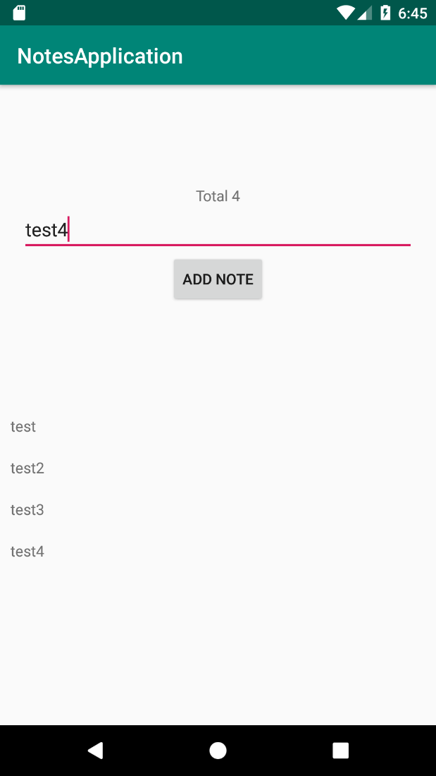
Figure 10.13: The life cycle of an activity compared to the ViewModel life cycle

Feel free to investigate the application and see if you can address any issues you may find. Here are a few to start with:
    - If no text has been written when the button is clicked, a note shouldn't be saved.
    - Add a test to NoteDatabase.
    - Add a new field to the Note entity that will allow users to check and uncheck their notes.

Chapter 11: Persisting Data

Activity 11.01: Dog Downloader

Solution:
- Start by adding the following libraries to app/build.gradle:
implementation 'commons-io:commons-io:2.6' implementation 'androidx.preference:preference:1.1.1' def lifecycle_version = "2.2.0"
implementation "androidx.lifecycle:lifecycle- extensions:$lifecycle_version"
implementation 'com.squareup.retrofit2:retrofit:2.6.2' implementation 'com.squareup.retrofit2:converter-gson:2.6.2' implementation 'com.google.code.gson:gson:2.8.6'
def room_version = "2.2.5"
implementation "androidx.room:room-runtime:$room_version" kapt "androidx.room:room-compiler:$room_version"
- Create the api package.
- Create a Dog data class, which will map the JSON data, containing the status and the list of URLs:
data class Dog(
@SerializedName("status") val status: String, @SerializedName("message") val urls: List<String>
)
- Now, create a Retrofit interface, which will define how we load the list of
Dogs and how the download will be executed through a dynamic URL:
interface DownloadService {

@GET("breed/hound/images/random/{number}")
fun getDogs(@Path("number") number: Int): Call<Dog>

@GET
fun downloadFile(@Url fileUrl: String): Call<ResponseBody>
}

The @Path annotation allows us to dynamically set certain parts of the path and the @Url allows us to place a dynamic URL in the download function. The method will return a ResponseBody object, which will contain methods to allow us to access the bytes (through InputStream) of the file.
- Add the INTERNET permission to the AndroidManifest.xml file:
<uses-permission android:name="android.permission.INTERNET"/>
- Create the storage package and, inside this, create the room package.
- Create a DogEntity class, which will contain an ID and the URL for the dog photo:
@Entity(tableName = "dogs") data class DogEntity(
@PrimaryKey(autoGenerate = true) @ColumnInfo(name = "id") val id: Long,
@ColumnInfo(name = "url") val url: String
)
- Create a DogDao interface, which will contain the method to insert a list of
Dogs, query the existing dogs, and delete all the dogs in the table:
@Dao
interface DogDao {

@Insert(onConflict = OnConflictStrategy.REPLACE)
fun insertDogs(dogs: List<DogEntity>)

@Query("SELECT * FROM dogs")
fun loadDogs(): LiveData<List<DogEntity>>

@Query("DELETE FROM dogs") fun deleteAll()
}

- Create the DogDatabase class, which will connect the entity and the Dao:
@Database(
entities = [DogEntity::class], version = 1
)
abstract class DogDatabase : RoomDatabase() {

abstract fun dogDao(): DogDao
}
- Create the xml resource directory inside the res folder.
- Create a provider_paths.xml file inside the xml directory that will point
to the external media folder. In this example, we will save the files directly in the root folder:
<?xml version="1.0" encoding="utf-8"?>
<paths>
<external-cache-path name="my-media" path="." />
</paths>
- Inside the storage package, create the filesystem package.
- Create the FileToUriMapper class, which will convert a file into a Uri to
allow us to test the other classes better:
class FileToUriMapper {

fun getUriForFile(context: Context, file: File): Uri {
return FileProvider.getUriForFile( context,
"com.android.testable.remote_media_provider",
file
)
}
}

- Create a ProviderFileHandler class, which will be responsible for writing inside a file that will belong to FileProvider:
class ProviderFileHandler( private val context: Context,
private val fileToUriMapper: FileToUriMapper
) {

fun writeStream(name: String, inputStream: InputStream) { val fileToSave = File(context.externalCacheDir, name) val outputStream =
context.contentResolver.openOutputStream(
fileToUriMapper.getUriForFile(context, fileToSave),
"rw"
)
IOUtils.copy(inputStream, outputStream)
}
}
- Make sure you have the provider in the AndroidManifest.xml file:
<provider
android:name="androidx.core.content.FileProvider" android:authorities="com.android.testable
.remote_media_provider" android:exported="false"
android:grantUriPermissions="true">
<meta-data
android:name="android.support
.FILE_PROVIDER_PATHS"
android:resource="@xml/provider_paths" />
</provider>
Make sure to set the same authority here as you did in FileToUriMapper.
- Create a preferences.xml file in res/values where we will store our key for SharedPreferences and define our key:
<?xml version="1.0" encoding="utf-8"?>
<resources>
<string name="preference_key_nr_results" translatable="false">preference_key_nr_results</string>
</resources>

- Create a package named preference in the storage package.
- In the preference package, create DownloadPreferencesWrapper, which will be responsible for retrieving the number of results we want to display on the screen. In case there is no value saved, we will default to 10 results:
const val DEFAULT_NO_OF_RESULTS = 10

class DownloadPreferencesWrapper( private val context: Context,
private val sharedPreferences: SharedPreferences
) {

fun getNumberOfResults(): Int {
return sharedPreferences.getString( context.getString
(R.string.preference_key_nr_results), DEFAULT_NO_OF_RESULTS.toString()
).orEmpty().toIntOrNull() ?: DEFAULT_NO_OF_RESULTS
}
}
- Now, move on to the Repository aspect and create a new package
called repository.
- Create a class named Result, which will have three outputs: Loading, Success, and Error. We can achieve this through the Kotlin sealed class feature:
sealed class Result<T> {

class Loading<T> : Result<T>()
data class Success<T>(val data: T) : Result<T>() class Error<T> : Result<T>()
}
- Define a model that will be used by our UI layer:
data class DogUi(val url: String)

- Define a mapper class that will convert one type of model into another:
class DogMapper {

fun mapServiceToEntity(dog: Dog): List<DogEntity> = dog.urls.map {
DogEntity(0, it)
}

fun mapEntityToUi(dogEntity: DogEntity): DogUi = DogUi(dogEntity.url)
}
- Next, define our repository interface and name it DownloadRepository:
interface DownloadRepository {

fun loadDogList(): LiveData<Result<List<DogUi>>>

fun downloadFile(url: String): LiveData<Result<Unit>>
}
- Provide the implementation for the repository. The implementation for retrieving the list of URLs will set the Loading state first, and then it will monitor any changes in the database and start the request. When the request finishes, it inserts the data in the Database, which should then provide notification regarding the changes to the data model:
DownloadRepositoryImpl.kt
- override fun loadDogList(): LiveData<Result<List<DogUi>>> {
- val result = MediatorLiveData<Result<List<DogUi>>>()
- result.postValue(Result.Loading())
- result.addSource(dogDao.loadDogs()) { dogEntities ->
- Result.Success(dogEntities.map { dogMapper.mapEntityToUi(it) })
31 }
- downloadService.getDogs(downloadPreferencesWrapper
.getNumberOfResults())
- .enqueue(object : Callback<Dog> {
- override fun onResponse(call: Call<Dog>, response: Response<Dog>) {
- if (response.isSuccessful) {
- executor.execute {
- dogDao.deleteAll()
- dogDao.insertDogs(dogMapper
.mapServiceToEntity (response.body()!!))
39 }
40 } else {
41 result.postValue(Result.Error())
42 }
43
44
45
}
46
47
48
49
50
51
override fun onFailure(call: Call<Dog>, t: Throwable) {
result.postValue(Result.Error())
}

})
return result
}
The complete code for this step can be found at http://packt.live/2LRdtMz.

The implementation for downloading a file will set the Loading state when the download is started. Then, if the connection to the server isn't established, or the server replies with an error or the download cannot be performed, it will set the state to Error. If the download is completed successfully, it will show a success message:
DownloadRepositoryImpl.kt
override fun downloadFile(url: String): LiveData<Result<Unit>> {
val result = MutableLiveData<Result<Unit>>() result.postValue(Result.Loading()) downloadService.downloadFile(url)
.enqueue(object : Callback<ResponseBody> {

override fun onFailure(call: Call<ResponseBody>, t: Throwable) {
result.postValue(Result.Error()) t.printStackTrace()
}

override fun onResponse( call: Call<ResponseBody>,
response: Response<ResponseBody>
) {
if (response.isSuccessful) { executor.execute {
try {
response.body()?.let {
val name = url.substring (url.lastIndexOf("/") + 1)
providerFileHandler.writeStream(

The complete code for this step can be found at http://packt.live/39RFbAF.
name,
response.body()
!!.byteStream()
)
result.postValue (Result.Success(Unit))
}
} catch (e: Exception) { e.printStackTrace() result.postValue(Result.Error())
}

}
} else {
result.postValue(Result.Error())
}
}

})
return result
}
- Now, create the Application class, which will initialize all of the required instances and provide access to the Repository instance to the rest of the app. Make sure to add the android:name attribute to AndroidManifest and to the application tag:
class RemoteProviderApplication : Application() {

lateinit var downloadRepository: DownloadRepository lateinit var preferencesWrapper: DownloadPreferencesWrapper

override fun onCreate() { super.onCreate()

val retrofit = Retrofit.Builder()
.baseUrl("https://dog.ceo/api/")
.addConverterFactory(GsonConverterFactory.create())
.build()

val downloadService =
retrofit.create<DownloadService>
(DownloadService::class.java) val database =
Room.databaseBuilder(applicationContext,
DogDatabase::class.java, "dog-db")
.build()
preferencesWrapper = DownloadPreferencesWrapper( this,
PreferenceManager.getDefaultSharedPreferences(this)
)
downloadRepository = DownloadRepositoryImpl( preferencesWrapper, ProviderFileHandler(
this, FileToUriMapper()
),
downloadService, database.dogDao(), DogMapper(),
Executors.newSingleThreadExecutor()
)
}
}
- Move on to MainViewModel, which will have a reference to Repository and will use MediatorLiveData to connect to the LiveData repository and that will allow the UI to observe only once, but to make multiple calls to retrieve the data from the repository:
class MainViewModel(private val downloadRepository: DownloadRepository) : ViewModel() {

private val dogsLiveData: MediatorLiveData<Result<List<DogUi>>> by lazy {
MediatorLiveData<Result<List<DogUi>>>()
}

private val downloadResult: MediatorLiveData<Result<Unit>> by lazy {
MediatorLiveData<Result<Unit>>()
}

fun getDogs() {

dogsLiveData.addSource(downloadRepository.loadDogList())
{
dogsLiveData.postValue(it)
}
}

fun getDogsLiveData(): LiveData<Result<List<DogUi>>> { return dogsLiveData
}

fun downloadFile(url: String) { downloadResult.addSource(downloadRepository
.downloadFile(url)) { downloadResult.postValue(it)
}
}

fun getDownloadLiveData(): LiveData<Result<Unit>> = downloadResult

}
- Now, build the UI. Create the activity_main.xml file in the layout folder, which will contain RecyclerView and ProgressBar, which is indefinite and can be used to show the status of the download request:
activity_main.xml
9
10
11
12
13
14
15
16
17
18
19
20
21
22
23
24
25
26
27
28
29
30
<androidx.recyclerview.widget.RecyclerView android:id="@+id/activity_main_recycler_view" android:layout_width="0dp" android:layout_height="0dp" app:layout_constraintBottom_toBottomOf="parent" app:layout_constraintLeft_toLeftOf="parent" app:layout_constraintRight_toRightOf="parent" app:layout_constraintTop_toTopOf="parent" />
<ProgressBar
android:id="@+id/activity_main_progress_bar" android:layout_width="wrap_content" android:layout_height="wrap_content" android:elevation="5dp" android:indeterminate="true" android:visibility="gone" app:layout_constraintBottom_toBottomOf="parent" app:layout_constraintLeft_toLeftOf="parent" app:layout_constraintRight_toRightOf="parent" app:layout_constraintTop_toTopOf="parent" />

</androidx.constraintlayout.widget.ConstraintLayout>
The complete code for this step can be found at http://packt.live/3c4nXmF.

- Create the layout for the rows, which will be one TextView, and display the URL:
view_dog_item.xml
<?xml version="1.0" encoding="utf-8"?>
<TextView xmlns:android="http://schemas.android.com
/apk/res/android" android:id="@+id/view_dog_item_url_text_view"
android:layout_width="wrap_content" android:layout_height="wrap_content" android:padding="10dp" />
- Create an adapter, which will handle the display for every row and will have a reference to a lambda that will be invoked when a row is clicked:
class MainAdapter(
private val layoutInflater: LayoutInflater,
private val onRowClickListener: (DogUi) -> Unit
) : RecyclerView.Adapter<MainAdapter.DogViewHolder>() { private val dogs = mutableListOf<DogUi>()
override fun onCreateViewHolder(parent: ViewGroup, viewType: Int): DogViewHolder =
DogViewHolder(layoutInflater.inflate(R.layout.view_dog_item,
parent, false))
override fun getItemCount(): Int = dogs.size override fun onBindViewHolder(holder: DogViewHolder,
position: Int) { holder.bind(dogs[position])
}

fun updateDogs(dogs: List<DogUi>) { this.dogs.clear() this.dogs.addAll(dogs) this.notifyDataSetChanged()
}

inner class DogViewHolder(containerView: View) : RecyclerView.ViewHolder(containerView) {

private val urlTextView: TextView =
containerView.findViewById<TextView>
(R.id.view_dog_item_url_text_view)

init {
containerView.setOnClickListener { val position = adapterPosition
if (position > RecyclerView.NO_POSITION) { onRowClickListener.invoke(dogs[position])
}
}
}

fun bind(dog: DogUi) { urlTextView.text = dog.url
}
}
}
- Finally, add ViewModel and Adapter to MainActivity and implement the
download function:
MainActivity.kt
val downloadRepository = (application as RemoteProviderApplication).downloadRepository
mainViewModel = ViewModelProvider(this, object : ViewModelProvider.Factory {
override fun <T : ViewModel?> create(modelClass: Class<T>): T {
return MainViewModel(downloadRepository) as T
}
}).get(MainViewModel::class.java)

val progressBar = findViewById<ProgressBar>
(R.id.activity_main_progress_bar) mainViewModel.getDownloadLiveData()
.observe(this, Observer { result -> when (result) {
is Result.Loading -> { progressBar.visibility = View.VISIBLE
}
is Result.Success -> {

The complete code for this step can be found at http://packt.live/3qEEjq1.
progressBar.visibility = View.GONE
Toast.makeText(this, getString(R.string.success), Toast.LENGTH_LONG)
.show()
}
is Result.Error -> { progressBar.visibility = View.GONE
Toast.makeText(this, getString(R.string.error), Toast.LENGTH_LONG)
.show()
}
}
})
If you run the code, you will see the following output:
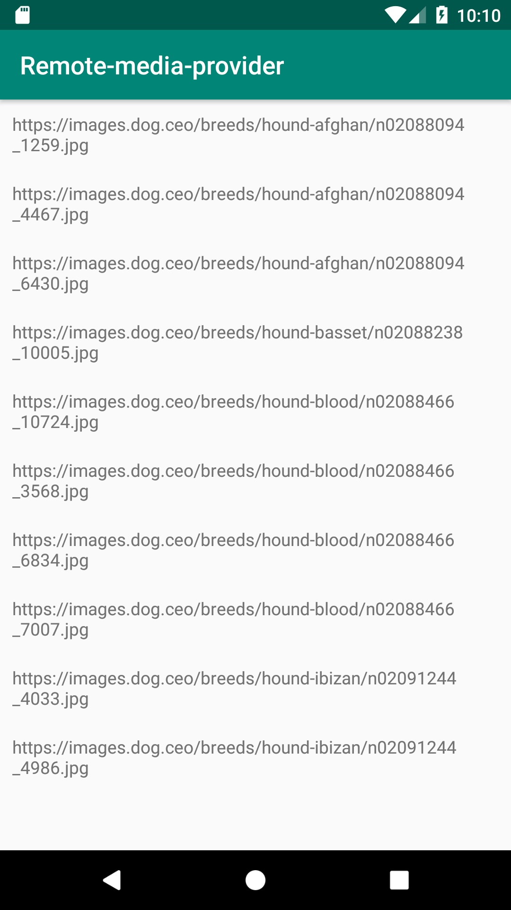
Figure 11.12: Output of the activity's main screen

- Clicking the items will trigger the download for each individual item. You can
view the files using Device File Explorer:
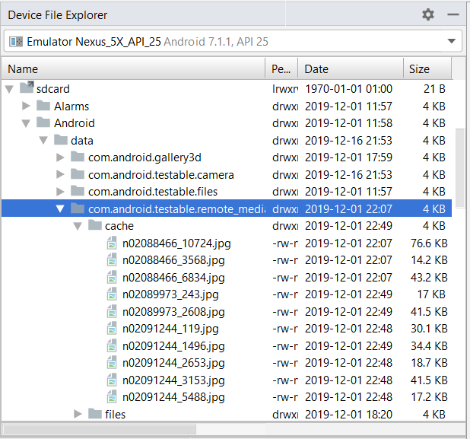
Figure 11.13: Viewing downloaded files through Device File Explorer
- Now, define the menu for the main activity, but first we need a Settings icon. We can extract that by right-clicking on the res folder and selecting New | Vector Asset. Select a Settings icon from that list and save it as ic_settings.
- Now, we can create a menu folder in the res folder and inside that we create the menu_main.xml file with the following specifications:
<?xml version="1.0" encoding="utf-8"?>
<menu xmlns:android="http://schemas.android.com
/apk/res/android">
<item

android:id="@+id/menu_item_settings" android:icon="@drawable/ic_settings" android:title="@string/settings" />
</menu>
- Define the preference_settings.xml file inside res/xml:
<?xml version="1.0" encoding="utf-8"?>
<PreferenceScreen xmlns:app="http://schemas.android.com
/apk/res-auto">

<EditTextPreference app:key="@string/preference_key_nr_results" app:title="@string/number_of_items" />

</PreferenceScreen>
- Also, define SettingsFragment, which will display just the one preference and, as a summary, it will display the existing value from SharedPreferences:
class SettingsFragment : PreferenceFragmentCompat() {
override fun onCreatePreferences(savedInstanceState: Bundle?, rootKey: String?) {
setPreferencesFromResource(R.xml.preferences_settings, rootKey)
val resultsPreference =
findPreference<EditTextPreference>
(getString(R.string.preference_key_nr_results)) val preferencesWrapper =
(requireActivity().application as RemoteProviderApplication).preferencesWrapper
resultsPreference?.summary = preferencesWrapper.getNumberOfResults().toString()

resultsPreference?.onPreferenceChangeListener = Preference.OnPreferenceChangeListener { _, newValue
->
resultsPreference?.summary = newValue?.toString() true
}
}
}

- Insert the fragment in a new activity called SettingsActivity, which will
have activity_settings.xml as the layout:
<?xml version="1.0" encoding="utf-8"?>
<fragment xmlns:android="http://schemas.android.com
/apk/res/android" android:id="@+id/activity_settings_fragment_container"
class="com.android.testable.remote_media_provider
.SettingsFragment" android:layout_width="match_parent"
android:layout_height="match_parent" />
- The code inside SettingsActivity will be as follows:
class SettingsActivity : AppCompatActivity() {

override fun onCreate(savedInstanceState: Bundle?) { super.onCreate(savedInstanceState) setContentView(R.layout.activity_settings)
}
}
- Add the activity to the AndroidManifest.xml file:
<activity android:name=".SettingsActivity" />
- Finally, start it from MainActivity when the Settings option is selected:
override fun onCreateOptionsMenu(menu: Menu?): Boolean {
menuInflater.inflate(R.menu.menu_main, menu)
return true
}

override fun onOptionsItemSelected(item: MenuItem): Boolean { return when (item.itemId) {
R.id.menu_item_settings -> {
startActivity(Intent(this, SettingsActivity::class.java))
true
}
else -> {
super.onOptionsItemSelected(item)

}
}

}
Running this code and selecting the Settings option will give us the following screen. If you go and set a new numeric value, when you return to MainActivity, the list will refresh itself with the new number of items:
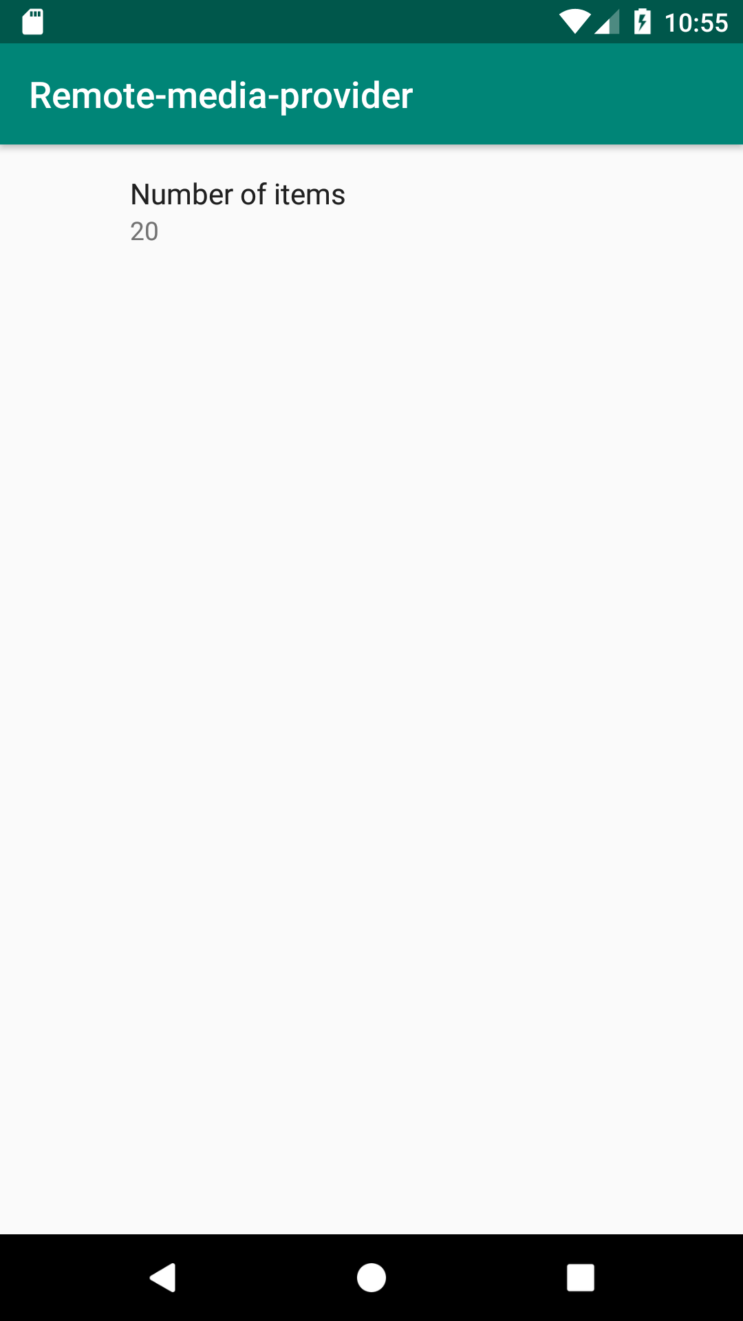
Figure 11.14: The output of SettingsActivity

Chapter 12: Dependency Injection with Dagger and Koin

Activity 12.01: Injected Repositories

Solution:
- Start with the app/build.gradle dependency configuration:
implementation "androidx.constraintlayout:constraintlayout:2.0.4"
implementation 'androidx.recyclerview:recyclerview:1.1.0' def lifecycle_version = "2.2.0"
implementation "androidx.lifecycle:lifecycle- extensions:$lifecycle_version"
implementation 'com.squareup.retrofit2:retrofit:2.6.2' implementation 'com.squareup.retrofit2:converter-gson:2.6.2' implementation 'com.google.code.gson:gson:2.8.6' implementation 'com.google.dagger:dagger:2.29.1'
kapt 'com.google.dagger:dagger-compiler:2.29.1' testImplementation 'junit:junit:4.12'
testImplementation 'android.arch.core:core-testing:2.1.0' testImplementation 'org.mockito:mockito-core:3.2.4' androidTestImplementation 'androidx.test.ext:junit:1.1.2' androidTestImplementation 'androidx.test:rules:1.3.0'
androidTestImplementation 'androidx.test
.espresso:espresso-core:3.3.0' androidTestImplementation 'com.android.support.test
.espresso:espresso-contrib:3.0.2'
- Add the Kotlin application processor plugin to the app/build.gradle file:
apply plugin: 'kotlin-kapt'
- Create the api package.
- Add the model for api:
data class Post(
@SerializedName("id") val id: Long, @SerializedName("userId") val userId: Long, @SerializedName("title") val title: String, @SerializedName("body") val body: String
)

- Add the class responsible for retrieving the list of posts:
interface PostService {

@GET("posts")
fun getPosts(): Call<List<Post>>
}
- Create the repository package and add the following interface:
interface PostRepository {

fun getPosts(): LiveData<List<Post>>
}
- Create the implementation for the preceding class in which the error scenarios
will not be handled:
class PostRepositoryImpl(private val postService: PostService) : PostRepository {

override fun getPosts(): LiveData<List<Post>> { val result = MutableLiveData<List<Post>>() postService.getPosts().enqueue(object :
Callback<List<Post>> {

override fun onFailure(call: Call<List<Post>>, t: Throwable) {
}

override fun onResponse(call: Call<List<Post>>, response: Response<List<Post>>) {
if (response.isSuccessful) { result.postValue(response.body())
}
}
})
return result
}
}

- And now, let's write one test for this class:
@RunWith(MockitoJUnitRunner::class) class PostRepositoryImplTest {

@get:Rule
val rule = InstantTaskExecutorRule() @InjectMocks
lateinit var postRepository: PostRepositoryImpl @Mock
lateinit var postService: PostService @Mock
lateinit var call: Call<List<Post>>

@Before
fun setUp() {
Mockito.'when'(postService.getPosts()).thenReturn(call)
}

@Test
fun getPosts_success() { val postList = listOf(
Post(1, 1, "title1", "body1"),
Post(2, 2, "title2", "body2")
)
Mockito.'when'(call.enqueue(Mockito.any())).thenAnswer { (it.arguments[0] as Callback<List<Post>>)
.onResponse(call, Response.success(postList))
}
val result = postRepository.getPosts() assertEquals(postList, result.value)
}
}

- Next, let's define PostViewModel:
class PostViewModel(private val postRepository: PostRepository) : ViewModel() {

fun getPosts(): LiveData<List<Post>> = postRepository.getPosts()
}
- And now, let's write the test for this class:
@RunWith(MockitoJUnitRunner::class) class PostViewModelTest {

@InjectMocks
lateinit var postViewModel: PostViewModel @Mock
lateinit var postRepository: PostRepository

@Test
fun getPosts() {
val expected = Mockito.mock(LiveData::class.java) Mockito.'when'(postRepository.getPosts())
.thenReturn(expected as LiveData<List<Post>>?) val result = postViewModel.getPosts()
assertEquals(expected, result)
}
}
- Now, let's create the view_post_row.xml file in which we define the layout for every row:
<?xml version="1.0" encoding="utf-8"?>
<androidx.constraintlayout.widget.ConstraintLayout xmlns:android="http://schemas.android.com/apk/res/android"
xmlns:app="http://schemas.android.com/apk/res-auto" android:layout_width="match_parent" android:layout_height="wrap_content" android:padding="10dp">

<TextView
android:id="@+id/view_post_row_title"

android:layout_width="wrap_content" android:layout_height="wrap_content" app:layout_constraintStart_toStartOf="parent" app:layout_constraintTop_toTopOf="parent" />

<TextView
android:id="@+id/view_post_row_body" android:layout_width="wrap_content" android:layout_height="wrap_content" android:layout_marginTop="5dp" app:layout_constraintStart_toStartOf="parent" app:layout_constraintTop_toBottomOf
="@id/view_post_row_title" />

</androidx.constraintlayout.widget.ConstraintLayout>
- Next, let's create the PostAdapter class responsible for binding the
row layout:
class PostAdapter(private val layoutInflater: LayoutInflater) :
RecyclerView.Adapter<PostAdapter.PostViewHolder>() { private val posts = mutableListOf<Post>()
override fun onCreateViewHolder(parent: ViewGroup, viewType: Int): PostViewHolder =
PostViewHolder(layoutInflater.inflate
(R.layout.view_post_row, parent, false)) override fun getItemCount(): Int = posts.size
override fun onBindViewHolder(holder: PostViewHolder, position: Int) {
holder.bind(posts[position])
}

fun updatePosts(posts: List<Post>) { this.posts.clear() this.posts.addAll(posts) this.notifyDataSetChanged()
}

inner class PostViewHolder(containerView: View) : RecyclerView.ViewHolder(containerView) {

private val titleTextView: TextView =
containerView.findViewById<TextView>
(R.id.view_post_row_title) private val bodyTextView: TextView =
containerView.findViewById<TextView>
(R.id.view_post_row_body)

fun bind(post: Post) { bodyTextView.text = post.body titleTextView.text = post.title
}
}
}
- Now, add following code to the activity_main.xml file:
<?xml version="1.0" encoding="utf-8"?>
<androidx.recyclerview.widget.RecyclerView xmlns:android="http://schemas.android.com/apk/res/android"
android:id="@+id/activity_main_recycler_view" android:layout_width="match_parent" android:layout_height="match_parent" />
- Next, let's add the following to the onCreate method of MainActivity:
class MainActivity : AppCompatActivity() { private lateinit var postAdapter: PostAdapter
override fun onCreate(savedInstanceState: Bundle?) { super.onCreate(savedInstanceState) setContentView(R.layout.activity_main)

postAdapter = PostAdapter(LayoutInflater.from(this)) val recyclerView = findViewById<RecyclerView>
(R.id.activity_main_recycler_view) recyclerView.adapter = postAdapter
recyclerView.layoutManager = LinearLayoutManager(this)
}
}

- Make sure the MAIN intent filter is added to AndroidManifest.xml:
<activity android:name=".MainActivity">
<intent-filter>
<action android:name= "android.intent.action.MAIN" />

<category android:name= "android.intent.category.LAUNCHER" />
</intent-filter>
</activity>
- Let's create an empty Application class named MyApplication:
class MyApplication : Application() {

override fun onCreate() { super.onCreate()
}
}
- Now, let's set up Dagger in the project. We can start with NetworkModule in
which we will provide a dependency to Retrofit and one to PostService:
@Module
class NetworkModule {

@Singleton @Provides
fun provideRetrofit(): Retrofit { return Retrofit.Builder()
.baseUrl("https://jsonplaceholder.typicode.com/")
.addConverterFactory(GsonConverterFactory.create())
.build()
}

@Singleton @Provides
fun providePostService(retrofit: Retrofit): PostService {
return retrofit.create<PostService>
(PostService::class.java)
}
}

- Next, let's create a RepositoryModule class:
@Module
class RepositoryModule {

@Singleton @Provides
fun providePostRepository(postService: PostService): PostRepository {
return PostRepositoryImpl(postService)
}
}
- We will need a MainActivityModule class in which we will provide the
ViewModelProvider.Factory instance with PostViewModel:
@Module
class MainActivityModule {

@Provides
fun provideViewModelFactory(postRepository: PostRepository): ViewModelProvider.Factory {
return object : ViewModelProvider.Factory {
override fun <T : ViewModel?> create(modelClass: Class<T>): T {
return PostViewModel(postRepository) as T
}
}
}
}
- We will need a subcomponent that will use the preceding module, which will
contain a method to inject dependencies into MainActivity:
@Subcomponent(modules = [MainActivityModule::class]) interface MainActivitySubcomponent {

fun inject(mainActivity: MainActivity)
}

- Now, we will need to move on to creating the ApplicationComponent interface, which contains a method to create the preceding subcomponent and will initialize the dependency graph with NetworkModule and RepositoryModule:
@Singleton
@Component(modules = [NetworkModule::class, RepositoryModule::class]) interface ApplicationComponent {

fun createActivitySubcomponent(): MainActivitySubcomponent
}
- In the MyApplication class, initialize ApplicationComponent:
lateinit var applicationComponent : ApplicationComponent

override fun onCreate() { super.onCreate() applicationComponent =
DaggerApplicationComponent.create()
}
- Finally, inject ViewModelProvider.Factory into MainActivity and obtain the ViewModel reference:
@Inject
lateinit var factory: ViewModelProvider.Factory
private lateinit var postAdapter: PostAdapter

override fun onCreate(savedInstanceState: Bundle?) { (application as MyApplication).applicationComponent
.createActivitySubcomponent()
.inject(this) super.onCreate(savedInstanceState) setContentView(R.layout.activity_main)

postAdapter = PostAdapter(LayoutInflater.from(this)) val recyclerView = findViewById<RecyclerView>
(R.id.activity_main_recycler_view) recyclerView.adapter = postAdapter
recyclerView.layoutManager = LinearLayoutManager(this)
val viewModel = ViewModelProvider(this, factory).get(PostViewModel::class.java)
viewModel.getPosts().observe(this, Observer {

postAdapter.updatePosts(it)
})
}
- Add the internet permission to AndroidManifest.xml:
<manifest ...>
...
<uses-permission android:name= "android.permission.INTERNET" />
...
</manifest>
- If you run the app at this point, the posts should be displayed on the screen:
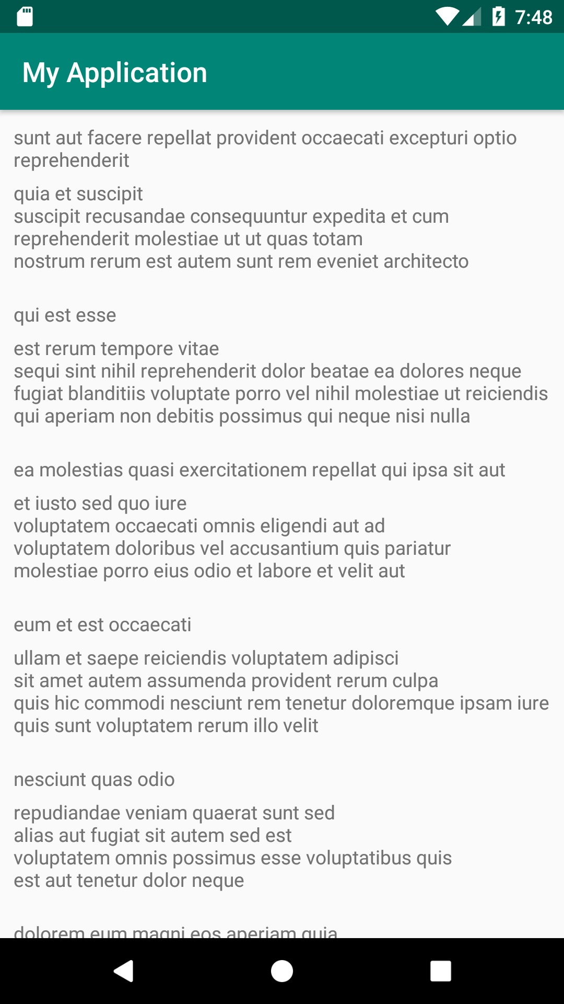

Figure 12.7: Displaying the list of posts in a Dagger application

- Let's work on setting up the dummy data for the UI test. In order to do this, we will need to create a class that will output a list of dummy posts. Normally, we would need to go to the API level to make sure that the components work well together. However, in order to simplify the work, we will work on the repository layer. What we need to do is create DummyRepository, which will return a list of posts, and, using Dagger, we will inject it into ViewModel:
class DummyRepository : PostRepository {

override fun getPosts(): LiveData<List<Post>> { val liveData = MutableLiveData<List<Post>>() liveData.postValue(
listOf(
Post(1L, 1L, "Title 1", "Body 1"),
Post(2L, 1L, "Title 2", "Body 2"),
Post(3L, 1L, "Title 3", "Body 3")
)
)
return liveData
}
}
- Next, we have to tweak RepositoryModule in order to be able to extend it from the test, so we will have to make the class open as well as the function we want to override:
@Module
open class RepositoryModule {

@Singleton @Provides
open fun providePostRepository(postService: PostService): PostRepository {
return PostRepositoryImpl(postService)
}
}

- Now, we should move on to the androidTest package and create a
TestRepositoryModule class, which will extend RepositoryModule:
@Module
class TestRepositoryModule : RepositoryModule() {

@Singleton @Provides
override fun providePostRepository(postService: PostService): PostRepository {
return DummyRepository()
}
}
- Next, we will need to modify the MyApplication class in order to provide the
repository module programmatically and make it extendable:
open class MyApplication : Application() {
lateinit var applicationComponent: ApplicationComponent override fun onCreate() {
super.onCreate()
applicationComponent = DaggerApplicationComponent.builder()
.repositoryModule(createRepositoryModule())
.build()
}

open fun createRepositoryModule(): RepositoryModule {
return RepositoryModule()
}
}

- Next, let's create a TestApplication class in the androidTest package that will extend from MyApplication and inject TestRepositoryModule:
class TestApplication :MyApplication() {

override fun createRepositoryModule(): RepositoryModule { return TestRepositoryModule()
}
}
- Now, let's create a TestRunner class and add TestApplication as the
target of the test:
class MyTestRunner : AndroidJUnitRunner() {

@Throws(Exception::class) override fun newApplication(
cl: ClassLoader?, className: String?, context: Context?
): Application? {
return super.newApplication(cl, TestApplication::class.java.name, context)
}
}
- Now, add the test runner to the app/build.gradle configuration:
android {
...
defaultConfig {
...
testInstrumentationRunner "com.android.myapplication.MyTestRunner"
}
}

- Let's create the MainActivityTest class in which we assert that the dummy
data will be displayed on the screen:
@RunWith(AndroidJUnit4::class) class MainActivityTest {
@JvmField @Rule
var activityRule: ActivityTestRule<MainActivity> = ActivityTestRule(MainActivity::class.java)

@Test
fun testDisplaysPosts() {
onView(withText("Title 1")).check(matches(isDisplayed())) onView(withText("Body 1")).check(matches(isDisplayed())) onView(withText("Title 2")).check(matches(isDisplayed())) onView(withText("Body 2")).check(matches(isDisplayed())) onView(withText("Title 3")).check(matches(isDisplayed())) onView(withText("Body 3")).check(matches(isDisplayed()))
}
}
If the test is successful, this means that the test setup we have used for Dagger has worked.

Activity 12.02: Koin-Injected Repositories

Solution:
- Update the app/build.gradle file to include Koin:
implementation "androidx.constraintlayout:constraintlayout:2.0.4"
implementation 'androidx.recyclerview:recyclerview:1.1.0' def lifecycle_version = "2.2.0"
implementation "androidx.lifecycle:lifecycle- extensions:$lifecycle_version"
implementation 'com.squareup.retrofit2:retrofit:2.6.2' implementation 'com.squareup.retrofit2:converter-gson:2.6.2' implementation 'com.google.code.gson:gson:2.8.6' implementation 'org.koin:koin-android:2.2.0-rc-4' implementation "org.koin:koin-android-viewmodel:2.2.0-rc-4"

testImplementation 'junit:junit:4.12'
testImplementation 'android.arch.core:core-testing:2.1.0'

testImplementation 'org.mockito:mockito-core:3.2.4' androidTestImplementation 'androidx.test.ext:junit:1.1.2' androidTestImplementation 'androidx.test:rules:1.3.0'
androidTestImplementation 'androidx.test
.espresso:espresso-core:3.3.0' androidTestImplementation 'com.android.support.test
.espresso:espresso-contrib:3.0.2'
- Delete all the Dagger modules, components, and subcomponents.
- Add the required Koin modules and configure Koin in the
MyApplication class:
open class MyApplication : Application() {

private val networkModule = module { single {
Retrofit.Builder()
.baseUrl("https://jsonplaceholder.typicode.com/")
.addConverterFactory(GsonConverterFactory
.create())
.build()
}

single {
providePostService(get())
}
}
private val repositoryModule = module { single {
providePostRepository(get())
}
}
private val viewModelModule = module { viewModel {
PostViewModel(get())
}
}

override fun onCreate() { super.onCreate() startKoin {
androidContext(this@MyApplication)

modules(listOf(networkModule, repositoryModule, viewModelModule))
}
}

private fun providePostService(retrofit: Retrofit):
PostService {
return retrofit.create(PostService::class.java)
}

open fun providePostRepository(postService: PostService): PostRepository {
return PostRepositoryImpl(postService)
}
}
- Inject PostViewModel into MainActivity using Koin:
class MainActivity : AppCompatActivity() { private lateinit var postAdapter: PostAdapter
override fun onCreate(savedInstanceState: Bundle?) { super.onCreate(savedInstanceState) setContentView(R.layout.activity_main)

postAdapter = PostAdapter(LayoutInflater.from(this))
val recyclerView =
findViewById<RecyclerView>
(R.id.activity_main_recycler_view) recyclerView.adapter = postAdapter recyclerView.layoutManager = LinearLayoutManager(this) val viewModel: PostViewModel = getViewModel() viewModel.getPosts().observe(this, Observer {
postAdapter.updatePosts(it)
})
}
}
- Change TestApplication to return DummyRepository:
class TestApplication : MyApplication() {

override fun providePostRepository(postService: PostService): PostRepository {

return DummyRepository()
}
}
The final output will be as follows:


Figure 12.8: Displaying the list of posts in a Koin application
If you run the application and the test, they should provide the same output as in the previous activity, as presented in Figure 12.8.

Chapter 14: Coroutines and Flow

Activity 14.01: Creating a TV Guide App

Solution:
Here is one way you can develop the TV Guide app:
- Create a new project in Android Studio named TV Guide with a package name of com.example.tvguide.
- Add the INTERNET permission in the AndroidManifest.xml file, inside the manifest tag but outside the application tag:
<uses-permission android:name="android.permission.INTERNET" />
- Add the Retrofit, Coroutines, Moshi, Lifecycle, and other libraries to your project by adding the following in your app/build.gradle file:
implementation 'androidx.lifecycle:lifecycle-runtime-ktx:2.5.1'
implementation 'androidx.lifecycle:lifecycle-viewmodel-ktx:2.5.1'
implementation 'androidx.recyclerview:recyclerview:1.2.1'

implementation 'com.google.android.material:material:1.7.0'

implementation 'com.github.bumptech.glide:glide:4.12.0'

implementation 'com.squareup.retrofit2:retrofit:2.9.0'
implementation 'com.squareup.retrofit2:converter-moshi:2.9.0'

implementation 'org.jetbrains.kotlinx:kotlinx-coroutines-core:1.6.4'
implementation 'org.jetbrains.kotlinx:kotlinx-coroutines-android:1.6.4'

- Add a layout_margin dimension value by creating a dimens.xml file in the
res/values directory with the following:
<resources>
<dimen name="layout_margin">16dp</dimen>
</resources>
This will be used for the view margins in the layout.
- Open strings.xml and add the following string values:
<string name="tv_show_overview">Overview: %s</string>
<string name="tv_show_poster">Poster</string>
<string name="tv_show_release">First Air Date: %s</string>
- Create a view_tv_show_item.xml layout file with ImageView for the poster and TextView for the name of the TV show:
<?xml version="1.0" encoding="utf-8"?>
<androidx.constraintlayout.widget.ConstraintLayout xmlns:android="http://schemas.android.com/apk/res/android"
xmlns:app="http://schemas.android.com/apk/res-auto"
xmlns:tools="http://schemas.android.com/tools"
android:layout_width="match_parent"
android:layout_height="wrap_content">

<ImageView
android:id="@+id/tv_poster"
android:layout_width="match_parent"
android:layout_height="240dp"
android:contentDescription="@string/tv_show_poster"
app:layout_constraintBottom_toBottomOf="parent"
app:layout_constraintEnd_toEndOf="parent"
app:layout_constraintStart_toStartOf="parent"
app:layout_constraintTop_toTopOf="parent"
tools:src="@tools:sample/backgrounds/scenic" />

<TextView
android:id="@+id/tv_show_title"
android:layout_width="match_parent"
android:layout_height="wrap_content"
android:layout_marginStart="@dimen/layout_margin"
android:layout_marginEnd="@dimen/layout_margin"
android:ellipsize="end"
android:gravity="center"
android:lines="1"
android:textSize="20sp"
app:layout_constraintEnd_toEndOf="@id/tv_poster"
app:layout_constraintStart_toStartOf="@id/tv_poster"
app:layout_constraintTop_toBottomOf="@id/tv_poster"
tools:text="TV Show" />

</androidx.constraintlayout.widget.ConstraintLayout>
This layout file will be used for each TV show in the list.
- Remove the Hello World TextView in activity_main.xml and add a
RecyclerView for the list of TV shows:
<androidx.recyclerview.widget.RecyclerView android:id="@+id/tv_show_list" android:layout_width="match_parent" android:layout_height="match_parent"
app:layoutManager
="androidx.recyclerview.widget.GridLayoutManager" app:layout_constraintBottom_toBottomOf="parent"
app:layout_constraintTop_toTopOf="parent" app:spanCount="2" tools:listitem="@layout/view_tv_show_item" />
This RecyclerView with GridLayoutManager will display the list of
TV shows.
- Create a model class, TVShow, in a new package, com.example.tvguide. model:

data class TVShow(
@field:Json(name = "backdrop_path")
val backdropPath: String? = "",
@field:Json(name = "first_air_date")
val firstAirDate: String = "",
val id: Int = 0,
val name: String = "",
@field:Json(name = "original_language")
val originalLanguage: String = "",
@field:Json(name = "original_name")
val originalName: String = "",
val overview: String = "",
val popularity: Float = 0f,
@field:Json(name = "poster_path")
val posterPath: String? = "",
@field:Json(name = "vote_average")
val voteAverage: Float = 0f,
@field:Json(name = "vote_count")
val voteCount: Int = 0
)
This will be the model class representing a TV Show object from the API.
- Create another class named TVResponse, in the com.example.tvguide.model package:
This will be the model class for the response you get from the API endpoint for the TV shows on air.
data class TVResponse(
val page: Int,
val results: List<TVShow>
)
- Create a new activity named DetailsActivity with activity_details.xml as the layout file. Open the AndroidManifest.xml file and add the parentActivityName
attribute in the DetailsActivity declaration:
<activity android:name=".DetailsActivity" android:parentActivityName=".MainActivity" />
This adds an up icon in the details activity for going back to the main screen.
- Open the activity_details.xml file. Add the views for the details of the TV show:

<?xml version="1.0" encoding="utf-8"?>
<androidx.constraintlayout.widget.ConstraintLayout xmlns:android="http://schemas.android.com/apk/res/android"
xmlns:app="http://schemas.android.com/apk/res-auto"
xmlns:tools="http://schemas.android.com/tools"
android:layout_width="match_parent"
android:layout_height="wrap_content"
tools:context=".DetailsActivity">

<ImageView
android:id="@+id/tv_poster"
android:layout_width="match_parent"
android:layout_height="240dp"
android:layout_margin="@dimen/layout_margin"
android:contentDescription="@string/tv_show_poster"
app:layout_constraintStart_toStartOf="parent"
app:layout_constraintTop_toTopOf="parent"
tools:src="@tools:sample/avatars" />

<TextView
android:id="@+id/title_text"
style="@style/TextAppearance.AppCompat.Medium"
android:layout_width="0dp"
android:layout_height="wrap_content"
android:layout_marginTop="@dimen/layout_margin"
app:layout_constraintEnd_toEndOf="@+id/tv_poster"
app:layout_constraintStart_toStartOf="@+id/tv_poster"
app:layout_constraintTop_toBottomOf="@+id/tv_poster"
tools:text="Name" />

<TextView
android:id="@+id/release_text"
style="@style/TextAppearance.AppCompat.Medium"
android:layout_width="0dp"
android:layout_height="wrap_content"
android:layout_marginTop="@dimen/layout_margin"
app:layout_constraintEnd_toEndOf="@+id/title_text"
app:layout_constraintStart_toStartOf="@+id/title_text"
app:layout_constraintTop_toBottomOf="@+id/title_text"
tools:text="Release Date" />

<TextView
android:id="@+id/overview_text"
style="@style/TextAppearance.AppCompat.Medium"
android:layout_width="0dp"
android:layout_height="wrap_content"
android:layout_marginTop="@dimen/layout_margin"
app:layout_constraintEnd_toEndOf="@+id/release_text"
app:layout_constraintStart_toStartOf="@+id/release_text"
app:layout_constraintTop_toBottomOf="@+id/release_text"
tools:text="Overview" />
</androidx.constraintlayout.widget.ConstraintLayout>
This will add an ImageView for the poster and multiple TextViews for the name, release date, and overview of the TV show on the details screen.

- Open DetailsActivity. Add the following:
companion object {
const val EXTRA_TITLE = "title"
const val EXTRA_RELEASE = "release"
const val EXTRA_OVERVIEW = "overview"
const val EXTRA_POSTER = "poster"

const val IMAGE_URL = "https://image.tmdb.org/t/p/w185/"
}
- In the onCreate function, add the following at the end:
val titleText: TextView = findViewById(R.id.title_text)
val releaseText: TextView = findViewById(R.id.release_text)
val overviewText: TextView = findViewById(R.id.overview_text)
val poster: ImageView = findViewById(R.id.tv_poster)

val extras = intent.extras

titleText.text = extras?.getString(EXTRA_TITLE).orEmpty()
releaseText.text =
getString(R.string.tv_show_release, extras?.getString(EXTRA_RELEASE).orEmpty().take(4))

overviewText.text =
getString(R.string.tv_show_overview, extras?.getString(EXTRA_OVERVIEW).orEmpty())

val posterPath = extras?.getString(EXTRA_POSTER).orEmpty()
Glide.with(this@DetailsActivity)
.load("$IMAGE_URL$posterPath")
.placeholder(R.mipmap.ic_launcher)
.fitCenter()
.into(poster)

This will display the poster, name, release, and overview of the TV show selected.
- Create a TVShowAdapter adapter class for the list of TV shows with the
following contents:
class TVShowAdapter(private val clickListener: TVClickListener) : RecyclerView.Adapter<TVShowAdapter.TVShowViewHolder>() {

private val tvShows = mutableListOf<TVShow>()

override fun onCreateViewHolder(parent: ViewGroup, viewType: Int): TVShowViewHolder {
val view = LayoutInflater.from(parent.context)
.inflate(R.layout.view_tv_show_item, parent, false)
return TVShowViewHolder(view)
}

override fun getItemCount() = tvShows.size

override fun onBindViewHolder(holder: TVShowViewHolder, position: Int) {
val tvShow = tvShows[position] holder.bind(tvShow)
holder.itemView.setOnClickListener { clickListener.onShowClick(tvShow) }
}

fun addTVShows(shows: List<TVShow>) { tvShows.addAll(shows) notifyItemRangeInserted(0, shows.size)

}

class TVShowViewHolder(itemView: View) : RecyclerView.ViewHolder(itemView) {
private val imageUrl = "https://image.tmdb.org/t/p/w185/" private val titleText: TextView by lazy {
itemView.findViewById(R.id.tv_show_title)
}
private val poster: ImageView by lazy {
itemView.findViewById(R.id.tv_poster)
}

fun bind(show: TVShow) {
titleText.text = show.name

Glide.with(itemView.context)
.load("$imageUrl${show.poster_path}")
.placeholder(R.mipmap.ic_launcher)
.fitCenter()
.into(poster)
}
}

interface TVClickListener {
fun onShowClick(show: TVShow)
}
}
This class will be the RecyclerView's adapter and ViewHolder.

- Create TelevisionService in the com.example.tvguide.api package:
interface TelevisionService {

@GET("tv/on_the_air")
suspend fun getTVShows(@Query("api_key") apiKey: String): TVResponse
}
This will define the endpoint you will use to retrieve the TV shows that are on the air.

- Create a TVShowRepository class with a constructor for tvService:
class TVShowRepository(private val tvService: TelevisionService) {
private val apiKey = “your_api_key_here”
}
- Change the apiKey with the API key you got from The Movie Database API:
private val apiKey = “your_api_key_here”
- Create a function fetchTvShows to retrieve the list from the endpoint:

- Create a TVShowViewModel class with a constructor for tvShowRepository and dispatcher:
fun fetchTVShows(): Flow<List<TVShow>> {
return flow {
emit(tvService.getTVShows(apiKey).results)
}.flowOn(Dispatchers.IO)
}
class TVShowViewModel(
private val tvShowRepository: TVShowRepository,
private val dispatcher: CoroutineDispatcher = Dispatchers.IO
) : ViewModel() {
}

- Add tVShows StateFlow for the list of TV shows and error StateFlow for the error message:

- Add the fetchTVShows function with a coroutine using
private val _tvShows = MutableStateFlow(emptyList<TVShow>())
val tvShows: StateFlow<List<TVShow>> = _tvShows

private val _error = MutableStateFlow("")
val error: StateFlow<String> = _error
viewModelScope to collect the TV shows from tvShowRepository:

- Create an application class named TVApplication with a property for
init {
fetchTVShows()
}

private fun fetchTVShows() {
viewModelScope.launch(dispatcher) {
tvShowRepository.fetchTVShows()
.catch {
_error.value = "An exception occurred: ${it.message}"
}.collect {
_tvShows.value = it
}
}
}
tvShowRepository:
class TVApplication : Application() {
lateinit var tvShowRepository: TVShowRepository

}
This will be the application class for the app. It will hold a reference to
tvShowRepository.

- Override the onCreate function of the TVApplication class and initialize the tvService and tvShowRepository objects:
override fun onCreate() {
super.onCreate()

val retrofit = Retrofit.Builder()
.baseUrl("https://api.themoviedb.org/3/")
.addConverterFactory(MoshiConverterFactory.create())
.build()
val tvService = retrofit.create(TelevisionService::class.java)
tvShowRepository = TVShowRepository(tvService)
}
- Set TVApplication as the value for the android:name attribute of the application in the AndroidManifest.xml file:
<application
...
android:name=".TVApplication"
... />
- Open MainActivity and add the openShowDetails function to open the details screen when clicking on a TV show from the list:

private fun openShowDetails(tvShow: TVShow) {
val intent = Intent(this, DetailsActivity::class.java).apply {
putExtra(DetailsActivity.EXTRA_TITLE, tvShow.name)
putExtra(DetailsActivity.EXTRA_RELEASE, tvShow.firstAirDate)
putExtra(DetailsActivity.EXTRA_OVERVIEW, tvShow.overview)
putExtra(DetailsActivity.EXTRA_POSTER, tvShow.posterPath)
}
startActivity(intent)
}
- In the MainActivity class, define a field for the adapter for the TV shows:
private val tvShowAdapter by lazy {
TVShowAdapter(object : TVShowAdapter.TVClickListener {
override fun onShowClick(show: TVShow) {
openShowDetails(show)
}
})
}

This will create an adapter with the list of TV shows. When a TV show is clicked, the openShowDetails function will be called.
- In the onCreate function, set the adapter for the tv_show_list RecyclerView:

- After that lines, add the following code to initialize tvShowRepository and tvShowViewModel:
val tvShowRecyclerView: RecyclerView = findViewById(R.id.tv_show_list)
tvShowRecyclerView.adapter = tvShowAdapter

val tvShowRepository = (application as TVApplication).tvShowRepository
val tvShowViewModel = ViewModelProvider(this, object : ViewModelProvider.Factory {
override fun <T : ViewModel> create(modelClass: Class<T>): T {
return TVShowViewModel(tvShowRepository) as T
}
})[TVShowViewModel::class.java]
- Then, below that, collect the tvShows and error Flows from tvShowViewModel:
This will update the activity's RecyclerView with the TV shows fetched and show a Snackbar message when there is an error.
lifecycleScope.launch {
repeatOnLifecycle(Lifecycle.State.STARTED) {
launch {
tvShowViewModel.tvShows.collect { tvShows ->
tvShowAdapter.addTVShows(tvShows)
}
}
launch {
tvShowViewModel.error.collect { error ->
if (error.isNotEmpty()) Snackbar.make(tvShowRecyclerView, error, Snackbar.LENGTH_LONG).show()
}
}
}
}

- Run your application. The app will display a list of TV shows. Click on a TV show, and you will see its details, such as the release year and an overview:
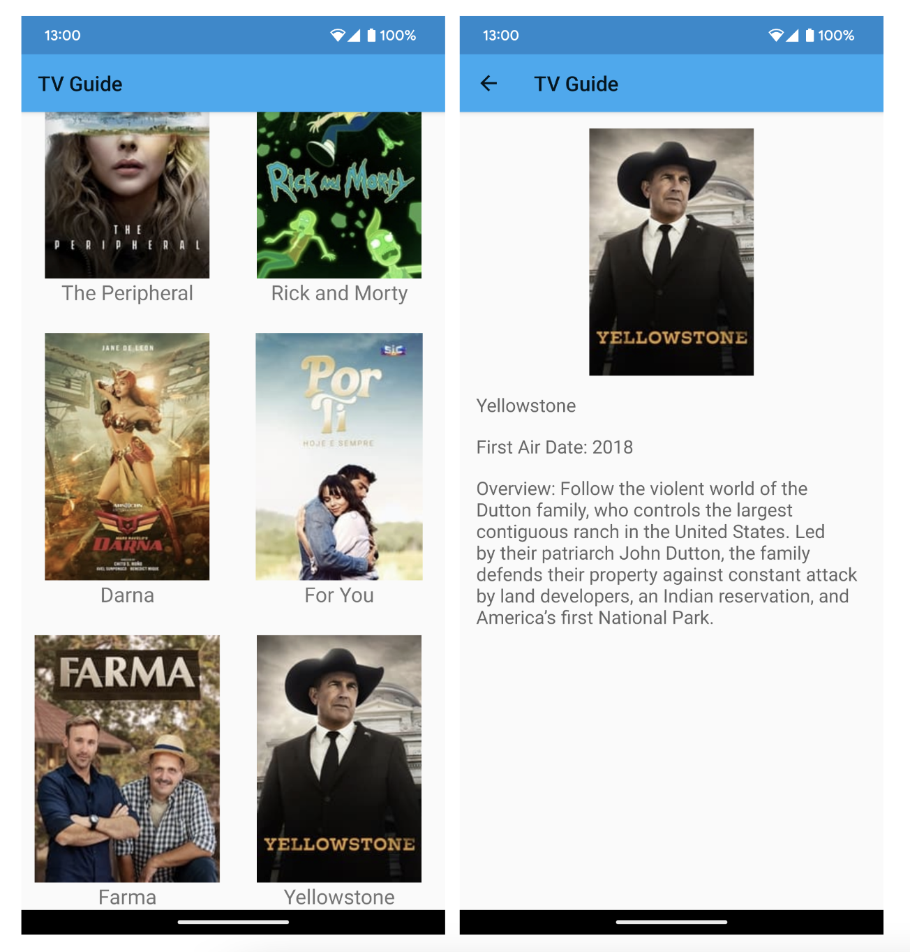
​​
Figure 14.7: The TV Guide app’s main screen and details screen

Chapter 15: Architecture Patterns

Activity 15.01: Revisiting the TV Guide App

Solution:
You can use the TV Guide app you developed in the previous chapter or make a copy of it. Here is one way you can improve the app using the MVVM architectural pattern with data binding, the Repository pattern with Room, and WorkManager:
- Open the TV Guide app in Android Studio.
- Open the app/build.gradle file and add the kotlin-kapt plugin at the
end of the plugins block:
plugins {
...
id 'kotlin-kapt'
}
- Add the data binding dependency in the android block:
buildFeatures {
dataBinding true
}
This will enable data binding in your application.
- Add the dependencies for the Room library and WorkManager:
implementation 'androidx.room:room-runtime:2.4.3' implementation 'androidx.room:room-ktx:2.4.3' kapt 'androidx.room:room-compiler:2.4.3'

implementation 'androidx.work:work-runtime:2.7.1'
This will allow you to use Room and WorkManager in your project.
- Create a RecyclerViewBinding class that contains the binding adapter for the RecyclerView list:
@BindingAdapter("list")
fun bindTVShows(view: RecyclerView, tvShows: List<TVShow>?) {
val adapter = view.adapter as TVShowAdapter adapter.addTVShows(tvShows ?: emptyList())
}

This adds the app:list attribute for RecyclerView, wherein you can pass the list of TV shows that will be set to the adapter to update the RecyclerView content.
- Open the activity_main.xml file and wrap everything inside a layout tag:
<layout xmlns:android="http://schemas.android.com/apk/res/android" xmlns:app="http://schemas.android.com/apk/res-auto" xmlns:tools="http://schemas.android.com/tools">

<androidx.constraintlayout.widget.ConstraintLayout
...
</layout>
This will allow the data binding library to generate a binding class for the layout.
- Inside the layout tag and before the ConstraintLayout tag, add a data
element with a variable for the viewModel:
<data>
<variable
name="viewModel" type="com.example.tvguide.TVShowViewModel" />
</data>
The viewModel layout variable corresponds to your TVShowViewModel class.
- In RecyclerView, add the list to be displayed with app:list:
app:list="@{viewModel.TVShows}"
This will pass the TVShows from the TVShowViewModel into RecyclerView.
- Open MainActivity, remove the line for setContentView, and add the following:
val binding: ActivityMainBinding = DataBindingUtil. setContentView(this,
R.layout.activity_main
- Remove the observer from TVShowViewModel and replace it with the data
binding code:
binding.viewModel = tvShowViewModel binding.lifecycleOwner = this

This binds the tvShowViewModel to the viewModel layout variable in the
activity_main.xml file.
- Run your application. It will display a list of TV shows. Clicking on a TV show will open a details screen where you can see additional information about the show, such as the release year and a plot overview:

​​
Figure 15.7: The TV Guide app looks the same with data binding
You have added data binding in the TV Guide app. In the next steps, you will be using Room to cache the list of TV shows in the local database.

- Open the TVShow class and add an Entity annotation for it:
@Entity(tableName = "tvshows", primaryKeys = [("id")]) data class TVShow( ... )
This creates a tvShows table for the list of TV shows, with id as the
primary key.
- Create a TVDao data access object for accessing the TV shows table in a new package called com.example.tvguide.database:

This class has a function for getting the list of TV shows from the database and another function for adding a list to the database.
@Dao
interface TVDao {
@Insert(onConflict = OnConflictStrategy.REPLACE)
fun addTVShows(tvShows: List<TVShow>)

@Query("SELECT * FROM tvshows")
fun getTVShows(): List<TVShow>
}
- Create a TVDatabase class in the com.example.tvguide. database package:
@Database(entities = [TVShow::class], version = 1) abstract class TVDatabase : RoomDatabase() {

abstract fun tvDao(): TVDao

companion object { @Volatile
private var instance: TVDatabase? = null

fun getInstance(context: Context): TVDatabase {
return instance ?: synchronized(this) {
instance ?: buildDatabase(context).also
{ instance = it }
}
}

private fun buildDatabase(context: Context): TVDatabase {
return Room.databaseBuilder(context, TVDatabase::class.java, "tvshows-db")
.build()
}
}
}
This database has a version of 1, a single entity for TVShow, and a data access
object for the TV shows.
- Update the TVShowRepository class with a constructor for tvDatabase:
class TVShowRepository(private val tvService: TelevisionService, private
val tvDatabase: TVDatabase) { ... }
- Update the fetchTVShows function to get the TV shows from the database. If
there's nothing yet, retrieve the list from the endpoint and save it:
fun fetchTVShows(): Flow<List<TVShow>> {
return flow {
val tvDao: TVDao = tvDatabase.tvDao()
val savedTVShows = tvDao.getTVShows()
if (savedTVShows.isEmpty()) {
val tvShows = tvService.getTVShows(apiKey).results
tvDao.addTVShows(tvShows)
emit(tvShows)
} else {
emit(savedTVShows)
}
}.flowOn(Dispatchers.IO)
}

- Run your application. It will display a list of TV shows. If you turn off mobile data or disconnect from the wireless network, you will still see the list because it is now cached in the database:
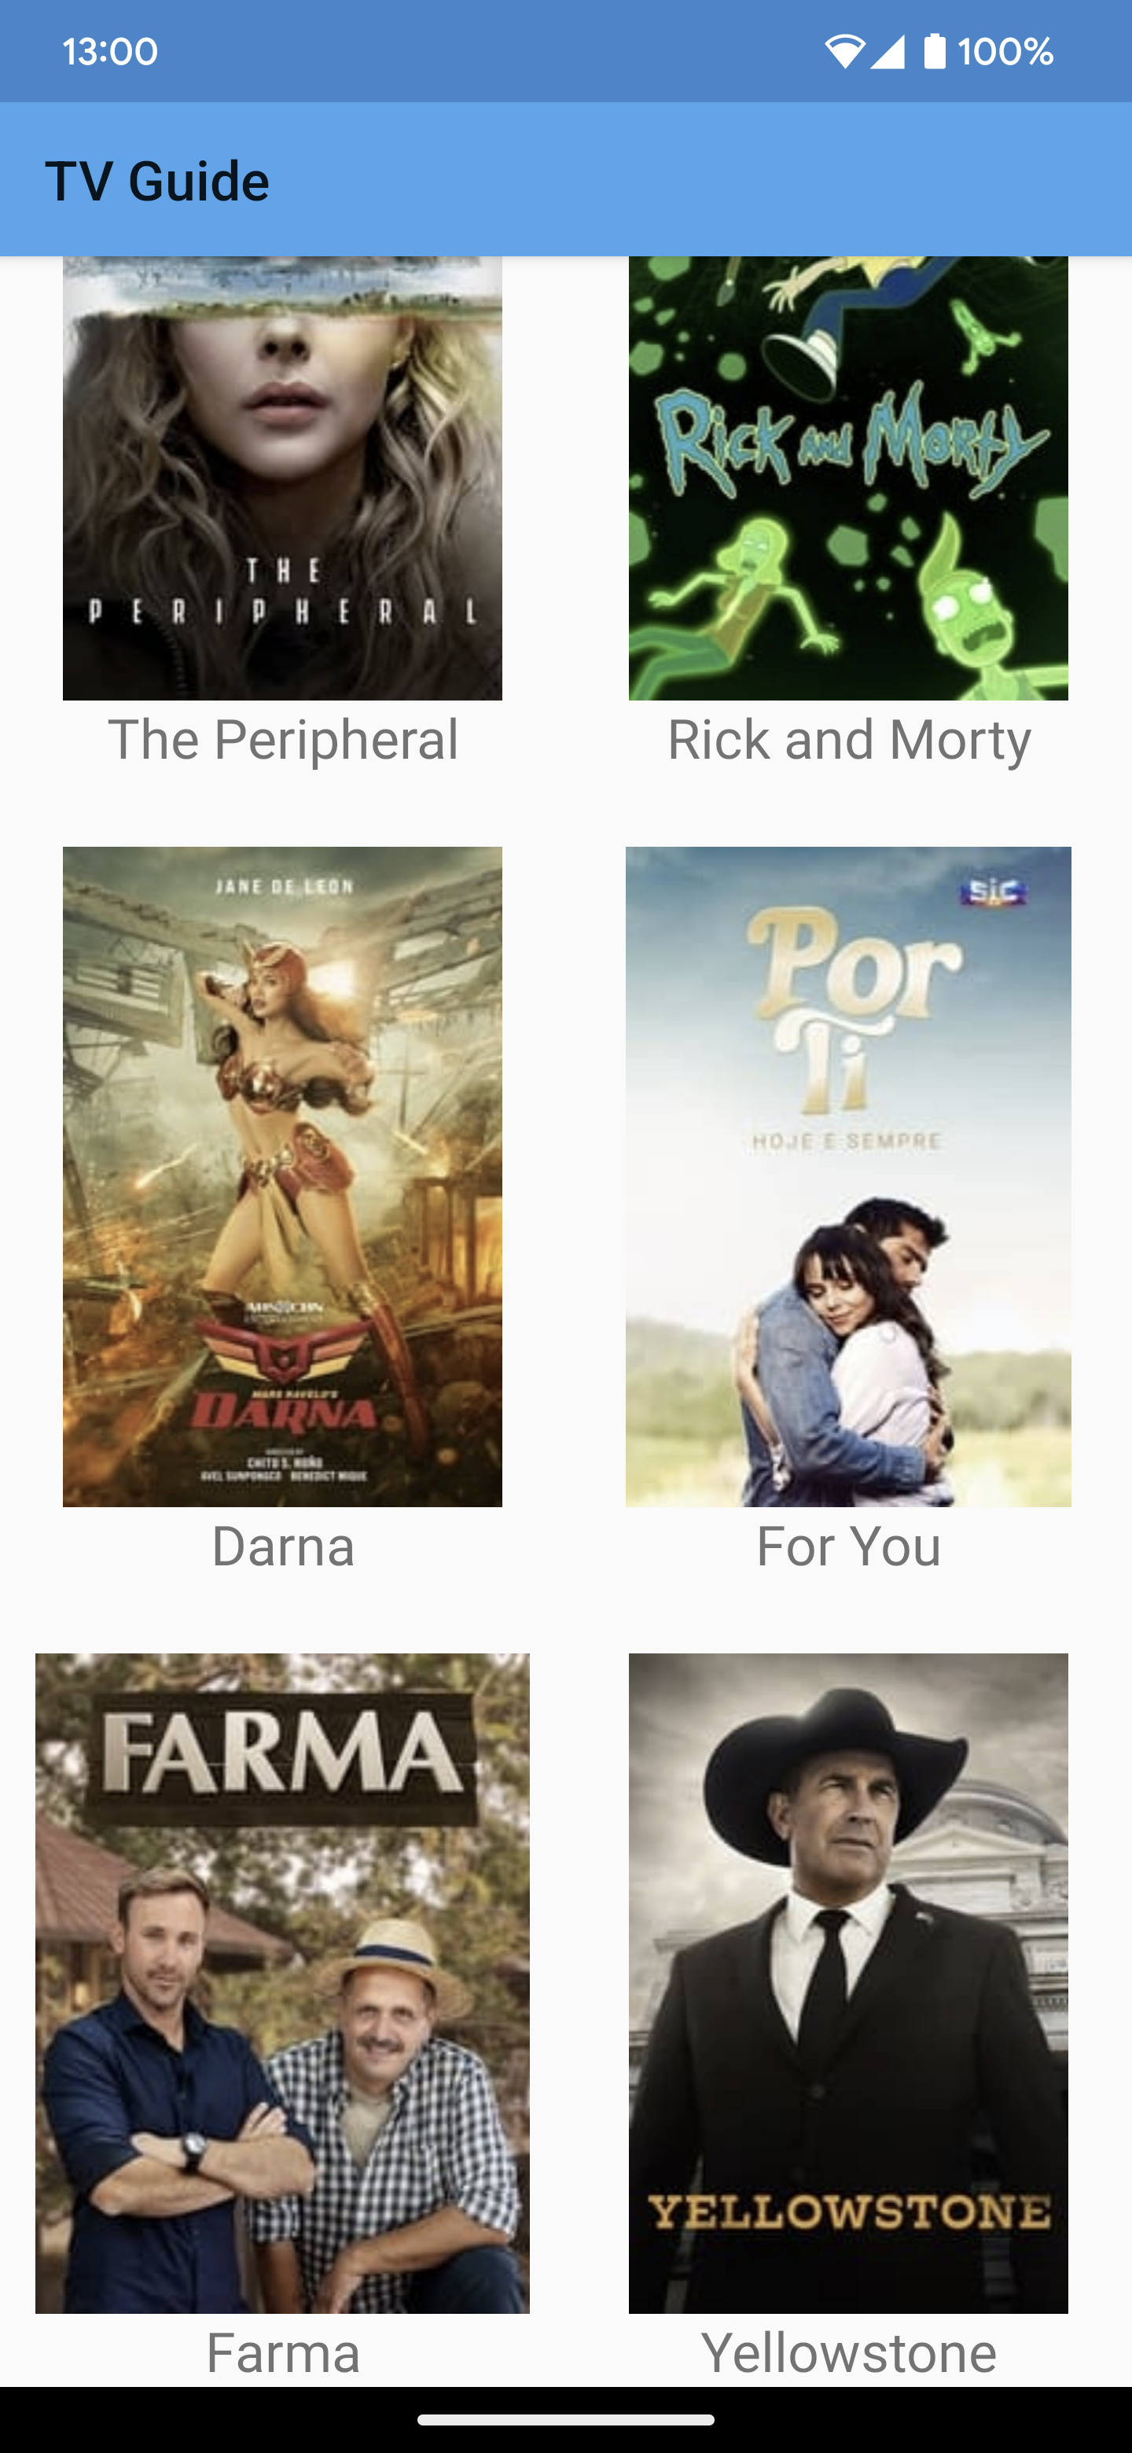
​​
Figure 15.8: The main screen of the TV Guide app with the list of TV shows

- When you click on a TV show, the details screen will be displayed:
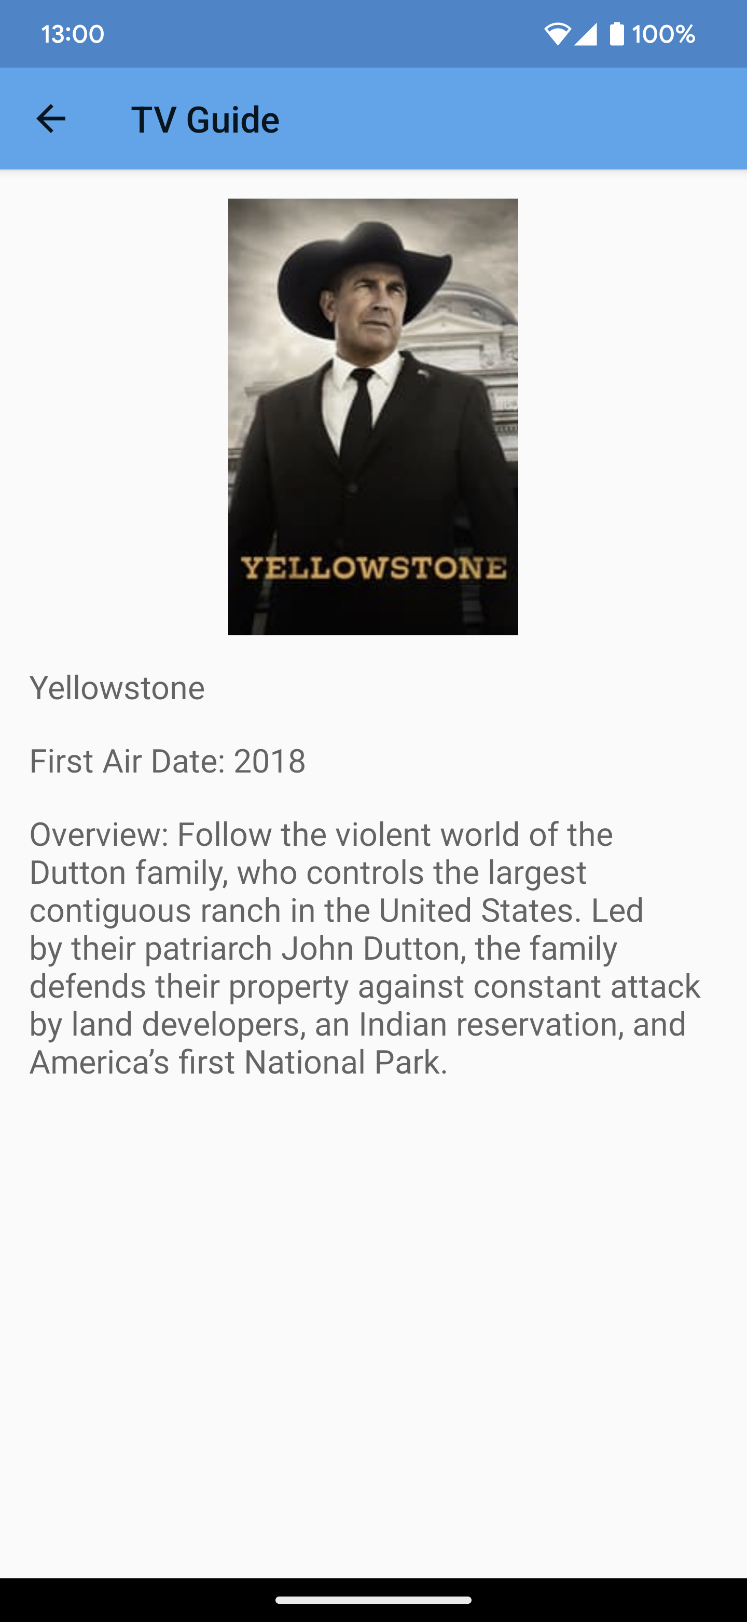
​​
Figure 15.9: The details screen showing more information about the chosen TV show
You have cached the list of TV shows in the local database. In the next steps, you will be adding WorkManager to schedule a task for fetching data from the server and saving it to the local database at regular intervals.

- Open TVShowRepository and add a suspending function for fetching TV
shows from the network and saving them to the database:
suspend fun fetchTVShowsFromNetwork(){
val tvDao: TVDao = tvDatabase.tvDao()
try {
val tvShows = tvService.getTVShows(apiKey)
val shows = tvShows.results
tvDao.addTVShows(shows)
} catch (exception: Exception) {
Log.d("TVShowRepository", "An error occurred: ${exception.message}")
}
}
This will be the function that will be called by the Worker class that will be running to fetch and save the TV shows.
- Create the TVShowWorker class:
class TVShowWorker(private val context: Context, params: WorkerParameters) : Worker(context, params) {
override fun doWork(): Result {
val tvShowRepository = (context as TVApplication).tvShowRepository
CoroutineScope(Dispatchers.IO).launch { tvShowRepository.fetchTVShowsFromNetwork()
}
return Result.success()
}
}

- Open TVApplication and at the end of the onCreate function, schedule
TVShowWorker to retrieve and save the shows:
override fun onCreate() {
...

val constraints = Constraints.Builder().setRequiredNetworkType(NetworkType
.CONNECTED).build()
val workRequest = PeriodicWorkRequest
.Builder(TVShowWorker::class.java, 1, TimeUnit.HOURS)
.setConstraints(constraints)
.addTag("tvshow-work")
.build() WorkManager.getInstance(applicationContext).enqueue(workRequest)
}
This schedules TVShowWorker to run every hour when the device is connected to the network.
- Run your application. It will display the list of TV shows. Now, the list of TV shows will be fetched and saved at scheduled intervals, even when the app is closed.

Chapter 16: Animations and Transitions with CoordinatorLayout and MotionLayout

Activity 16.01: Password Generator

Solution:
Here is one way we can create the Password Generator app:
  - Create a new Empty Activity project in Android Studio with Password Generator as the name. Set its package name to com.example. passwordgenerator and Minimum SDK to API 21: Android 5.0 Lollipop.
  - Add the MaterialComponents dependency to your app/build.gradle
file:
implementation 'com.google.android.material:material:1.7.0'
We will add this so that we can use TextInputLayout and
TextInputEditText for the input text field for the password length.
  - Make sure that the dependency for ConstraintLayout is version 2 or
above, for example:
implementation 'androidx.constraintlayout:constraintlayout:2.1.4'
This will allow us to use MotionLayout in our layout files.
  - Open the themes.xml file and make sure that the activity's theme is using a
theme from MaterialComponents. See the following example:
<style name="AppTheme" parent="Theme.MaterialComponents.Light.DarkActionBar">
We need to do this as the TextInputLayout and TextInputEditText we
will be using later require your activity to use a MaterialComponents theme.
  - Go to the strings.xml file and add the following string values:
<string name="text_length">Password Length (6–20)</string>

<string name="check_numbers">Add Numbers</string>
<string name="check_special">Add Special Characters</string>
<string name="check_upper_case">Add Uppercase Characters</string>

<string name="button_copy">Copy</string>
<string name="button_generate">Generate Password</string>
  - Open the activity_main.xml file . Remove the Hello World TextView and add the input text field for the length:
  - Add the checkboxes for uppercase, numbers, and special characters below the length text field layout:
<com.google.android.material.textfield.TextInputLayout
android:id="@+id/length_text_layout"
style="@style/Widget.MaterialComponents.TextInputLayout.OutlinedBox"
android:layout_width="match_parent"
android:layout_height="wrap_content"
android:layout_margin="16dp"
android:hint="@string/text_length"
app:layout_constraintEnd_toEndOf="parent"
app:layout_constraintStart_toStartOf="parent"
app:layout_constraintTop_toTopOf="parent">

<com.google.android.material.textfield.TextInputEditText
android:id="@+id/length_text"
android:layout_width="match_parent"
android:layout_height="wrap_content"
android:inputType="number"
android:maxLength="2"
android:textSize="18sp" />
</com.google.android.material.textfield.TextInputLayout>
<CheckBox
android:id="@+id/uppercase_check"
android:layout_width="match_parent"
android:layout_height="wrap_content"
android:layout_margin="16dp"
android:text="@string/check_upper_case"
app:layout_constraintTop_toBottomOf="@id/length_text_layout" />

<CheckBox
android:id="@+id/number_check"
android:layout_width="match_parent"
android:layout_height="wrap_content"
android:layout_margin="16dp"
android:text="@string/check_numbers"
app:layout_constraintTop_toBottomOf="@id/uppercase_check" />

<CheckBox
android:id="@+id/special_check"
android:layout_width="match_parent"
android:layout_height="wrap_content"
android:layout_margin="16dp"
android:text="@string/check_special"
app:layout_constraintTop_toBottomOf="@id/number_check" />
  - At the bottom of the checkboxes, add a Generate Password button:
<Button
android:id="@+id/generate_button" android:layout_width="wrap_content" android:layout_height="wrap_content" android:layout_margin="16dp" android:text="Generate Password" app:layout_constraintEnd_toEndOf="parent" app:layout_constraintTop_toBottomOf="@id/special_check" />
  - Run the application. Your app should look like the following:
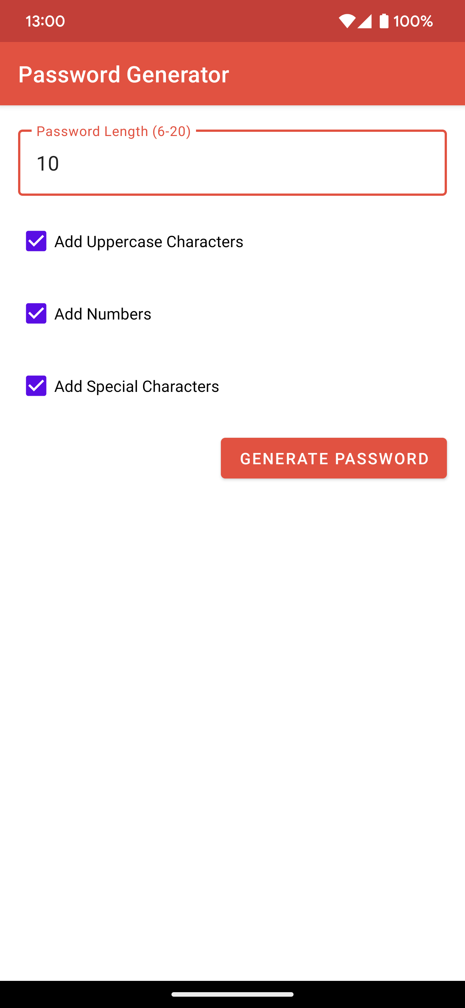
​​
Figure 16.21: The Input Screen of the Password Generator app

  - Create another activity. Go to the File menu and click on New | Activity
| Empty Activity. Name it OutputActivity. Make sure Generate Layout File is checked so that activity_output will be created.
  - Let's customize the activity transition from the input screen (MainActivity) to OutputActivity. Open themes.xml and update the activity theme with the windowActivityTransitions, windowEnterTransition, and windowExitTransition style attributes:
<item name="android:windowActivityTransitions"> true</item>
<item name="android:windowEnterTransition"> @android:transition/slide_right</item>
<item name="android:windowExitTransition"> @android:transition/fade</item>
This will enable the activity transition, add a slide right enter transition, and add
an exit transition to fade on the activity.
  - Open MainActivity. At the end of the onCreate function, add the following code:
val lengthText: EditText =
findViewById(R.id.length_text)
val uppercaseCheckbox: CheckBox =
findViewById(R.id.uppercase_check)
val numberCheckbox: CheckBox =
findViewById(R.id.number_check)
val specialCheckbox: CheckBox =
findViewById(R.id.special_check)
val button: Button =
findViewById(R.id.generate_button)
button.setOnClickListener {

val length = length_text.text.toString().toInt() if (length < 6 || length > 20) {
Snackbar.make(it, "Length must be from 6 to 20", Snackbar.LENGTH_SHORT).show()
return@setOnClickListener
}

val intent = Intent(this, OutputActivity::class.java).apply {
putExtra("length", lengthText.text.toString())
putExtra("uppercase", uppercaseCheck.isChecked)
putExtra("numbers", numberCheck.isChecked) putExtra("special", speciaCheck.isChecked)
}
startActivity(intent, ActivityOptions
.makeSceneTransitionAnimation(this).toBundle())
}
This will add a ClickListener component on the Generate button. When it's tapped, the system will open OutputActivity and pass the length, uppercase, number, and special character values as intent extras.
  - Open the activity_output.xml file and change androidx. constraintlayout.widget.ConstraintLayout to the following:
androidx.constraintlayout.motion.widget.MotionLayout
This will allow us to use MotionLayout for the output screen.
  - Add app:layoutDescription="@xml/motion_scene" and app:motionDebug="SHOW_ALL" to the MotionLayout tag. The first will set the res/xml/motion_scene.xml file as motion_scene for MotionLayout. The latter will allow us to see the animation path and
progress in the editor and on the device. activity_output will now look like
the following:
<androidx.constraintlayout.motion.widget.MotionLayout xmlns:android="http://schemas.android.com/apk/res/android" xmlns:app="http://schemas.android.com/apk/res-auto" xmlns:tools="http://schemas.android.com/tools" android:layout_width="match_parent" android:layout_height="match_parent" app:layoutDescription="@xml/motion_scene" app:motionDebug="SHOW_ALL"

tools:context=".OutputActivity">
...
</androidx.constraintlayout.motion.widget.MotionLayout>
  - Add three instances of TextView to the output activity for the three
passwords generated:
<TextView
android:id="@+id/password1_text" style="@style/TextAppearance.AppCompat.Headline" android:layout_width="wrap_content" android:layout_height="wrap_content" android:layout_marginBottom="60dp" app:layout_constraintBottom_toTopOf
="@id/password2_text" app:layout_constraintEnd_toEndOf="parent"
app:layout_constraintStart_toStartOf="parent" tools:text="First Password" />

<TextView
android:id="@+id/password2_text" style="@style/TextAppearance.AppCompat.Headline" android:layout_width="wrap_content" android:layout_height="wrap_content" app:layout_constraintBottom_toBottomOf="parent" app:layout_constraintEnd_toEndOf="parent" app:layout_constraintStart_toStartOf="parent" app:layout_constraintTop_toTopOf="parent" tools:text="Second Password" />

<TextView
android:id="@+id/password3_text" style="@style/TextAppearance.AppCompat.Headline" android:layout_width="wrap_content" android:layout_height="wrap_content" android:layout_marginTop="60dp" app:layout_constraintEnd_toEndOf="parent" app:layout_constraintStart_toStartOf="parent" app:layout_constraintTop_toBottomOf
="@+id/password2_text" tools:text="Third Password" />

  - Add a Copy button at the bottom of the screen:
<Button
android:id="@+id/button" android:layout_width="wrap_content" android:layout_height="wrap_content" android:layout_marginBottom="60dp" android:text="Copy" app:layout_constraintBottom_toBottomOf="parent" app:layout_constraintEnd_toEndOf="parent" app:layout_constraintStart_toStartOf="parent" />
  - Open OutputActivity. Add the following function:
private fun generatePassword( length: Int, addUpperCase: Boolean, addNumbers: Boolean, addSpecial: Boolean
): String {
val password = mutableListOf<Char>()

val lowercaseCharacters = ('a'..'z').toList() val upperCaseCharacters
= lowercaseCharacters.map { it.toUpperCase() } val numbers = ('0'..'9').toList()
val specialCharacters = "~!@#$%^&*()_+-="

val characters = mutableListOf<Char>() characters.addAll(lowercaseCharacters) if (addUpperCase) {
characters.addAll(upperCaseCharacters) password.add(upperCaseCharacters.random())
}

if (addNumbers) { characters.addAll(numbers) password.add(numbers.random())
}

if (addSpecial) { val specials

= specialCharacters.toCharArray().toList() characters.addAll(specials) password.add(specials.random())
}

while (password.size < length) { password.add(characters.random())
}

password.shuffle()

return password.joinToString("")
}
This will generate the password depending on the input provided by the user.
  - At the end of the onCreate function, add the following code:
val length: Int = intent
?.getStringExtra("length")?.toInt() ?: 0 val upperCase: Boolean = intent
?.getBooleanExtra("uppercase", false) ?: false
val numbers: Boolean = intent
?.getBooleanExtra("numbers", false) ?: false val special: Boolean = intent
?.getBooleanExtra("special", false) ?: false
val password1: TextView =
findViewById(R.id.password1_text)
password1.text = generatePassword( length = length,
addUpperCase = upperCase, addNumbers = numbers, addSpecial = special
)
val password2: TextView = findViewById
(R.id.password2_text) password2.text = generatePassword(
length = length, addUpperCase = upperCase, addNumbers = numbers, addSpecial = special
)
val password3: TextView = findViewById
(R.id.password3_text) password3.text = generatePassword(

length = length, addUpperCase = upperCase, addNumbers = numbers, addSpecial = special
)
val button: Button = findViewById(R.id.button)
button.setOnClickListener {
val clipboard = getSystemService (Context.CLIPBOARD_SERVICE) as ClipboardManager

val password = when { password1.isVisible -> {
password1.text.toString()
}
password2.isVisible -> {
password2.text.toString()
}
else -> {
password3.text.toString()
}
}

val clip: ClipData = ClipData
.newPlainText("password", password) clipboard.setPrimaryClip(clip)

Snackbar.make(it, "Password has been copied!", Snackbar.LENGTH_SHORT).show()
}
This will generate the three passwords based on the user input and add a ClickListener component to the Copy button for the user to copy the selected password to the clipboard.
  - In OutputActivity, we will be creating an animation per password TextView. When the user has selected one, we'll be moving the selected password to the center and hiding the others. We'll also show the Copy button.

  - Create a motion_scene.xml file in the res/xml directory. This will be our motion_scene file where the animation configuration will be defined. Use motion_scene as the root element for the file.
  - We'll first create ConstraintSet for the default view in the motion_scene. xml file:
<ConstraintSet android:id="@+id/passwords_start">
<Constraint
android:id="@id/password2_text"
android:layout_width="wrap_content"
android:layout_height="wrap_content"
app:layout_constraintBottom_toBottomOf="parent"
app:layout_constraintEnd_toEndOf="parent"
app:layout_constraintStart_toStartOf="parent"
app:layout_constraintTop_toTopOf="parent" />
<Constraint
android:id="@id/password1_text"
android:layout_width="wrap_content"
android:layout_height="wrap_content"
android:layout_marginBottom="60dp"
app:layout_constraintBottom_toTopOf="@id/password2_text"
app:layout_constraintEnd_toEndOf="parent"
app:layout_constraintStart_toStartOf="parent" />
<Constraint
android:id="@id/password3_text"
android:layout_width="wrap_content"
android:layout_height="wrap_content"
android:layout_marginTop="60dp"
app:layout_constraintEnd_toEndOf="parent"
app:layout_constraintStart_toStartOf="parent"
app:layout_constraintTop_toBottomOf="@+id/password2_text" />

<Constraint
android:id="@+id/button"
android:layout_width="wrap_content"
android:layout_height="wrap_content"
android:layout_marginBottom="60dp"
android:visibility="gone"
app:layout_constraintBottom_toBottomOf="parent"
app:layout_constraintEnd_toEndOf="parent"
app:layout_constraintStart_toStartOf="parent"
tools:visibility="visible" />
</ConstraintSet>
  - We'll then add the first ConstraintSet for when the first password is selected:
<ConstraintSet android:id="@+id/password1_end">
<Constraint
android:id="@id/password1_text"
android:layout_width="wrap_content"
android:layout_height="wrap_content"
app:layout_constraintBottom_toBottomOf="parent"
app:layout_constraintEnd_toEndOf="parent"
app:layout_constraintStart_toStartOf="parent"
app:layout_constraintTop_toTopOf="parent" />

<Constraint
android:id="@id/password2_text"
android:layout_width="wrap_content"
android:layout_height="wrap_content"
android:visibility="invisible"
app:layout_constraintBottom_toBottomOf="parent"
app:layout_constraintStart_toStartOf="parent"
app:layout_constraintTop_toTopOf="parent"
tools:visibility="visible" />
<Constraint
android:id="@id/password3_text"
android:layout_width="wrap_content"
android:layout_height="wrap_content"
android:visibility="invisible"
app:layout_constraintBottom_toBottomOf="parent"
app:layout_constraintEnd_toEndOf="parent"
tools:visibility="visible" />
<Constraint
android:id="@+id/button"
android:layout_width="wrap_content"
android:layout_height="wrap_content"
android:layout_marginBottom="60dp"
android:visibility="visible"
app:layout_constraintBottom_toBottomOf="parent"
app:layout_constraintEnd_toEndOf="parent"
app:layout_constraintStart_toStartOf="parent" />
</ConstraintSet>

  - Next, let's add ConstraintSet for when the second password is selected:
<ConstraintSet android:id="@+id/password2_end">
<Constraint
android:id="@id/password1_text"
android:layout_width="wrap_content"
android:layout_height="wrap_content"
android:visibility="invisible"
app:layout_constraintStart_toStartOf="parent"
app:layout_constraintTop_toTopOf="parent"
tools:visibility="visible" />
<Constraint
android:id="@id/password3_text"
android:layout_width="wrap_content"
android:layout_height="wrap_content"
android:visibility="invisible"
app:layout_constraintBottom_toBottomOf="parent"
app:layout_constraintEnd_toEndOf="parent"
tools:visibility="visible" />
<Constraint
android:id="@+id/button"
android:layout_width="wrap_content"
android:layout_height="wrap_content"
android:layout_marginBottom="60dp"
android:visibility="visible"
app:layout_constraintBottom_toBottomOf="parent"
app:layout_constraintEnd_toEndOf="parent"
app:layout_constraintStart_toStartOf="parent" />
</ConstraintSet>

  - Next, let's add ConstraintSet for when the third password is selected:
<ConstraintSet android:id="@+id/password3_end">
<Constraint
android:id="@id/password3_text"
android:layout_width="wrap_content"
android:layout_height="wrap_content"
app:layout_constraintBottom_toBottomOf="parent"
app:layout_constraintEnd_toEndOf="parent"
app:layout_constraintStart_toStartOf="parent"
app:layout_constraintTop_toTopOf="parent" />
<Constraint
android:id="@id/password1_text"
android:layout_width="wrap_content"
android:layout_height="wrap_content"
android:visibility="invisible"
app:layout_constraintStart_toStartOf="parent"
app:layout_constraintTop_toTopOf="parent"
tools:visibility="visible" />
<Constraint
android:id="@id/password2_text"
android:layout_width="wrap_content"
android:layout_height="wrap_content"
android:visibility="invisible"
app:layout_constraintBottom_toBottomOf="parent"
app:layout_constraintEnd_toEndOf="parent"
app:layout_constraintTop_toTopOf="parent"
tools:visibility="visible" />
<Constraint
android:id="@+id/button"
android:layout_width="wrap_content"
android:layout_height="wrap_content"
android:layout_marginBottom="60dp"
android:visibility="visible"
app:layout_constraintBottom_toBottomOf="parent"
app:layout_constraintEnd_toEndOf="parent"
app:layout_constraintStart_toStartOf="parent" />
</ConstraintSet>
  - Finally, add Transition for when each password is selected:
<Transition
app:constraintSetEnd="@id/password1_end"
app:constraintSetStart="@id/passwords_start"
app:duration="2000">
<OnClick
app:clickAction="transitionToEnd"
app:targetId="@id/password1_text" />
</Transition>

<Transition
app:constraintSetEnd="@id/password2_end"
app:constraintSetStart="@id/passwords_start"
app:duration="2000">
<OnClick
app:clickAction="transitionToEnd"
app:targetId="@id/password2_text" />
</Transition>

<Transition
app:constraintSetEnd="@id/password3_end"
app:constraintSetStart="@id/passwords_start"
app:duration="2000">
<OnClick
app:clickAction="transitionToEnd"
app:targetId="@id/password3_text" />
</Transition>

  - Run the application by going to the Run menu and clicking the Run app menu item. Note the transition between the input and output screen. When the Android UI is opening OutputActivity, you will notice that the views are sliding right, and while closing, the views fade out.
  - Input a length, select uppercase, numbers, and special characters, and tap on the Generate button. Three passwords will be displayed.
  - Select one of the password and the rest will move out of view. A Copy button will also be displayed. Click on it and check whether the password you selected is now on the clipboard. The initial and final state of the output screen will be similar to Figure 16.22:

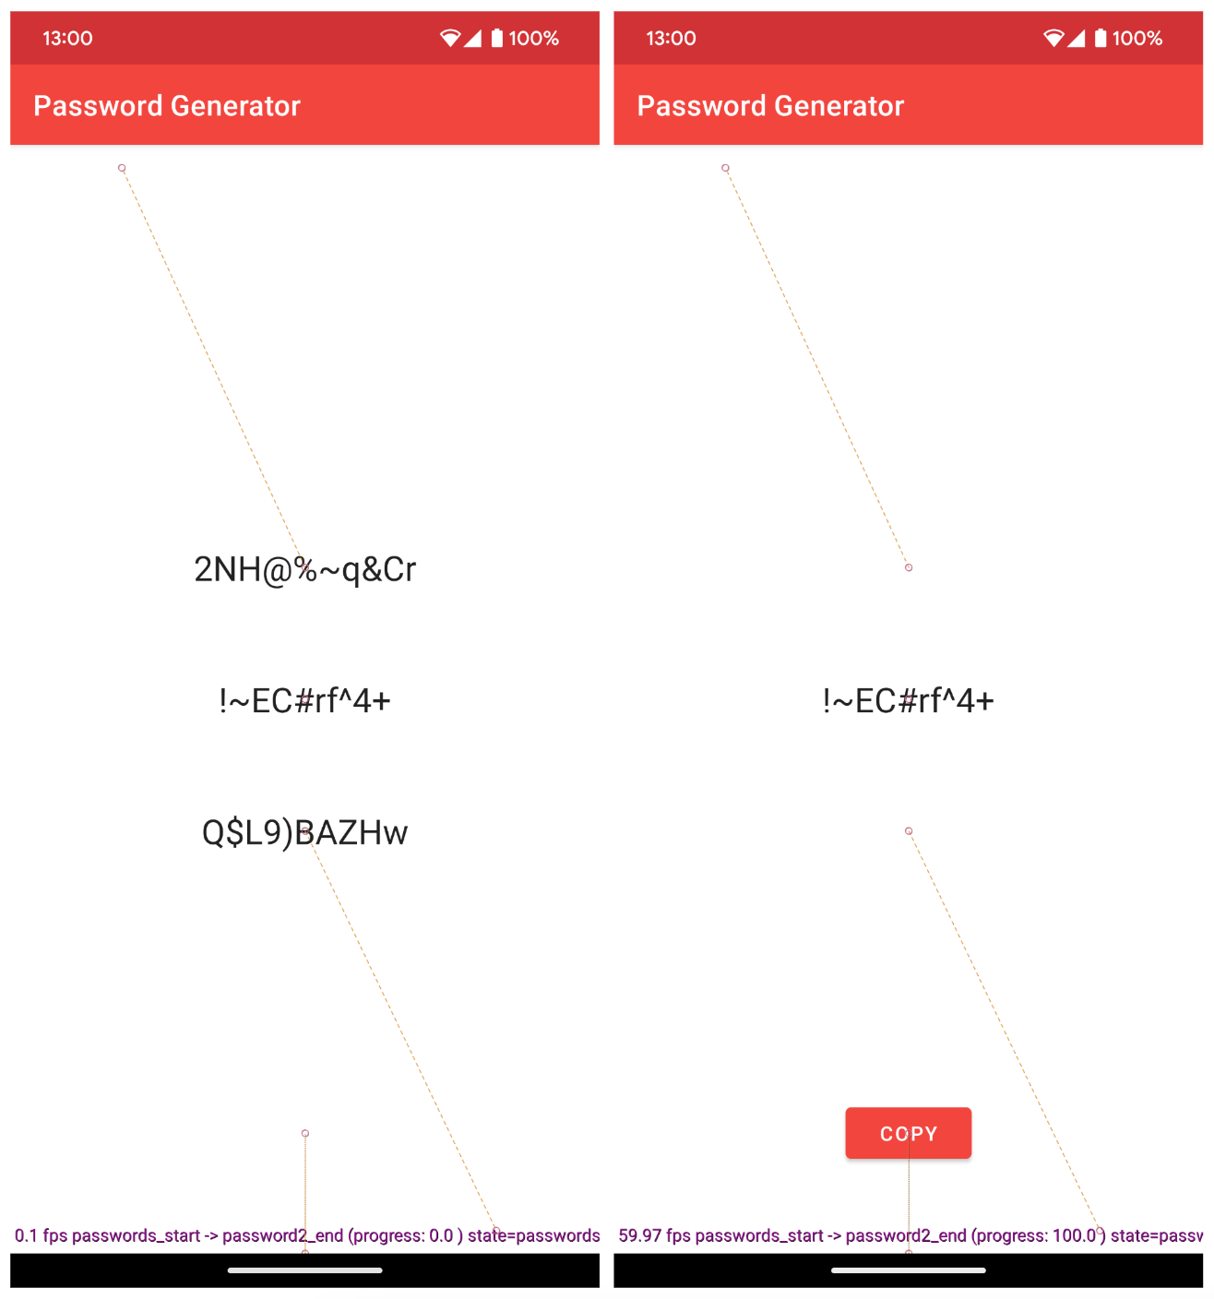
Figure 16.22: The start and end state of MotionLayout in the Password Generator app

